**The University of Illinois Hospital & Health Sciences System Combined Residency Program**

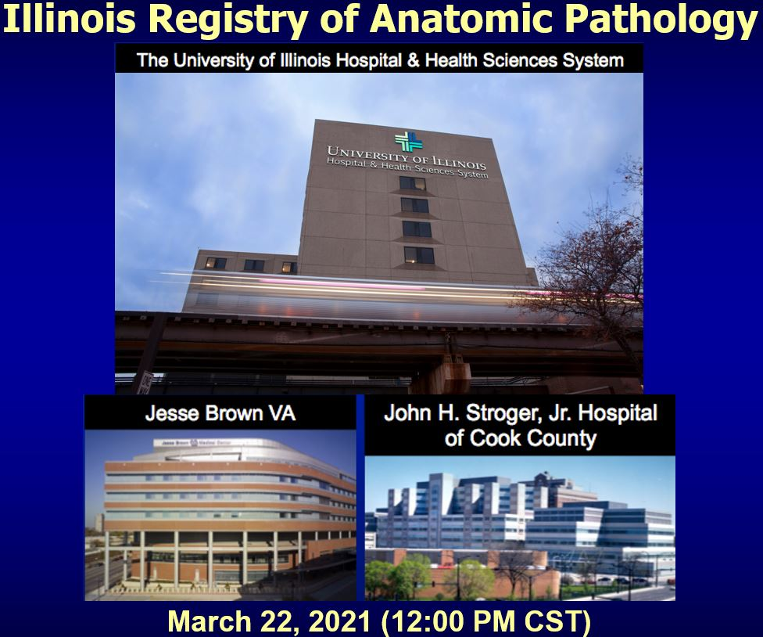

Case Histories

**Case 1: Presenter: Batool Huzaifa Husain, MD; Attending: Vikas Mehta, MD:**

The patient is a 45-years-old Caucasian female presented with heavy vaginal bleeding for 5 months, worsening, since 1 day and fatigue, SOB, difficulty voiding, defecating since 1 month. Past medical history is significant for no periods since several years prior to these symptoms. Imaging showed large, ill-defined uterine mass, replacing the entire uterus and cervix. The mass was biopsied and representative section is submitted for virtual review.

**Case 2: Presenter: Ujalla Sheikh, MBBS; Attending: Manuel Utset, MD, PhD:**

The patient is a 56-year-old female with cognitive impairment, loss of balance and headache for several months worsening over the last month. Almost one week prior to presentation, the patient fell in the bathroom and hit her head, and she had another near fall episode the day prior to presentation. Her daughter noted declining mental function with memory impairment, confusion, and speech difficulty that had accelerated over the previous month. Mini-Mental State Examination (MMSE) with total score of 21 out of 30. Head CT scan showed a heterogeneously enhancing mass centered approximately at the left basal ganglia and thalamus with areas of intrinsic low attenuation and calcification and enhancement and enlargement of the left midbrain. Brain MRI with and without contrast showed a large enhancing multilobulated left thalamic mass, approximately 5 cm in greatest dimension, that extended to the lateral and third ventricles. Stereotactic brain biopsy of mass was performed, 2 sections of which are submitted for virtual review.

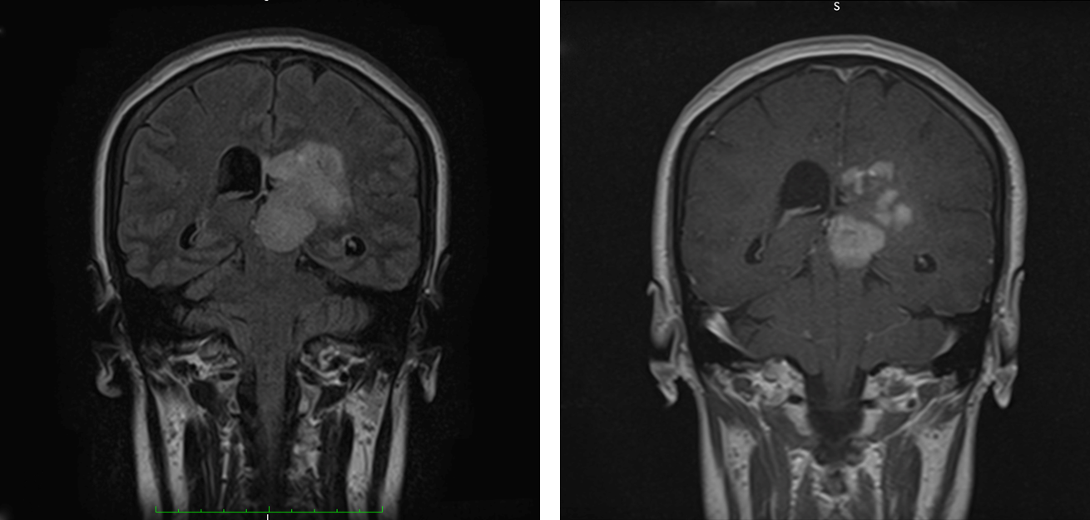

**Case 3: Presenter: Saman Karimi, MD; Attending: Vikas Mehta, MD:**

The patient is a 33-year-old male with no significant medical history presents for evaluation of azoospermia. Scrotal ultrasound demonstrated an incidental 1.1 cm hypoechoic mass in the superior pole of the right testis with prominent vascularity. Biopsy of the bilateral testes revealed maturation arrest. A nodulectomy was performed, and a section of the lesion is submitted for virtual review.

**Case 4: Presenter** **Robert Post, DO; Attending: Steven Garzon, MD:**

The patient is an 11-year-old male with no signiﬁcant past medical history who presented to the clinic with a 2-year history of abnormal gait. Two years after the onset of symptoms, a painful mass was noticed on his left shin. Radiography demonstrated an expansile, heterogenous lesion arising from the anterior tibial cortex with lucent and sclerotic features. A CT guided biopsy of the lesion was performed. The biopsy is submitted for virtual review.

**Case 5: Presenter: Pouyan Kheirkhah, MD; Attending: Tibor Valyi-Nagy, MD:**

The patient is a 41-year-old male patient with HIV had presented with right sided facial pain in the V1 and V2 dermatomes and previous workup and imaging studies. The patient had undergone treatment of a presumed right-side cerebellopontine angle meningioma as determined by the magnetic resonance imaging characteristics without biopsy. The patient subsequently underwent right-sided retrosigmoid craniotomy for gross total resection of the tumor. The postoperative period was uneventful with resolution of the trigeminal neuralgia. A representative section of resection is submitted for virtual review.

**Case 6: Presenter: Bartlomiej Lukasz Radzik, MD; Attending: Carlos Murga-Zamalloa, MD:**

The patient is a 45-year-old male with a past history of HIV started on HAART therapy 3 months prior to presentation and a 20 kg weight loss over the last 4 months as well as H. Pylori and diverticulosis. The patient presented with abdominal pain in the lower left quadrant and constant post-prandial diarrhea. A CT scan showed severe wall thickening and sigmoid colitis with air-containing fluid collection consistent with perforation and abscess formation. A segment of the perforated colon was removed. A representative section is submitted for virtual review.