ILLINOIS REGISTRY OF PATHOLOGY FOR 14 NOVEMBER 2016 NORTHWESTERN MEMORIAL HOSPITAL FEINBERG SCHOOL OF MEDICINE, NORTHWESTERN UNIVERSITY

Case 1
Presenter: Brandon Umphress, MD, PGY II
Attendings: Dr. Kirtee Raparia, Dr. Anjana Yeldandi
Clinical History: A 33-year-old Central American male with no significant past medical history presented to Northwestern Memorial Hospital with progressively worsening dyspnea of four weeks. His dyspnea was associated with a productive cough, worsening dysphagia, and progressive hoarseness. Furthermore, the patient noted an unintentional weight loss over the past 2 months of approximately 20 pounds. One week prior to his presentation, the patient was seen at an outside clinic and was treated with doxycycline and prednisone, however, experienced no improvement. On physical examination, the patient’s oxygen saturation on 4L nasal cannula was 94%. His exam was remarkable for intermittent stridor, intercostal retractions, and peripheral clubbing. Labs were drawn and a CBC demonstrated an elevated WBC of 18.6 k/µL. Computed tomography of the chest and neck revealed tracheal calcification with endoluminal thickening and irregularity. Due to concern for airway obstruction, a tracheostomy was performed, followed by laryngoscopic examination of the trachea, which confirmed the presence of a diffusely thickened and irregular surface. Tracheal biopsies were performed.
Final Diagnosis: Tracheal Rhinoscleroma
Differential Diagnosis:
- Histiocytic or xanthomatous neoplasm
- Metastatic clear cell neoplasm
- Erdheim-Chester Disease
- Infectious process
- Rosai-Dorfman Disease
Pathologic Findings:
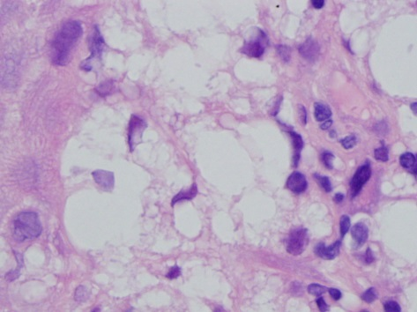
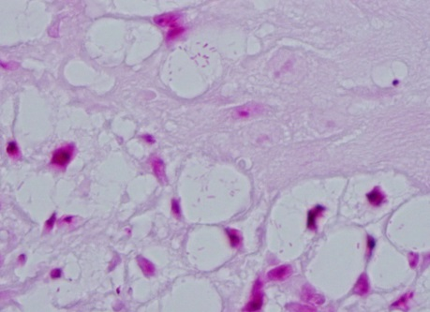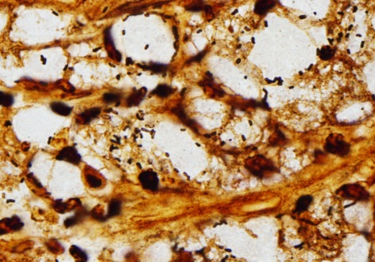
The above figures demonstrate tracheal squamous mucosa with infiltrative cells in a nested pattern with clear cytoplasm and peripherally located small nuclei with associated background chronic inflammation. The cells of interest were identified as “Mikulicz Cells.” Gram stain highlighted numerous gram negative rod shaped organisms within the cytoplasm of the clear cells. Additionally, these organisms were identifiable with Steiner silver staining. Immunohistochemistry revealed that the cells of interest were CD68 positive. PAS and GMS staining failed to highlight the presence of fungal organisms, and AFB staining was negative.
Bacterial cultures were positive for gram negative rods and further biochemical testing confirmed the presence of the genus, Klebsiella. Subsequent entire 16s rRNA gene sequencing speciated the organism as Klebsiella rhinoscleromatis.
Discussion: Rhinoscleroma is described as a chronic infectious granulomatous process which presents as mass lesions involving the respiratory tract from the nasopharynx down to the trachea. Most commonly, Rhinoscleroma involves the nasal cavity (tracheal involvement is rarely reported in the literature). As in our case, this entity is usually secondary to Klebsiella rhinoscleromatis, however, cases secondary to Klebsiella ozaenae have been reported. Epidemiologically, patients are from developing countries within Central America, Eastern Europe, and Southeast Asia, and disease manifestation is often associated with poory hygiene, poor nutrition, and crowded living conditions.
Clinically, patients will classically present in one of three possible stages. The first stage, Catarrhal-atrophic, is associated with rhinorrhea and recurrent sinusitis and typically lasts for weeks to months. Histologically, one would likely see squamous metaplasia with a neutrophilic infiltrate. The second stage, Granulomatous-Hypertrophic, characterized by mass formation with tissue destruction, lasts for months to years. Histologically, Mikulicz cells are present in this stage. The third stage, Sclerotic, is chronic with extensive scarring and deformity. In terms of pathophysiology, the organisms invade the squamous lining of the respiratory tract whereby they undergo phagocytosis by resident macrophages. A protective mucopolysaccharide capsule prevents the macrophages from degrading the organisms, which over time results in the macrophages undergoing massive dilatation. The nucleus is pushed to the periphery thereby forming the distinctive Mikulicz cell.
The diagnosis of Rhinoscleroma can be quite challenging as bacterial cultures are only positive in 50-60% of cases and gram staining may not always highlight involvement with organisms. Histologic examination, specifically during the second stage, is extremely helpful as the Mikulicz cell is essentially pathognomonic for Rhinoscleroma. Treatment with ciprofloxacin or trimethoprim-sulfamethoxazole for 3-6 months has proven effective; however, recurrence rates do remain high. For more advanced disease, reconstructive surgery is often necessary.
References:
1. Bigi A., Bartolomeo M., Costes V., Makeieff M. Tracheal rhinoscleroma. Euro Ann of Otolaryng, 2016; 133(1): p. 51-53.
2. Chan, T.V. and J.H. Spiegel. Klebsiella rhinoscleromatis of the membranous nasal septum. J Laryngol Otol, 2007; 121(10): p. 998-1002.
3. De Champs, C., J.F. Vellin, L. Diancourt, S. Brisse, J.L. Kemeny, L. Gilain, and T. Mom. Laryngeal scleroma associated with Klebsiella pneumoniae subsp. ozaenae. J Clin Microbiol, 2005; 43(11).
4. de Pontual, L., P. Ovetchkine, D. Rodriguez, A. Grant, A. Puel, J. Bustamante, S. Plancoulaine, L. Yona, P.Y. Lienhart, D. Dehesdin, M. Huerre, R. Tournebize, P. Sansonetti, L. Abel, and J.L. Casanova. Rhinoscleroma: a French national retrospective study of epidemiological and clinical features. Clin Infect Dis, 2008; 47(11): p. 1396-402.
5. Hart, C.A. and S.K. Rao. Rhinoscleroma. J Med Microbiol, 2000; 49(5): p. 395-6.
6. Yigla, M., O. Ben-Izhak, I. Oren, N. Hashman, and F. Lejbkowicz. Laryngotracheobronchial involvement in a patient with nonendemic rhinoscleroma. Chest, 2000; 117(6): p. 1795-8.

Case 2:
Presenter: Melanie Hakar DO, PGY II
Attendings: Bob Alexiev, MD
Guang-Yu Yang, MD, PhD

Clinical History: The patient is a 41-year-old male with no significant past medical history. He presented with a one-month history of left-sided nasal obstruction, rhinorrhea, intermittent limited epistaxis, and a two-week history of left-sided proptosis. He underwent a CT of the sinuses, which revealed a 7.1 cm mass centered in the left nasal cavity and left maxillary sinus. The mass showed areas of calcification and was invasive into the bone. He subsequently underwent surgical resection of the mass. A representative section of the mass was submitted for your review.
Final Diagnosis: Ewing sarcoma, adamantinoma-like variant

Differential Diagnosis:
- Sinonasal undifferentiated carcinoma (SNUC)
- NUT midline carcinoma
- Olfactory neuroblastoma
- Myoepithelial carcinoma
- Other small round blue cell tumors

Histology: Histologically, the tumor exhibited distinctive areas of nested growth pattern with prominent stromal fibrosis and infiltration into the bone. The tumor cells were small and uniform with minimal amount of pale eosinophilic to clear cytoplasm and round or oval nuclei with finely dispersed chromatin and small nucleoli. Approximately 20% of the tumor showed epithelial differentiation composed of small clusters of basaloid cells within an osteofibrous background. Additionally, there were areas of metaplastic bone formation. No tumor necrosis was identified. Mitotic rate was 7 mitoses/10 high power fields.
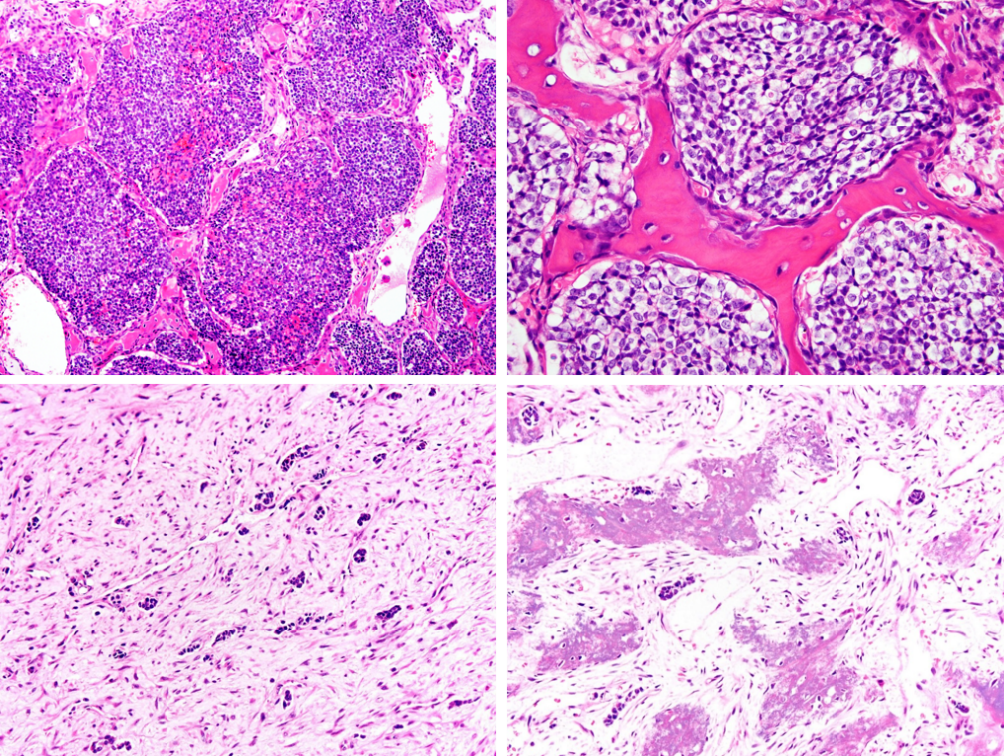
Positive IHC Negative IHC
CD99 (strong, membranous) NUT-1
AE1/AE3 WT1
CK 5/6 Synaptophysin
P63 Chromogranin
FLI-1 EMA
Vimentin
P16
SMA
Caldesmon
Desmin

Discussion:

Our differential diagnoses centered primarily on small round blue cell tumors of the head and neck region.

Sinonasal undifferentiated carcinoma (SNUC) is composed of small to medium-sized polygonal cells, which tend to form nests, sheets, and trabeculae. Tumor permeation of blood vessels, with tumor filling and distending the vascular lumina, is extensive and often a distinguishing feature. SNUC is positive for cytokeratin and/or EMA.

NUT midline carcinoma is composed of monotonous small to medium-sized basaloid cells set within a desmoplastic stroma. These tumors frequently show foci of frank squamous differentiation. They characteristically have a chromosomal rearrangement of the NUT gene on chromosome 15.

Olfactory neuroblastoma is an uncommon neoplasm derived from the olfactory neuroepithelium. It is composed of nests of monomorphic medium-sized rounded cells that show neuroendocrine features set in a fibrillary background. The cells are bordered by a complete or discontinuous layer of slender S100-positive sustentacular cells.

Myoepithelial carcinoma shows a range of histologic patterns. They are composed of monotonous epithelioid cells set in a myxoid and/or hyaline extracellular matrix in varying proportions. These tumors are positive for cytokeratin, SMA, GFAP, CD10, and calponin.

The striking cytologic monotony of the tumor cells, along with the strong membranous positivity for CD99, prompted further investigation of the tumor with FISH assay. This was positive for EWSR1-FLI1 gene rearrangement. Taken together with the areas of epithelial differentiation, the tumor was classified as an adamantinoma-like Ewing sarcoma.

The Ewing sarcoma family of tumors (EFT) is a group of neoplasms defined by recurrent EWSR1-EWS related gene fusions. Approximately 5% of EFTs involve the head and neck, where its histologic appearance overlaps with other small round blue cell tumors commonly occurring at this site. Precise tumor classification is crucial, as EFT is typically treated with specific chemotherapy protocols that may differ from the therapeutic regimens of other head and neck malignancies.

The adamantinoma-like variant of Ewing sarcoma has most commonly been reported in the long bones or surrounding soft tissues, with rare case reports of adamantinoma-like EFT in the head and neck. These generally affect younger patients and have been reported in the sinonasal tract, parotid gland, thyroid gland, and orbit. This variant shows complex epithelial differentiation, exhibiting histologic evidence of squamous differentiation.

IHC shows strong membranous immunoreactivity for CD99, with positivity for cytokeratin (20-30% of cases), p40, and high molecular weight keratin. When present, expression of synaptophysin in the setting of absent or focal chromogranin and diffuse p40 positivity is an unusual staining pattern that should raise suspicion for an adamantinoma-like Ewing sarcoma. For definitive diagnosis, demonstration of the EWSR1-FLI1 gene rearrangement is necessary.

Treatment consists of surgical excision, radiation, and chemotherapy. Secondary to the small number of reported cases of the adamantinoma-like variant of Ewing sarcoma in the head and neck region, the prognosis can be quite variable.

Our patient remains stable two months following surgical resection and is currently undergoing further treatment with chemotherapy and radiation.

Take Home Messages:

- The morphology of Ewing. sarcoma can overlap with many other small round blue cell tumors in the head and neck region
- Striking cytologic monotony and CD99 positivity should prompt consideration of diagnosis of Ewing sarcoma family of tumors.
- Tumors showing frank epithelial differentiation in setting of CD99 positivity should be sent for genetic studies for evaluation of EWSR1 gene rearrangement.
- Precise tumor classification is critical for appropriate neoadjuvant therapy.

References:
Abbas, A. Poorly differentiated sinonasal tract malignancies: A review focusing on recently described entities. Cesk Patol. 2016; 52:146-53.
Gorelick J, Ross D, Marentette L, et al. Sinonasal undifferentiated carcinoma: case series and review of the literature. Neurosurgery 2000; 47:750-4.
Edgar M, Caruso AM, Kim E, Foss RD. Nut midline carcinoma of the nasal cavity. Head and Neck Pathology (2016). Doi:10.1007/s12105-016-0763-0.
Haerle SK, Gullane PJ, Witterick IJ, Gentili F. Sinonasal carcinomas: epidemiology, pathology, and management. Neurosurg Clin N Am. 2014; 24:39-49.
Pinto A, Dickman P, Parham D. Pathobiologic Markers of the Ewing Sarcoma Family of Tumors: State of the Art and Prediction of Behavior. Sarcoma. 2011; Article ID 856190, 15 pages.
Petersson F, Chao SS, Ng SB. Anaplastic myoepithelial carcinoma of the sinonasal tract: an under recognized salivary-type tumor among the sinonasal small round blue cell malignancies? Report of one case and a review of the literature. Head Neck Pathol. 2011; 2:144-153.
Bishop JA, Alaggio R, Zhang L, Seethala RR, Antonescu CR. Adamantinoma-like Ewing family tumors of the head and neck: A pitfall in the differential diagnosis of basaloid and myoepithelial carcinomas. Am J Surg Pathol. 2015; 39:1267-1274.

Case 3:
Presenter: Ryan Jones MD, PhD, PGY II
Attendings: Guang-Yu Yang, MD, PhD, Sambasiva Rao, MD
Clinical History: The patient is a 50 year-old female with an unremarkable past medical history. She is HIV-negative. She presented with slightly painful vaginal ulcers with discharge which resolved following treatment with an anti-fungal cream. Two months later she developed constitutional symptoms including general malaise. Liver enzymes were elevated and an ultrasound and MRI showed multiple lesions in the right and left hepatic lobes ranging in size from 1.0 to 2.4 cm. At this time the patient also developed a non-painful non-pruritic rash on her trunk consisting of small round patches with central clearing. A skin biopsy was unrevealing. A liver biopsy of one of the lesions was performed.
Final Diagnosis: Inflammatory psuedotumor due to late secondary syphilis.
Differential diagnosis:
- Inflammatory psuedotumor
  - Bacterial (bartonella, mycobacterium, treponema, rickettsia)
  - Fungal infection (cryptococcus, aspergillus)
  - IgG4-related autoimmune hepatitis
- Inflammatory myofibroblastic tumor
- Inflammatory angiomyolipoma
- Follicular dendritic cell tumor
Histologic findings: The liver biopsy showed a mixed inflammatory infiltrate with abundant plasma cells and neutrophils, with necrosis and focal areas of fibrosis. The background liver adjacent to the mass showed non-specific portal inflammation.
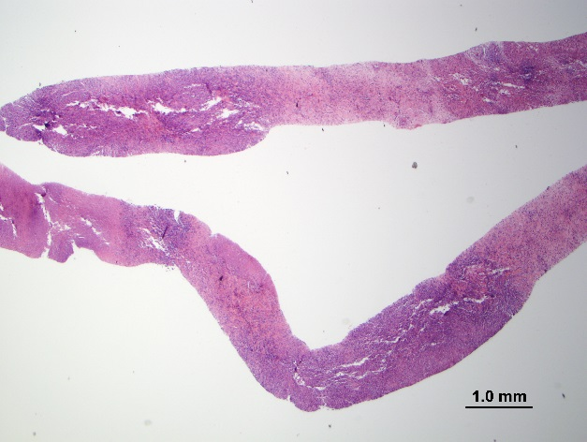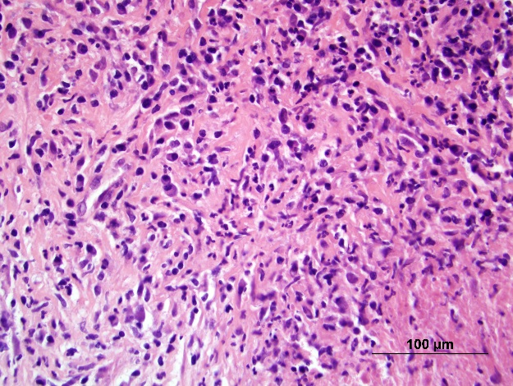

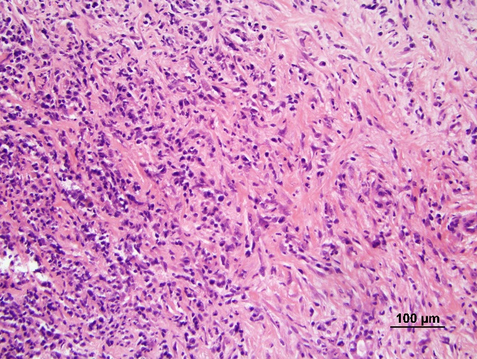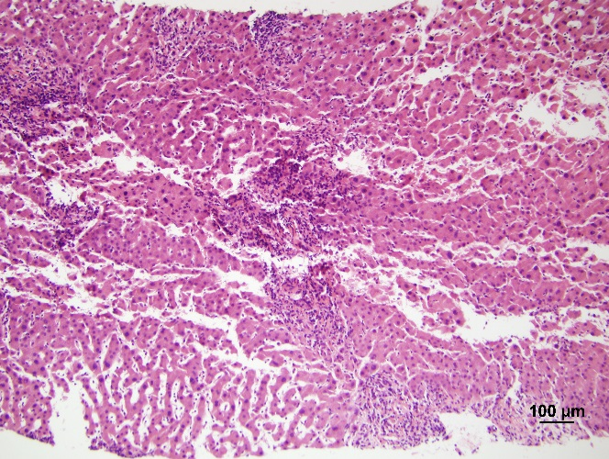
Positive stains:
- Treponema Pallidum immunostain
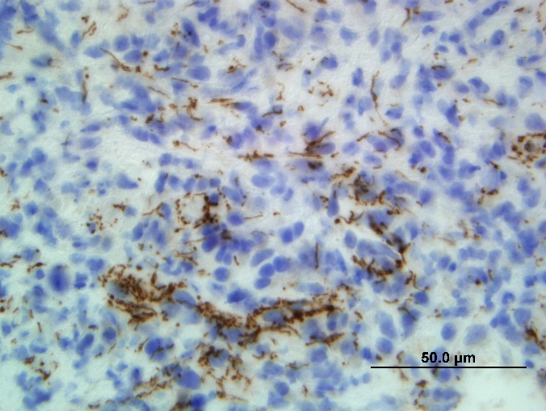
Negative stains:
- ALK
- Gram
- Warthin-starry
- Fite
- GMS
- PAS
- IgG4 – stained few scattered plasma cells
Discussion:
Mass lesions in the liver with abundant inflammatory infiltrates can be due to a number of etiologies. Neoplastic, infectious, as well as autoimmune causes should be considered as there can be a significant overlap of histologic features.
In our case, a liver biopsy was performed with showed a plasma cell rich inflammatory infiltrate with foci of necrosis and fibrosis. Therefore inflammatory pseudotumor was first on our differential, however we sought to rule out a possible neoplastic disorder such as inflammatory myofibroblastic tumor, inflammatory angiomyolipoma, and follicular dendritic cell tumor.
Inflammatory myofibroblastic tumors consist of myofibroblastic mesenchymal spindle cells with a plasma cell-rich inflammatory infiltrate. Morphologic variants include: nodular fasciitis like, compact spindle cell type, and fibrous type. ALK1 is positive in 75-89%, our case is negative.
Inflammatory angiomyolipomas are mesenchymal tumors in the PEComa family. These typically consist of mature adipose tissue, smooth muscle cells, and thick-walled vessels with an inflammatory infiltrate which can occasionally be the predominant feature. These can resemble inflammatory pseudotumors and inflammatory myofibroblastic tumors. These tumors typically stain with smooth muscle and melanocytic markers.
Follicular dendritic cell tumors are characteristically solitary fleshy lesions which are well-demarcated from the surrounding liver. They contain spindle to ovoid tumor cells with a lymphoid or plasma cell infiltrate. One variant is inflammatory pseudotumor-like. These tumors have an association with EBV, and are typically positive for CD21 and CD35.
Inflammatory pseudotumors are mass-like lesions which can be found in several organs. This is a broad category which can include bacterial infections, fungal infections, and IgG4-related autoimmune hepatitis. IgG4-related autoimmune hepatitis is a lymphoplasmacytic inflammation enriched in IgG4-positive plasma cells which create a tumor-like swelling with a variable degree of fibrosis. Our case showed very few IgG4-positive plasma cells.
In our case, several special histochemical stains were performed in hopes of finding a fungal or bacterial etiology for this inflammatory pseudotumor. Unfortunately all of these stains were negative. In light of the patient’s concurrent vaginal and dermatologic lesions an immunohistochemical stain for Treponema pallidum was performed and highlighted numerous organisms. Thus our diagnosis was inflammatory pseudotumor due to late secondary syphilis.
Syphilis is a sexually transmitted infection caused by Treponema pallidum, a bacterium in the spirochete family. These organisms are too slender to be observed by direct light microscopy, however darkfield microscopy can highlight these bacteria. Syphilis infections can be subdivided into early (primary and secondary) and late (tertiary). Primary syphilis is characterized by a chancre at the site of inoculation which is usually painless, and caused by a local immune reaction. The mean incubation time is 21 days following inoculation, and typically heal spontaneously after 4-6 weeks. Secondary syphilis occurs due to dissemination of the bacteria weeks to months after infection in a subset (~25%) of patients. Clinically patients will often have palmar and plantar rashes, lymphadenopathy and systemic symptoms. This stage usually resolves spontaneously, even in the absence of treatment. Tertiary syphilis occurs following years after infection (1-30 years), and may present with cardiovascular, neurologic, or gummatous symptoms. Symptoms of tertiary syphilis are highly variable, and definitive diagnosis relies on the demonstration of the organism within the lesions or tissues.
The liver can be involved in syphilis during either the secondary stage (syphilitic hepatitis), or during the tertiary stage (gumma). Syphilitic hepatitis affects 20-40% of HIV-positive patients, but is rare in HIV-negative hosts (as in this case). Clinical features include constitutional symptoms, jaundice, and elevated serum alkaline phosphatase. Histologic findings include granulomas, pericholangitis, non-specific portal inflammation, and focal perivenular necrosis. Mass lesions due to secondary syphilis are very rare, but can be seen (as in our case). Gummatous lesions of tertiary syphilis contain abundant fibrosis with or without granulomatous inflammation, central necrosis, and endarteritis. Demonstration of organisms in gumma lesions is rare, but if found are extremely helpful in diagnosis. The healing of gummatous lesions may lead to fibrous scars with extreme examples resulting in hepar lobatum.
Our patient was treated for syphilis with a course of penicillin and had near complete resolution of her symptoms and hepatic lesions.
References:
Gleason BC, Hornick JL. Inflammatory myofibroblastic tumours: where are we now? J Clin Pathol. 2008 Apr;61(4):428-37. Epub 2007 Oct 15.
Abbas Agaimy, Bruno Märkl. Inflammatory angiomyolipoma of the liver: an unusual case suggesting relationship to IgG4-related pseudotumor. Int J Clin Exp Pathol. 2013; 6(4): 771–779.
LM Lai et al. Shedding light on inflammatory pseudotumor in children: spotlight on inflammatory myofibroblastic tumor. Pediatr Radiol (2015) 45: 1738.
Odze and Goldblum Surgical Pathology of the GI Tract, Liver, Biliary Tract and Pancreas, Chapter 46, 1228-1261.e4
Sternberg’s diagnostic surgical pathology. Editor, Stacey E. Mills. Sixth edition.
Solari PR, Jones C, Wallace MR. Hepatic Lesions with Secondary Syphilis in an HIV-Infected Patient. Case Rep Med. 2014

Case 4:
Presenter: Maria Cristina Isales, MD, PGYII
Attendings: Ajit Paintal, MD
Sambasiva Rao, MD
Clinical History: The patient is a 40 year old male presenting with shortness of breath and hemoptysis. He has a 10 pack year history of smoking. Five year prior, he underwent surgical excision of a foot lesion. A chest CT performed at Northwestern Memorial Hospital revealed multiple nodules in bilateral lungs. During this workup, a 2.4 cm left thyroid nodule was identified and a total thyroidectomy was performed.
Final diagnosis: Metastatic malignant glomus tumor.
Differential diagnosis:
Poorly differentiated thyroid carcinoma
Anaplastic thyroid carcinoma
Medullary thyroid carcinoma
Malignant myopericytoma
Leiomyosarcoma
Malignant PEComa
Malignant glomus tumor
Histology:
On low power, there is a well circumscribed nodule composed of sheets and solid nests of spindle to epithelioid shaped cells with intervening slit-like, branching vessels, or hemangiopericytoma-like vasculature. Extensive areas of necrosis are identified throughout the specimen. Vascular invasion is identified. Higher magnification reveals small to large cells with indistinct cell borders and round to oval nuclei, a variable chromatin pattern including cells with vesicular to clumped chromatin, prominent nucleoli, and brisk mitotic activity.
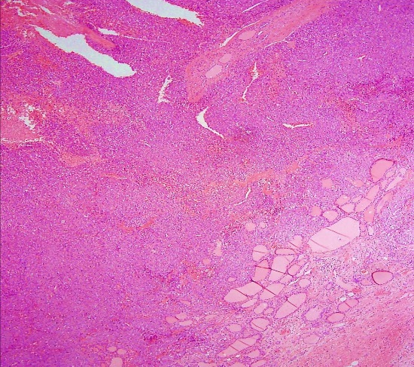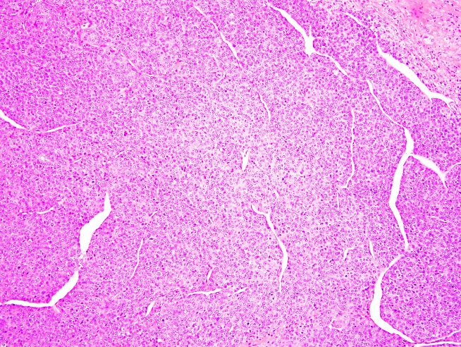

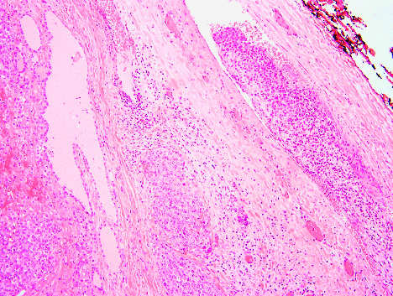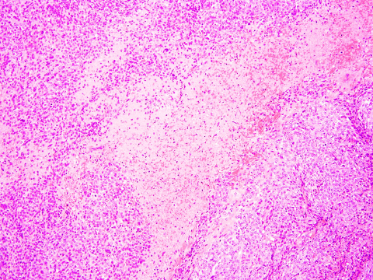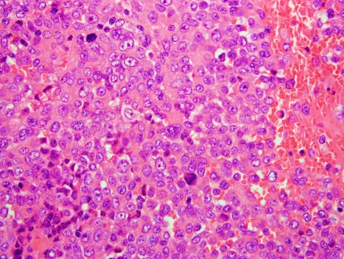

Immunostains:
Antibody | Reactivity
SMA | Positive (95%)
Vimentin | Positive
Collagen type IV | Positive
Laminin | Positive
CD99 | Positive (70%)
CD34 | Positive (32%)

Antibody | Reactivity
Desmin | Negative
Keratin | Negative
S100 | Negative
Synaptophysin | Negative
Chromogranin | Negative
CD31 | Negative

Discussion:
Glomus tumors were first reported in 1812; however, the histology was first described by Masson in 1924. These tumors account for 2% of all soft tissue tumors and are a part of the pericytic family of neoplasms, which includes myofibroma, myoperictyoma and angioleiomyoma. The glomus body is a contractile neuromyoarterial structure responsible for adjusting the blood pressure and temperature of the cutis by regulating blood flow. The location of the tumors is believed to be related to the presence of glomus bodies but perivascular smooth muscle cells may also be able to differentiate into glomoid cells. Clinically, these lesions present as painful, thermosensitive nodules. The most common location is in the subungual region, but they may also occur in deep seated visceral locations, such as the lung, pancreas, stomach, liver, gastrointestinal and genitourinary tracts. The female to male ratio is 3:2, and the mean age of diagnosis is 42 years. 10% of glomus tumors are multiple; however, a smaller percentage of these are familial. The familial variant is associated with the glomulin mutation at 1p22.1. Histologic examination of a glomus tumor demonstrates a perivascular proliferation of homogeneous cells with round to ovoid nuclei around blood vessels within a myxoid matrix. Immunohistochemical stains are positive for SMA, vimentin, collagen type IV, and laminin. Desmin, keratin, S100, synaptophysin, chromogranin, and CD31 are often negative.
Malignant glomus tumors were first reported in 1972, but there are limited case reports of malignant transformation. A malignant glomus tumor may arise from a preexisting benign glomus or de novo. The histology of a de novo malignant glomus tumor is different from that of a preexisting benign glomus with malignant transformation. The histologic appearance of a de novo malignant glomus tumor consists of spindled malignant cells in short fascicles. An overexpression of Bcl-2 and inactivation of p53 may contribute to malignancy. The criteria for malignancy were first established in 2001 and revised in the updated World Health Organization (WHO) classification in 2013. A malignant glomus tumor must: 1) demonstrate marked atypia with mitotic activity or 2) have atypical mitotic figures. A glomus tumor of uncertain malignant potential does not fulfill the criteria for malignancy but has one atypical feature in addition to nuclear pleomorphism. The criteria of a glomus tumor of uncertain malignant potential is: 1) superficial location with mitotic activity or 2) a large size (>2 cm) and/or deep location. 38% of cases fulfilling malignant criteria develop metastases. Metastasis and death can occur in up to 40% of malignant glomus tumors. While there is no standardized treatment for malignant glomus tumors, they should be considered as high-grade sarcomas with regard to management and patients should be followed closely.
References:
- Chung DH, Kim NR, Kim T, Lee S, Lee YD, Cho HY. Malignant glomus tumor of the thyroid gland where is heretofore an unreported organ: a case report and literature review. Endocr Pathol. 2015; 26(1): 37-44.
- Chou T, Pan SC, Shieh SJ et al. Glomus tumor: Twenty year experience and literature review. Annals of plastic Surgery. 2016; 76(1): S35-40.
- Folpe AL, Fanburg-Smith JC, Miettinen M, Weiss SW. Atypical and malignant glomus tumors: Analysis of 52 cases with a proposal for the reclassification of glomus tumors. Am J Surg Pathol. 2001; 25(1): 1012.
- Mravic M et al. Clinical and histopathological diagnosis of glomus tumor: an institutional experience of 138 cases. Int J Surg Pathol. 2015; 23(3): 181-88.
- Zoltan Gombos and Paul J. Zhang (2008) Glomus Tumor. Archives of Pathology & Laboratory Medicine: September 2008, Vol. 132, No. 9, pp. 1448-1452.
- Masson P. Le glomus neuromyoarteriel des regions tactiles et ses tumeurs. Lyon Chir 1924;21:257-80.

Case 5 (Brannan Griffin): Treated Giant Cell Tumor of Bone
Clinical history: The patient is 53 year-old female who presented with right hip and groin pain. X-ray imaging showed a mass with lobulation and a narrow transition between lesion and normal bone. CT imaging showed a 7 cm relatively homogenous, destructive lesion within the right sacrum invading the neural foramina. IR core-needle biopsy was performed and followed by chemotherapy for approximately 1 year. Interval MRI imaging studies showed recurrence of a mildly expansile, heterogeneous, contrast-enhancing mass that did not change significantly in size. No other suspicious osseous lesions were appreciated. At this time, the patient underwent intralesional debulking of her tumor with right partial sacrectomy.

Gross and histologic findings:
Debulking showed multiple fragments of pink-tan rubbery and boney tissue with no overt abnormalities. Histologic sections show a proliferation of woven bone as thick, irregular anastomosing trabeculae. Portions of the woven bone showed foci of cartilaginous differentiation. Intervening fibrovascular stroma was predominantly hypocellular but showed foci of increased cellularity with bland, spindled mononuclear cells. Native compact bone was also present and necrotic.
Differential Diagnosis:
- Fibrous dysplasia: Although fibrous dysplasia can occur in any bone, it most commonly affects craniofacial bones and the femur. The entity radiographically shows a geographic lesion with internal ground-glass matrix that is non-aggressive and thus does not disrupt the bone cortex. Cysts and cartilage formation may also be present. “Shepherd-crook” deformity is highly diagnostic when identified in the proximal femur. Microscopically, the entity shows varying portions of fibrous and osseous tissue. The fibrous component consists of bland fibroblastic cells with occasional vascularity. The osseous component consists of irregular, curvilinear trabeculae of woven bone with focal benign cartilage. Cementum-like bone and aneurysmal bone cyst-like features containing multinucleated giant cells and foamy histiocytes have also been reported. In comparison, imaging studies of our patient’s initial lesion and this entity are indistinct. The woven bone trabeculae present on histologic sections resembled fibrous dysplasia but the lack of a significant fibrous component precluded this diagnosis.
- Osteoblastoma: Osteoblastoma normally occurs in the posterior elements of the spine and sacrum and measures >2 cm. Radiographically, this entity shows a well-demarcated lytic, round-oval defect that often contains a periosteal shell of reactive bone and an internal component of calcification. Microscopically, the tumor consists of irregular trabeculae of woven bone lined by a single layer of appositionally placed osteoblasts. Intervening stroma is prominently vascular and often shows extravasated red blood cells. Scattered multinucleated giant cells and extraordinary hyaline cartilage may be present. In comparison, the location of the lesion and the paucicellular stroma with vascularity and woven bone trabeculae present on histologic sections all resembled osteoblastoma but the lack of an overt osteoblastic component precluded this diagnosis.
- Low-grade central osteosarcoma: In regards to all osteosarcomas, the frequency of low-grade central type is 1-2% and most tumors (80%) occur within medullary cavities of long bones. This entity on imaging usually shows a large, lytic lesion with coarse trabeculation and focally aggressive features. Some element of cortical disruption is often present. Microscopically, the tumor consists of both hypo- to moderately cellular areas of fibroblastic proliferation as fascicles or interlacing bundles. Spindled cells show minimal nuclear atypia and relatively few mitoses. Interestingly, bone production in this entity varies. The bone present is more often lamellar-like but can show an irregular branching and anastomosing pattern simulating woven bone. Foci of atypical cartilage can be seen, and benign multinucleated giant cells occur in 36% of cases. Immunohistochemical stains can aid in the diagnosis since low-grade central osteosarcomas are positive for MDM2 and CDK4 (protein expression), whereas similar-appearing benign fibro-osseous lesions are negative. In comparison, the woven bone trabeculae present on histologic sections resembled this entity but the lack of a monotonous spindled cell component precluded this diagnosis. Low-grade central osteosarcoma also exhibits entrapment of native bone due to its infiltrative nature. This behavior was not readily identified in the native compact bone present in this case.
Summary:
Denosumab chemotherapy produces significant histologic changes in treatment of giant cell tumors (GCT) of the bone. These changes vary over the course of treatment and create a diagnostic dilemma, especially in instances when an established history is unclear.
Denosumab is a human monoclonal antibody which neutralizes receptor of nuclear factor kβ ligand (RANKL). Stromal malignant cells in GCT produce RANKL colony stimulating factor (M-CSF) which induce monocyte recruitment and proliferation, as well as expression of RANK. Further stimulation by RANKL, induces monocyte fusion and giant cell transformation leading to the destructive nature of GCT via bone resorption. It is well documented that denosumab inhibits the proliferation and destructive process of this entity; however, the status of its influence on malignant stromal cells is unknown.
Histologic changes identified in a case series of denosumab-treated GCTs showed a decrease in presence of giant cells leading to a predominance of spindled mononuclear cells. Also, an increased amount of woven bone formation and fibrous tissue was identified. Histologic changes were further subdivided and appreciated to be different based on length of denosumab therapy. Early changes noted (defined as 2-8 months) included marked tumor cellularity in sheet-like and storiform patterns. Mononculear cells present contained hyperchromatic and vesicular nuclei with moderate pleomorphism. In the background was a pronounced mixed inflammatory infiltrate including foamy histiocytes. The early treated tumors also contained a peripheral shell of reactive woven bone with prominent osteoblastic rimming and varying degrees of new bone deposition. Mimicking entities with similar microscopic findings include high-grade osteosarcoma, malignant transformation of GCT, and nonossifying fibroma.
Moreover, extended changes noted (19-55 months) included decreased tumor cellularity with a loose fibrovascular stroma. Stromal cells present consisted of spindled mononuclear cells with bland nuclear features and varyingly foamy histiocytes. The dominant histology in lesions within this category was trabeculae of newly-formed woven bone. Bone trabeculae over time showed irregular branching and anastomosis with thickening. Mimicking entities with similar microscopic findings include low-grade osteosarcoma (central type), fibrous dysplasia, and osteoblastoma.

References:
- Fletcher, C et al. 2013. WHO Classification of Tumours of Soft Tissue and Bone. 4th Ed. Lyon, France: International Agency for Research on Cancer.
- Yamagashi, T et al. 2016. Disappearance of giant cells and presence of newly formed bone in the pulmonary metastasis of a sacral giant-cell tumor following denosumab treatment: A case report. Oncology Letters, 11: 243-246.
- Wojcik, J et al. 2016. Denosumab-treated Giant Cell Tumor of Bone Exhibits Morphologic Overlap with Malignant Giant Cell Tumor of Bone. American Journal of Surgical Pathology, 40: 1.
- Kawai, M et al. 2011. Emerging therapeutic opportunities for skeletal restoration. Nature Reviews Drug Discovery, 10: 141-156.
- Singh, AS et al. 2015. Giant-cell tumor of bone: treatment options and role of denosumab. Biologics, 9: 69-74.

Case 6 (Nina Rahimi): Malignant PEComa with TFE3 Mutation
- Clinical history: A 66-year-old female, with no significant past medical history, presented with epigastric pain, nausea for 1 week, and early satiety. An ultrasound performed to look for possible biliary pathology revealed an abdominal mass. Further characterization of the mass by an abdominal MRI revealed an 8.2 x 7 x 6.5 cm mass in the mesentery adjacent to multiple loops of small bowel, with a radiologic differential diagnosis given as gastrointestinal stromal tumor, desmoid tumor, or hemangioma. An exploratory laparotomy was performed to excise the peritoneal mass.
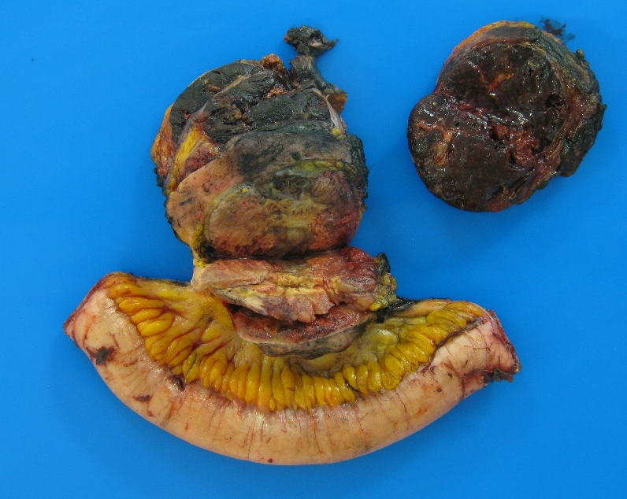
Gross and histologic findings:
Segment of uninvolved small bowel with attached mesenteric fat. Within the mesentery there is a well circumscribed yellow-tan mass, with areas of hemorrhage and focal areas of necrosis.
Histologic sections show an alveolar pattern with areas of hemorrhage and necrosis, and fine vasculature. Neoplastic cells appear epithelioid with clear to eosinophilic cytoplasm and show a high mitotic count (2-6 mitosis/hpf).
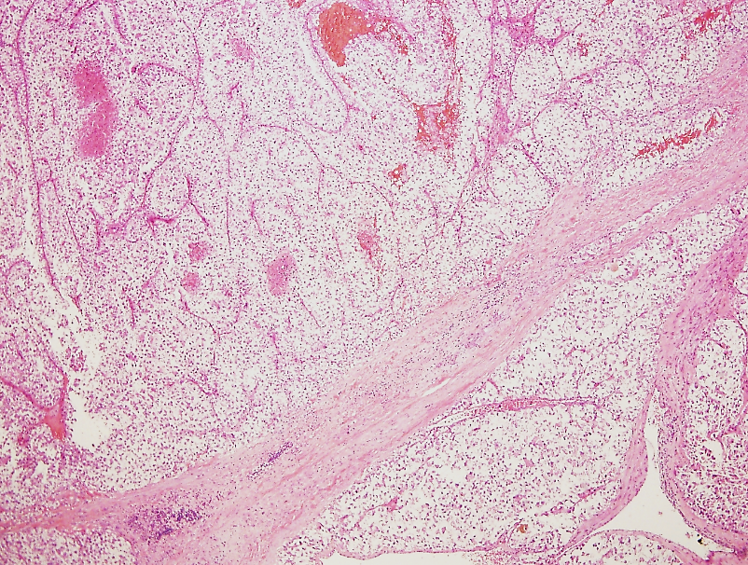
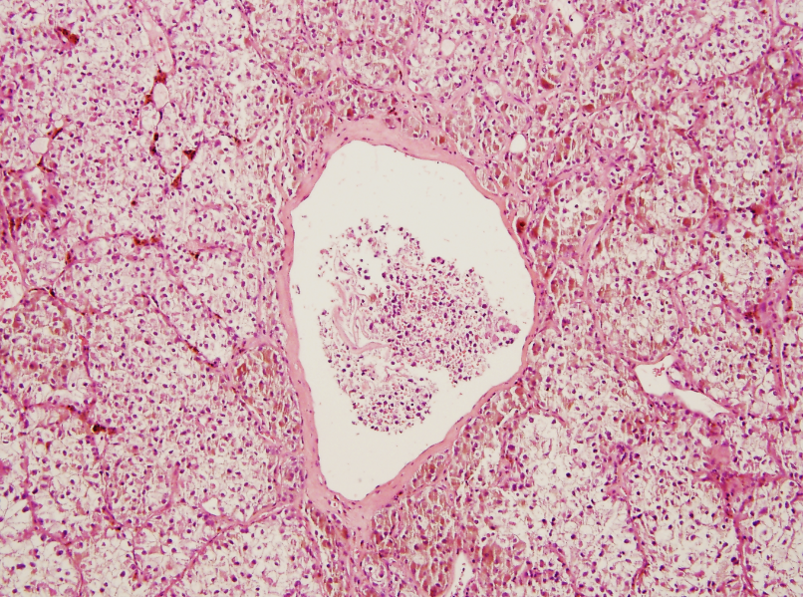

Immunohistochemistry:
Stain | Result
HMB45 | Positive
TFE3 | Positive
HepPar-1 | Negative
Inhibin | Negative
Cytokeratin 7 | Negative
CD10 | Negative
PAX-8 | Negative
CA-IX | Negative
AMACR | Negative
S100 | Negative
CD117 | Negative
Calretinin | Negative

Final Diagnosis: Malignant PEComa with TFE3 translocation
Differential Diagnosis: Tumors with TFE3 rearrangements
Xp11.2 translocation RCC
Alveolar soft part sarcoma
PEComa
Subset of epithelioid hemangioendothelioma

- Xp11.2 translocation RCC: The histologic appearance is variable, but classically shows mixed papillary and nested/alveolar architecture. Neoplastic cells have clear to eosinophilic, granular, voluminous cytoplasm with discrete borders, vesicular chromatin, prominent nucleoli, and the presence of extensive psammoma bodies. Distinct subtype of RCC that usually affects children and adolescents. Xp11.2 translocation RCC results from gene fusions between the TFE3 gene located on chromosome Xp11.2 and various partners. The ASPL-TFE3 gene fusion (Xp11.2, 17q25) is equivalent to the gene fusion seen in alveolar soft part sarcoma.
- Alveolar Soft Part Sarcoma: The histologic appearance shows large, round-to-polygonal cells containing eosinophilic, granular, or vacuolated cytoplasm plus one or more vesicular nuclei usually with a psuedoalveolar appearance because of the formation of distinct nests with central necrosis or loss of cohesion divided by fibrovascular septa. Also seen are intracytoplasmic crystalloid inclusions which are positive for periodic acid–Schiff. These tumors are mesenchymal in origin with a wide variation in the onset age and location. They harbor a mutation in t(X;17)(p11.2;q25). Although they are rare and slow growing tumors with a prolonged survival, the long term disease-specific mortality is high because of distant metastasis years after initial diagnosis. IHC is positive for TFE-3 and Desmin, and negative for HMB45 and Melan A.
Discussion:
- Perivascular epithelioid cell tumors (PEComas) are mesenchymal tumors with perivascular clear cell and epithelioid features that coexpress melanocytic and myoid markers. They predominantly affect females at a median age of 46 years. Morphologic variants of PEComas include angiomyolipoma, clear cell sugar tumor, lymphangioleiomyoma, and myomelanocytic tumors. Features of malignant PEComas include: size >5 cm , an infiltrative growth pattern, high nuclear grade, >1 mitosis / 50 HPF, necrosis, and vascular invasion. PEComas can be designated as follows: benign with none of the above listed worrisome features; uncertain malignant potential with either nuclear pleomorphism/multinucleated giant cells or size >5cm only; or malignant with two or more worrisome features. In a study from Agaram et al. two main pathways of genetic alteration have been shown in the development of PEComas including deletions and loss of function of tuberous sclerosis genes (TSC1 and TSC2) and translocations of transcription factor E3 (TFE3). These pathways are mutually exclusive.
References:
- Agaram, N. P., Y.-S. Sung, L. Zhang, C.-L. Chen, H.-W. Chen, S. Singer, M. A. Dickson, M. F. Berger and C. R. Antonescu (2015). "Dichotomy of Genetic Abnormalities in PEComas With Therapeutic Implications." The American Journal of Surgical Pathology 39(6): 813-825.
- Argani, P., S. Aulmann, P. B. Illei, G. J. Netto, J. Ro, H.-y. Cho, S. Dogan, M. Ladanyi, G. Martignoni, J. R. Goldblum and S. W. Weiss (2010). "A Distinctive Subset of PEComas Harbors TFE3 Gene Fusions." The American Journal of Surgical Pathology 34(10): 1395-1406.
- Argani, P., S. Aulmann, Z. Karanjawala, R. B. Fraser, M. Ladanyi and M. M. Rodriguez (2009). "Melanotic Xp11 Translocation Renal Cancers: A Distinctive Neoplasm With Overlapping Features of PEComa, Carcinoma, and Melanoma." The American Journal of Surgical Pathology 33(4): 609-619.
- Armah, H. B. and A. V. Parwani (2010). "Xp11.2 Translocation Renal Cell Carcinoma." Archives of Pathology & Laboratory Medicine 134(1): 124-129.
- Dickson, B. C., J. S. Brooks, T. L. Pasha and P. J. Zhang (2011). "TFE3 expression in tumors of the microphthalmia-associated transcription factor (MiTF) family." Int J Surg Pathol 19(1): 26-30.
- Flucke, U., R. J. Vogels, N. de Saint Aubain Somerhausen, D. H. Creytens, R. G. Riedl, J. M. van Gorp, A. N. Milne, C. J. Huysentruyt, M. A. Verdijk, M. M. van Asseldonk, A. J. Suurmeijer, J. Bras, G. Palmedo, P. J. Groenen and T. Mentzel (2014). "Epithelioid Hemangioendothelioma: clinicopathologic, immunhistochemical, and molecular genetic analysis of 39 cases." Diagn Pathol 9: 131.
- Folpe, A. L., T. Mentzel, H. A. Lehr, C. Fisher, B. L. Balzer and S. W. Weiss (2005). "Perivascular epithelioid cell neoplasms of soft tissue and gynecologic origin: a clinicopathologic study of 26 cases and review of the literature." Am J Surg Pathol 29(12): 1558-1575.
- Hodge, J. C., K. E. Pearce, X. Wang, A. E. Wiktor, A. M. Oliveira and P. T. Greipp (2014). "Molecular cytogenetic analysis for TFE3 rearrangement in Xp11.2 renal cell carcinoma and alveolar soft part sarcoma: validation and clinical experience with 75 cases." Mod Pathol 27(1): 113-127.
- Hornick, J. L. and C. D. Fletcher (2006). "PEComa: what do we know so far?" Histopathology 48(1): 75-82.
- Malinowska, I., D. J. Kwiatkowski, S. Weiss, G. Martignoni, G. Netto and P. Argani (2012). "Perivascular Epithelioid Cell Tumors (PEComas) Harboring TFE3 Gene Rearrangements Lack the TSC2 Alterations Characteristic of Conventional PEComas: Further Evidence for a Biological Distinction." The American Journal of Surgical Pathology 36(5): 783-784.
- Shen, Q., Q. Rao, Q.-Y. Xia, B. Yu, Q.-L. Shi, R.-S. Zhang and X.-J. Zhou (2014). "Perivascular epithelioid cell tumor (PEComa) with TFE3 gene rearrangement: Clinicopathological, immunohistochemical, and molecular features." Virchows Archiv 465(5): 607-613.
- Shon, W., J. Kim, W. Sukov and J. Reith (2016). "Malignant TFE3-rearranged perivascular epithelioid cell neoplasm (PEComa) presenting as a subcutaneous mass." British Journal of Dermatology 174(3): 617-620.

