IRAP 10/24/16

Illinois Registry of Anatomic Pathology

Case 1:
Presenter: Neelima Valluru MD, PGY II
Attendings: Mohammad Atieh DO

Clinical History: The patient is a 55 year old obese female with history of persistent anemia (since 2013), hyperlipidemia and occasional fatigue. She underwent colonoscopy, multiple endoscopies and EUS for workup of anemia. Colonoscopy showed hemorrhoids. Multiple EGD’s showed fungating mass and an endoscopic ultrasound revealed intramural mass predominantly arising from submucosa and deep mucosa. No malignant cells were identified on EUS guided FNA. The EGD biopsies were submitted for your review.
Final Diagnosis: Infiltrating, very-well differentiated adenocarcinoma, intestinal type, measuring 7.3cm in greatest dimension

Differential Diagnosis:
- Severe chronic active H. Pylori gastritis
- Inflamed hyperplastic polyp/Inflammatory type polyp
- MALT Lymphoma
- Signet ring cell carcinoma
- Gastrointestinal stromal tumor or other submucosal entities (given EUS findings)

Key Features:
Histological summary of multiple endoscopic biopsies:
- Acute and chronic inflammation
- Neutrophilic pit abscesses
- Intestinal metaplasia
- Prominent lymphoid infiltrates
- Prominent reactive glandular changes
- No overt features of malignancy are identified

Histology of excision specimen (subtotal gastrectomy):
For the most part, the tumor consists of a highly infiltrative adenocarcinoma composed predominantly of dilated and focally branching glands with large areas of intraluminal debris and a very-well differentiated lining (including the presence of goblet cells within infiltrating tumor gland epithelium). The characteristic archietectural features of the neoplastic glands include: Tortous glands, branching glands, anastomosing glands, cystically dilated glands with intraglandular necrotic debis, spiky glands and glands with intestinal metaplasia within the infiltrating tumor epithelium.
Additionally, tumor associated lymphoid hyperplasia and areas of microabscess formation are present (areas of gland rupture with associated histiocytic reaction are also seen). In most of the sections, the mucosa overlying the invasive tumor shows apparent chronic gastritis with intestinal metaplasia and no overtly identified superficial dysplasia, however, within this mucosa, the deeper basal glands are seen in multiple areas individually breaching the muscularis mucosa and invading the submucosa and beyond, and extending to the inked circumferential/serosal surface; rare areas of less well differentiated tumor glands with associated increased mucin production are noted in the deeper invasive component of the tumor. Immunostains were performed to further characterize the lesion. The tumor cells are positive for pankeratin (AE1/AE3), CK7, CK20, CDX2, CD10 and monoclonal CEA. The tumor is negative for EBER-ISH, Her-2-Neu (0-1+ staining), p53, GATA-3, PAX-8 and TTF-1. Overall, based on the staining profile and morphology of the tumor, the findings are most consistent with the so-called "very-well differentiated, intestinal type, form of gastric adenocarcinoma"

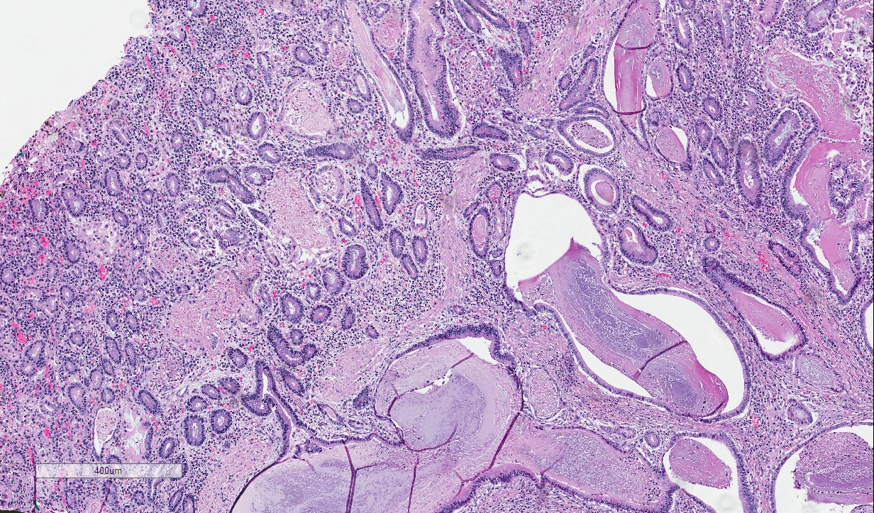

Review of Endoscopic Biopsies
Important diagnostic clues
-Cytoarchitectural features
-Intraglandular necrotic debris

Take home points:
- Rare tumor entity
- Diagnostically challenging on endoscopic biopsies
- Histological characteristics:
1) Highly differentiated glands
2) Low-grade/minimal nuclear atypia
3) Morphology mimics “intestinal metaplasia”

References:
1: Ushiku T, Arnason T, Ban S, Hishima T, Shimizu M, Fukayama M, Lauwers GY. Very well differentiated gastric carcinoma of intestinal type: analysis of diagnostic criteria. Mod Pathol. 2013 Dec;26(12):1620-31.
2: Okamoto N, Kawachi H, Yoshida T, Kitagaki K, Sekine M, Kojima K, Kawano T,Eishi Y. "Crawling-type" adenocarcinoma of the stomach: a distinct entity preceding poorly differentiated adenocarcinoma. Gastric Cancer. 2013Apr;16(2):220-32.
3: McFarland S, Manivel CJ, Ramaswamy A, Mesa H. Gastric-type extremely well-differentiated adenocarcinoma arising in the blind pouch of a bypassed stomach, presenting as colonic pseudo-obstruction. Ann Gastroenterol. 2015 Oct-Dec;28(4):499-501.
4: Joo M, Han SH. Gastric-Type Extremely Well-Differentiated Adenocarcinoma of the Stomach: A Challenge for Preoperative Diagnosis. J Pathol Transl Med. 2016 Jan;50(1):71-4.
5: Lee WA. Gastric extremely well differentiated adenocarcinoma of gastric phenotype: as a gastric counterpart of adenoma malignum of the uterine cervix. World J Surg Oncol. 2005 May 23;3:28.
6: Niimi C, Goto H, Ohmiya N, Niwa Y, Hayakawa T, Nagasaka T, Nakashima N. Usefulness of p53 and Ki-67 immunohistochemical analysis for preoperative diagnosis of extremely well-differentiated gastric adenocarcinoma. Am J Clin Pathol. 2002 Nov;118(5):683-92.

Case 2
Presenter: Bogdan Isaila MD, PGY III
Attending: Stefan E. Pambuccian MD

Clinical History:
A 53 year old woman presented with 1 year history of right parotid mass, tender and fluctuating in size. On physical exam it was estimated at about 3cm. Imaging studies showed a 2.7cm hypermetabolic soft tissue mass. Her oncologic history consists of an invasive ductal carcinoma of the breast with mucinous features, grade II, T3N0M0, ER/PR (+), HER2 (-)

Final Diagnosis: Acinic cell carcinoma with high-grade transformation ("dedifferentiated acinic cell carcinoma")

Differential Diagnosis:
-Metastasis from the patient's breast carcinoma
-Mammary analog secretory carcinoma
-Polymorphous low grade adenocarcinoma
-Salivary duct carcinoma
-Adenocarcinoma NOS
-Acinic cell carcinoma

Histology:
Neoplastic cells forming various architectural patterns: cords, ribbons, gland-like structures or solid sheets with areas of comedonecrosis, infiltration in adjacent salivary gland and areas of perineural and lymphovascular invasion. There is prominent cytologic atypia with large pleomorphic nuclei and numerous mitoses. There is no mucin formation.

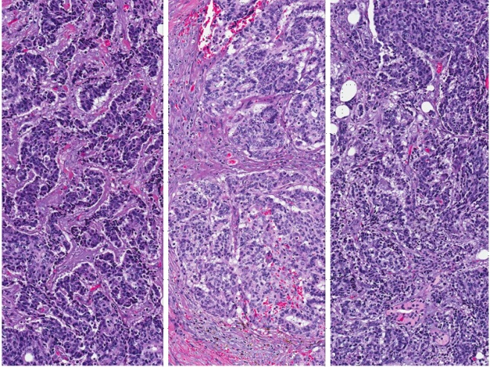
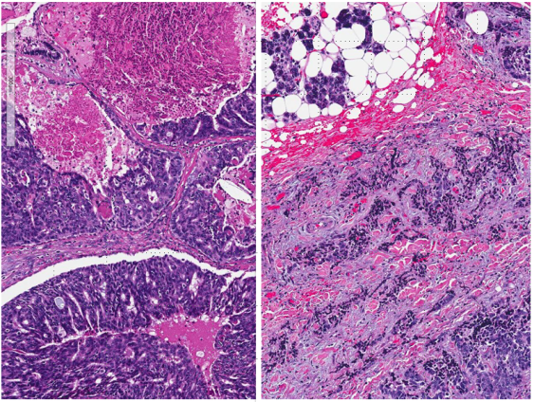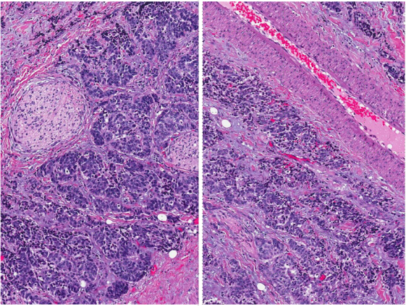

Positive IHC Negative IHC
Beta-catenin (membranous), diffuse, strong CK AE1/AE3
CK 8/18 ER
Cyclin D1, 60% AR
Ki67 diffuse, 90% S100
SOX10 P63
DOG1 Mammaglobin
P53 focal
GATA-3 weak, focal
CD117

Discussion:

Our first differential diagnosis consideration based on oncologic history was a metastasis from the patient's breast carcinoma. However histopathological features (absence of mucin, higher grade nuclei) and immunostaining profile (negative ER and equivocal, 2+, HER2) excluded a metastatic breast carcinoma.

Mammary analog secretory carcinoma (MASC) can have various architectural patterns (microcystic, solid, tubular) however lymphovascular, perineural invasion are rare, there is usually no necrosis and mitoses are rare. The cells are bland with vesicular nuclei and eosinophilic vacuolated cytoplasm. Mammaglobin, usually positive in MASC was negative in our case. S100(-) and SOX10 (+) were also opposite to the most common staining pattern encountered in MASC.

Polymorphous Low Grade Adenocarcinoma (PLGA) shows a triad of infiltrative growth, multiple architectural patterns and cellular uniformity. PLGA is frequently positive for p63 and S100. Our entity has a high grade architecture and was negative for p63 and S100.

Salivary duct carcinoma (SDC) was excluded based on the fact that is phenotypically ductal and virtually all cases are characterized by abundant eosinophilic granular cytoplasm and pleomorphic nuclei with prominent nucleoli. AR staining is positive in the majority of cases.

Adenocarcinoma not otherwise specified (NOS) is an exclusion diagnosis comprising high grade salivary gland tumors that cannot be included in any of the known specific salivary gland tumor.

Acinic cell carcinoma (AciCC) was included in the differential diagnosis, even though it usually shows large polygonal acinar cells with basophilic granular cytoplasm and intercalated duct type cells (eosinophilic to amphophilic cytoplasm). However, the positive immunostaining for DOG1 and SOX10 of our tumor (similar to what we would expect in acinic cell carcinoma) determined extensive additional sampling of our mass. One of the additional sections showed classical low grade acinic cell carcinoma architecture, with basophilic granular cytoplasm staining for PASD, confirming the diagnosis of an acinic cell carcinoma with high grade transformation.

High grade transformation in acinic cell carcinomas is a rare phenomenon, with no known etiologic factors and no correlation to prior radiation therapy. Tumors tend to be large (>3cm) and metastatic disease can be present at the time of diagnosis. The low grade component can be very limited in extent.

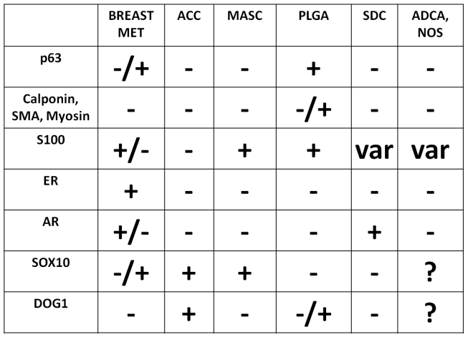

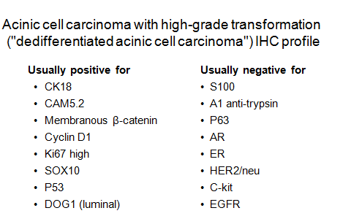

Immunohistochemistry is non specific. Cytokeratins are constantly positive; anti-amylase is negative in neoplastic cells and PASD, the only specific stain for acinic cell carcinomas, is negative in the areas of high grade transformation.

Novel markers are reinforcing the patterns of differentiation in AciCC. Discovered on gastrointestinal stromal tumor protein 1 (DOG1), also known as anoctamin-1/ANO1,is a chloride channel selectively expressed in the luminal plasmalemma of the acinar cells and intercalated ductal cells. It shows an admixture of apical membranous, cytoplasmic or partially membranous staining in normal acinar cells and acinic cell carcinoma.

SOX10 is a nuclear transcription factor critical for formation and differentiation of neural crest cells, variably expressed in the acinar and intercalated ductal cells.

Tumors with frequent and high SOX10 expression:
- Acinic cell carcinoma
- Adenoid cystic carcinoma
- Epithelial-myoepithelial carcinoma, myoepithelial carcinoma, and pleomorphic adenoma

Tumors with no SOX10 expression:
- Salivary duct carcinoma
- Mucoepidermoid carcinoma
- Squamous cell carcinoma
- Oncocytic carcinoma, oncocytoma, and Warthin tumor

For AciCC showing features of HGT, the treatment proposed is surgical resection followed by radiotherapy.

Take home messages:

- High grade transformation may occur in other salivary gland neoplasms (pleomorphic adenoma, mucoepidermoid carcinoma, polymorphous low grade adenocarcinoma, epithelial-myoepithelial carcinoma)
- The low grade component may be very limited in extent
- DOG1 and SOX10 are novel markers that reinforce the patterns of differentiation in AciCC
- Recognition is imperative as more aggressive clinical management is warranted

QUIZ:

The following statements are true about dedifferentiation in acinic cell carcinomas, except:

A. There are no known etiologic factors
B. There is no gender predilection
C. Prior radiation therapy increases the incidence
D. Most are already metastatic by the time of diagnosis
E. Tumors tend to be larger than 3cm

The immunoprofile of a parotid tumor is p63(-),S100 (+), ER (-), SOX10(+), Mammaglobin(+).
This profile most probably matches:

- A metastatic carcinoma from the breast
- An acinic cell carcinoma
- An acinic cell carcinoma with high grade transformation
- A mammary analog secretory carcinoma
- A salivary duct carcinoma

References:

Thompson LD, Aslam MN, Stall JN, Udager AM, Chiosea S, McHugh JB. Clinicopathologic and Immunophenotypic Characterization of 25 Cases of Acinic Cell Carcinoma with High-Grade Transformation. Head Neck Pathol. 2016 Jun;10

Skálová A, et al. Acinic cell carcinoma with high-grade transformation: a report of 9 cases with immunohistochemical study and analysis of TP53 and HER-2/neu genes. Am J Surg Pathol. 2009 Aug;33(8):1137-45

Ohtomo R, Mori T, Shibata S, Tsuta K, Maeshima AM, Akazawa C, et al. SOX10 is a novel marker of acinus and intercalated duct differentiation in salivary gland tumors: a clue to the histogenesis for tumor diagnosis. Mod Pathol. 2013;26:1041-50.

Williams L, Thompson LD, Seethala RR, Weinreb I, Assaad AM, Tuluc M, et al. Salivary duct carcinoma: the predominance of apocrine morphology, prevalence of histologic variants, and androgen receptor expression. Am J Surg Pathol. 2015;39:705-13.

Petersson, F. High-Grade Transformation (“Dedifferentiation”)-Malignant Progression of Salivary Gland Neoplasms, Including Carcinoma ex Pleomorphic Adenoma: A Review. Pathol Case Rev 2015; 20:27–37

Case 3
Presenter: Nicolas Lopez-Hisijos, DO, PGY3
Mentor: Kamran Mirza, MD, PhD

Clinical History:
A 51 year-old female with a history of paroxysmal atrial fibrillation, and recurrent skin rashes presented at a community hospital for worsening epigastric pain. As part of the work-up, a transthoracic echocardiogram (TTE) was performed that showed a significant drop in ejection fraction (EF) to 30%. A chest x-ray showed severe cardiomegaly and pulmonary congestion. A couple of days after admission, the patient collapsed while walking to the restroom due to cardiac arrest, requiring CPR and defibrillation. She was found to be on atrial fibrillation (A-fib) with rapid ventricular rate (RVR). After the code, the patient was intubated and transferred to Loyola University Medical Center (LUMC).
At LUMC, the patient’s arrhythmia was stabilized. She was found to have an elevated troponin (0.07 ng/ml). A stress MRI showed normal perfusion of the coronary arteries. A cardiac MRI showed evidence of myocardial edema, which raised the possibility of myocarditis. Of note, there was a left anterior descending (LAD) to left ventricle (LV) fistula, which was thought to be congenital and not the source of the patient’s symptoms. Also, the possibility of right sided heart failure seemed unlikely given a normal BNP and no symptoms of fluid overload. However, given the poor EF the patient was placed on inotropic medication. Blood cultures, urinalysis, and viral serologies were negative. At this point, in light of the patient’s medical history of recurrent skin rashes, which had previously been interpreted as vacuities, rheumatology was consulted. After extensive work-up, they were unable to find a source of autoimmune myocarditis. A skin biopsy was performed which showed lichenoid pigmented purpura, a benign process likely unrelated to her cardiac symptoms. After a week in the hospital, the patient was discharged with an implanted cardioverter defibrillator.
After discharge, the patient’s condition remained fair for a couple of months with intermittent palpitations and occasional shortness of breath. Due to a prolonged QT interval, her options for anti-arrhythmic drugs were limited and the possibility of ablation was discussed. Three months after the initial presentation the patient required emergency ablation. After four months she presented at an outside hospital with worsening shortness of breath and epigastric abdominal pain. At this point her EF had dropped to 20%. Given the worsening cardiac symptoms without a clear etiology, a myocardial biopsy was performed which was read as “endo-myocardial tissue with interstitial lymphocytic infiltrate with scattered eosinophils, consistent with myocarditis.” Fungal, parasitic, and viral stains were performed which were negative. RT PCR for cardiotropic viruses such as CMV were negative. Electron microscopy studies did not show viral inclusions or parasites and no deposits were seen. A clinical diagnosis of myocarditis was made based on the edema seen on imaging coupled with the lymphocytic infiltration seen in the biopsy. However, the etiology remained unclear.
After the biopsy results, the patient was placed on prednisone and dobutamine. After the steroid burst, a TTE was again performed which showed no improvement in EF, moderate aortic regurgitation, and severe tricuspid regurgitation. However her lactate levels had increased from 1.7 to 3.5, raising concern for poor perfusion despite intensive medical treatment. At this point, it was decided to place the patient in the cardiac transplantation list. She underwent orthotropic heart transplant two weeks later.

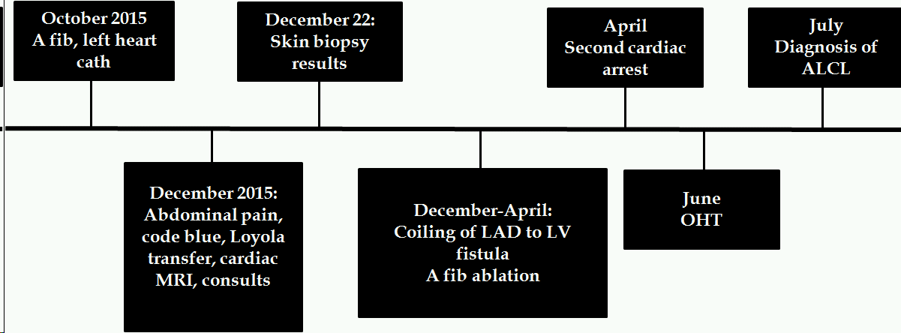
Figure 1: Clinical course from the detection of atrial fibrillation at the OSH to the OHT
at LUMC that led to the diagnosis of ALCL, ALK negative.

Pathologic Findings:
The explanted heart was grossly remarkable for an area of pallor in the posterior wall of the left ventricle. The weight and measurements were within normal limits. The valves were unremarkable with no lesions or calcifications. The coronary arteries were patent with no atherosclerosis. Histologic sections of the myocardium showed multiple large foci of lymphocytic infiltrates which were associated with myocyte damage. The infiltrate was composed mainly of small lymphocytes with occasional large pleomorphic cells. These larger lymphocytes showed a varied morphology including wreath-like nuclei, irregular nuclear contours, and “hallmark” cells. The pericardium and pericardial fat were also focally involved by this inflammatory infiltrate. Immunostains showed that the large cells were positive for CD45, CD30, and CD43 and negative for ALK-1, CD3, CD4, CD5, CD7, CD8, CD20, PAX5, CD15, CD21, CD61, CD10, CD61, BCL-2, CD10, CD15, CD68, TdT, MUM1, CD34, ALK1, CD56, EMA, BCL-6, EBER (ISH), and desmin. Special stains for fungus (GMS), and adenovirus and CMV immunostains were negative. Given the immunophenotype of the large pleomorphic cells, the possibility of cardiac involvement by a CD30 positive lymphoproliferative process was high on the differential diagnosis. Given the rarity of this finding, the case was sent out for consultation. Molecular studies to detect clonal B-cell and T-cell populations were performed at the outside institution and did not show evidence of a clonal population. Initially this was interpreted as a determinant factor favoring the diagnosis of a reactive process and myocarditis. However, given the morphologic findings, the consulting institution decided to amend their initial diagnosis and finally favored the diagnosis of ALK-1 negative anaplastic large cell lymphoma. After the diagnosis was made, unstained slides were sent for in-situ hybridization with a standard T-cell lymphoma panel. The large atypical cells showed amplification of c-Myc. Other probes tested were negative, these included TP63, ALK, TBL1XR1, TCL1A, and chromosome 7. The finding of c-Myc amplification solidified the diagnosis of a malignant lymphoid neoplasm.

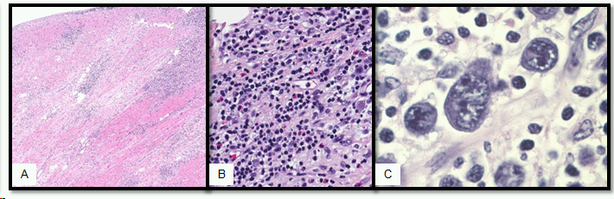
Figure 2: A patchy but extensive lymphocytic infiltrate was seen in the sections from the heart explant specimen (A). The infiltrate was composed mainly of small lymphocytes but numerous eosinophils and atypical large lymphoid cells were present (B). The larger cells showed very atypical morphology with large irregular nuclei with prominent nucleoli and hallmark morphology (C). In some areas these alrge atypical cells were present in sheets.

Discussion:
To our knowledge this is the first reported case of cardiac primary ALK negative ALCL. A couple cases of cardiac primary ALK positive ALCL have been reported in children and young adults. There are also many cases of secondary cardiac involvement by ALK positive ALCL that have been reported. Primary cardiac malignancies are rare in general, and primary cardiac lymphomas (PCL) are exceedingly rare and frequently diagnosed at autopsy. PCL usually affects immunocompromised hosts and is most commonly diffuse large B-cell lymphoma.
Anaplastic large cell lymphoma (ALCL) is a disease that is separated by the WHO into anaplastic lymphoma kinase (ALK) positive and negative subsets. Morphologically these are indistinguishable entities, however their clinical behavior and epidemiology are different. ALK positive ALCL most commonly affects children and young adults and has a good prognosis. It often presents with extra-nodal involvement, most commonly the skin and soft tissues. The expression of the ALK gene is most often a consequence of the fusion between the nucleophosmin (NPM) gene on chromosome 5 and the ALK gene on chromosome 2, t(2;5)(p23;q35). ALK negative most commonly affects adults after the fourth decade and is less likely to involve extra-nodal sites. It has a markedly worse prognosis than ALK positive ALCL.
Once the various etiologies of myocarditis had been ruled out, our differential diagnosis included peripheral T-cell lymphoma, not otherwise specified (PTCL, NOS), mycosis fungoides (MF) with large cell transformation, and Hodgkin lymphoma. The strong and diffuse expression of CD30 in our tumor cells ruled out PTCL, NOS. The previous skin biopsies which had been negative for lymphoma ruled-out MF. Finally, the T-cell immunophenotype (manifested only by CD43) ruled out the possibility of Hodgkin. A member of the tumor necrosis factor receptor super family (TNFRSF), CD30 is expressed in activated lymphocytes. It is commonly a positive regulator of apoptosis, limiting the proliferation of CD8 effector T-cells. Thus, the postulated normal counter part of ALCL is an activated mature T-cell. Clinically, both PTCL NOS and ALK negative ALCL have a similar prognosis. In our case, the large lymphocytes only expressed one T-cell marker, CD43, which before the current WHO, would have been considered a T/null cell phenotype, which is very common for both ALK positive and negative ALCLs.
An exuberant inflammatory response (myocarditis) was also high in the differential, especially since the T-cell receptor PCR did not show a clonal population. However, false negative results are common. Probable causes include the relative lack of tumor cells and a possible T-cell receptor rearrangement that is not recognized by the commercially available primers. Finally, the c-Myc amplification was consistent with a malignant process, as the role of c-Myc is well known in oncogenesis. However, the role c-Myc in ALK negative ALCL has not been recognized. Given the morphology of the tumor cells and the protracted clinical despite treatment the diagnosis of a malignant neoplasm was made.
Since transplant, our patient's cardiac function has continued to improve and there has been no evidence of rejection in subsequent biopsies.

References
1. Weilemann A, Grau M, Erdmann T, Merkel O, Sobhiafshar U, Anagnostopoulos I, Hummel M, Siegert A, Hayford C, Madle H, Wollert-Wulf B, Fichtner I, Dörken B, Dirnhofer S, Mathas S, Janz M, Emre NC, Rosenwald A, Ott G, Lenz P, Tzankov A, Lenz G.Essential role of IRF4 and MYC signaling for survival of anaplastic large cell lymphoma. Blood. 2015 Jan 1;125(1):124-32. doi: 10.1182/blood-2014-08-594507.
2. Lauten M, Vieth S, Hart C, Wössmann W, Tröger B, Härtel C, Bethge M, Schrauder A, Cario G. Cardiac anaplastic large cell lymphoma in an 8-year old boy. Leuk Res Rep. 2014 May 15;3(2):36-7. doi: 10.1016/j.lrr.2014.05.001. eCollection 2014.
3. Pankuweit S, Maisch B. [Etiology, diagnosis, management, and treatment of myocarditis. Position paper from the ESC Working Group on Myocardial and Pericardial Diseases]. Herz. 2013 Dec;38(8):855-61. doi: 10.1007/s00059-013-3988-7. German.
4. Caforio AL, Pankuweit S, Arbustini E, Basso C, Gimeno-Blanes J, Felix SB, Fu M, Heliö T, Heymans S, Jahns R, Klingel K, Linhart A, Maisch B, McKenna W, Mogensen J, Pinto YM, Ristic A, Schultheiss HP, Seggewiss H, Tavazzi L, Thiene G, Yilmaz A, Charron P, Elliott PM; European Society of Cardiology Working Group on Myocardial and Pericardial Diseases. Current state of knowledge on aetiology, diagnosis, management, and therapy of myocarditis: a position statement of the European Society of Cardiology Working Group on Myocardial and Pericardial Diseases. Eur Heart J. 2013 Sep;34(33):2636-48, 2648a-2648d. doi: 10.1093/eurheartj/eht210. Epub 2013 Jul 3.
5. Petrich A, Cho SI, Billett H. Primary cardiac lymphoma: an analysis of presentation, treatment, and outcome patterns. Cancer. 2011 Feb 1;117(3):581-9. doi: 10.1002/cncr.25444. Epub 2010 Oct 4.
6. Moritake H, Shimonodan H, Marutsuka K, Kamimura S, Kojima H, Nunoi H. C-MYC rearrangement may induce an aggressive phenotype in anaplastic lymphoma kinase positive anaplastic large cell lymphoma: Identification of a novel fusion gene ALO17/C-MYC. Am J Hematol. 2011 Jan;86(1):75-8. doi: 10.1002/ajh.21887. PubMed PMID: 21080342.

Presenter:
Aadil Ahmed, MD
Attending:
Jodi Speiser, MD

Clinical History:
An 80 year old male with a history of basal cell carcinoma of the posterior neck noticed a lesion on his posterior scalp that was increasing in size for the past few months. The patient consulted his dermatologist who performed a shave biopsy of the lesion. The patient was referred to Loyola University Medical Center (LUMC) for wide local excision. Physical examination showed a lesion measuring approximately 2.5 cm with a central 1cm abrasion. At Loyola, excisional biopsy with reconstruction of scalp was performed. The outside biopsy slides were reviewed along with the final excisional specimen slides at LUMC.

Differential Diagnoses:
Cutaneous leiomyosarcoma
Atypical fibroxanthoma
Plemorphic dermal sarcoma
Spindle cell squamous cell carcinoma
Spindle cell melanoma
Dermatofibrosarcoma Protuberans

Key Features:
Histology:
Dermal layer of the skin shows a densely cellular neoplasm with storiform pattern and irregular fascicles, composed of large pleomorphic spindle shaped cells with marked atypical nuclei, some multinucleated, some with prominent nuclei in background of collagenous stroma. There are frequent large and atypical mitotic figures (12/10 HPF) with no necrosis but extensive invasion into subcutaneous adipose tissue.

Positive IHC:
CD10
CD99
SMA (weakly positive)
CD68 (Focal-shave biopsy)

Negative IHC
Desmin, S-100, Keratin AE1/AE3, CD34, p63, Melan-A, MCK

Final Diagnosis:
Pleomorphic Dermal Sarcoma

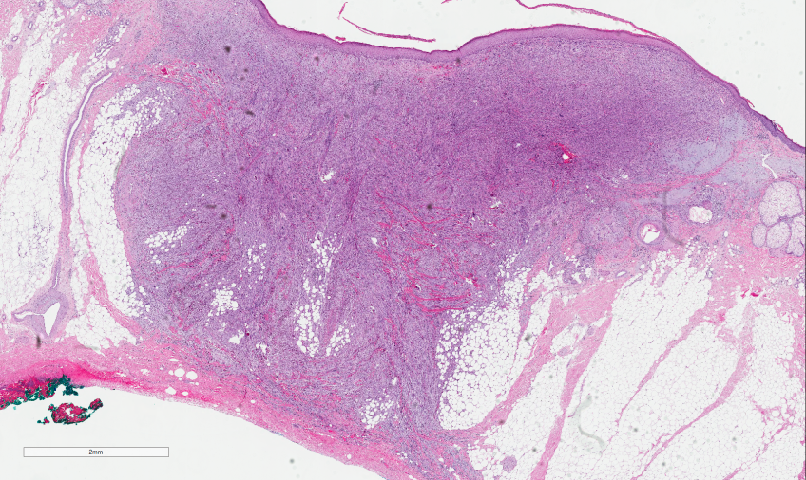

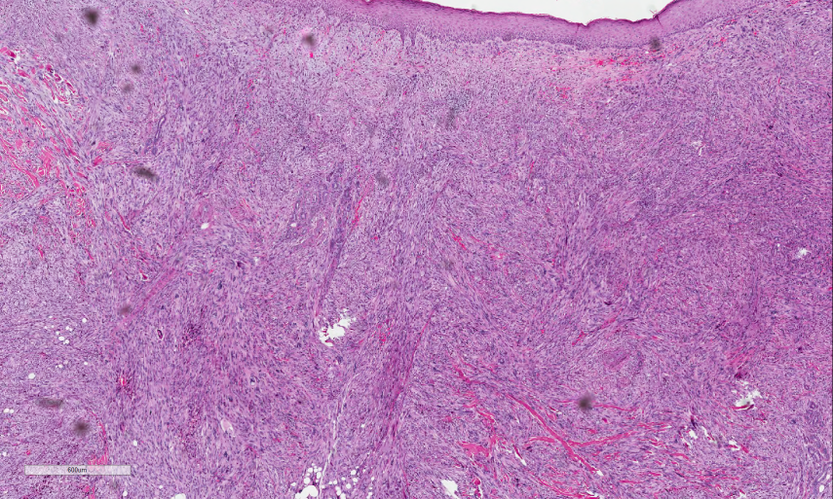

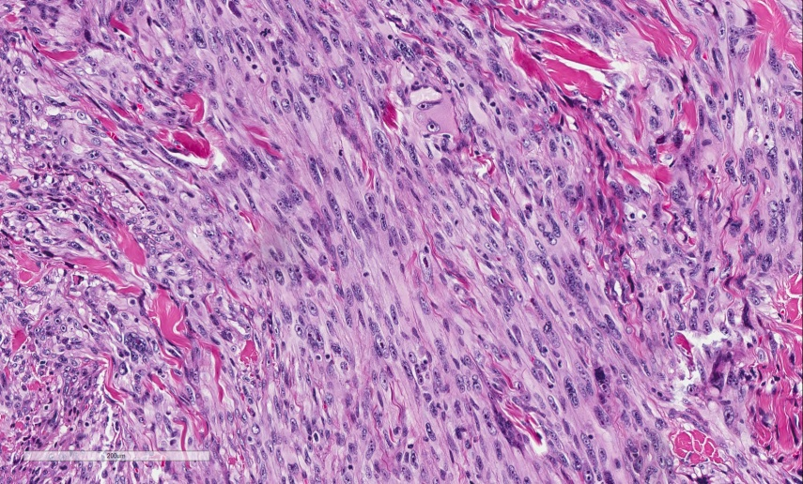

Discussion:
Pleomorphic neoplasms are typically associated with high-grade malignant behavior but not necessarily in primary cutaneous tumors. Such neoplasms constitute a spectrum of lesions with overlapping histological and immunohistochemical features.

In our case, shave biopsy showed smooth muscle markers positivity along with CD68. Due to such overlapping of IHC markers, the differential diagnoses of atypical fibroxanthoma/PDS vs cutaneous leiomyosarcoma was considered. However, the exact depth of invasion/ involvement of subcutaneous tissue is a distinct morphological feature that distinguishes between AFS and PDS and that cannot be estimated on shave biopsy; a definitive diagnosis in contrast to the outside report was not given.

The excisional biopsy showed a mass in dermal layer with invasion into subcutaneous adipose tissue. The mass is composed of large pleomorphic spindle shaped cells in a storiform or fascicular pattern with marked atypia and mitoses. The negative staining of S-100 and Melan-A helped in excluding the diagnosis of spindle cell melanoma while negative Keratin and p63 ruled out squamouc cell carcinoma with spindle cell features.

Though SMA were positive on shave biopsy, SMA was only focally positive on excisional biopsy. SMA is positive in a number of spindle cell tumors and in the absence of desmin, it favored against the cutaneous leiomyosarcoma.

As atypical fibroxanthoma and pleomorphic dermal sarcoma are similar in their morphology and immunohistochemistry (both can be CD10, CD99 positive), invasion into subcutaneous fat excluded the diagnosis of atypicalfibroxanthoma.

In addition, pleomorphic dermal sarcoma affects sun-damaged skin of the elderly with a strong male dilection (7:1) and a preference for the scalp. A short history of rapid growth is characteristic and ulceration is common. On the other hand, cutaneous leiomyosarcoma is more common on lower extremities.

PDS is a diagnosis of exclusion and the use of the term “pleomorphic dermal sarcoma” is to reflect their histological high grade but primarily dermal based tumor with potential for aggressive behavior. Undifferentiated pleomorphic sarcoma of the skin may be used but a distinction between deeper and superficial variant is necessary as former is related with poor prognosis.

Take home points:
- A definitive diagnosis should not be given on shave biopsy
- Immunohistochemistry is primarily non-specific; however it can be used to exclude certain neoplasms.
- Morphology and clinical history eventually plays a big role in differentiating pleomorphic dermal neoplasms from one another.

 | PDS | AFX | LMS
CD10 | 100% | 78-87%
CD99 | 35% | 35-73%
CD68 | + | ++
SMA | 70% | 30% | 91-100%
Desmin | - | - | 73-100%

References:

Brenn T. Pleomorphic dermal neoplasms: a review. Adv Anat Pathol. 2014 Mar;21(2):108-30

Miller K, Goodlad JR, Brenn T. Pleomorphic dermal sarcoma: adverse histologic features predict aggressive behavior and allow distinction from atypical fibroxanthoma. Am J Surg Pathol. 2012 Sep;36(9):1317-26

Bhattacharjee, P. and Lazova, R. (2005), Immunohistochemical Expression of Cutaneous Leiomyosarcoma. Journal of Cutaneous Pathology, 32: 76.
Hultgren TL, DiMaio DJ. Immunohistochemical staining of CD10 in atypical fibroxanthomas. J Cutan Pathol. 2007 May;34(5):415-9.

Case 5:
Presenter: Reema Khan MD, PGY II
Attendings: Dariusz Borys MD

Clinical History: 39 y/o female with PMH significant for nephrolithiasis who presents with L flank pain x5d, subjective fevers, chills, increased frequency. She describes her pain as dull, achy, 10/10 in severity, radiating down to LLQ, progressively worsening. The patient has been passing 1-2 stones per month for the past year but has never seeked medical treatment prior to this episode. CT scan and MRI scan demonstrate an expansile bone lesions with cortical thinning and no soft tissue involvement. Orthopedic surgery was consulted and a curettage was performed. A representative section of the curettage is submitted for your review.

Final Diagnosis: Osteitis fibrosa imperfecta (a.k.a. Brown tumor of hyperparathyroidism)

Differential Diagnosis:
Giant Cell Rich Osteosarcoma
Giant Cell Tumor
Aneurysmal Bone Cyst
Giant Cell Reparative Granuloma
Osteitis fibrosa cystica

Key Features:
Histology:
Low power view shows hypocellular and hypercellular regions. The hypercellular areas have aggregates of large cells admixed with hemorrhage and brown pigment deposition. Higher power shows diffusely scattered giant cells in a pink amorphous material background with fixed spindle-shaped stromal cells.

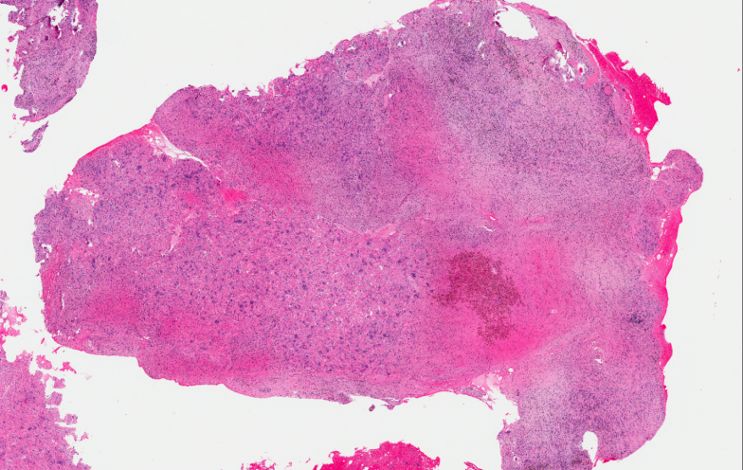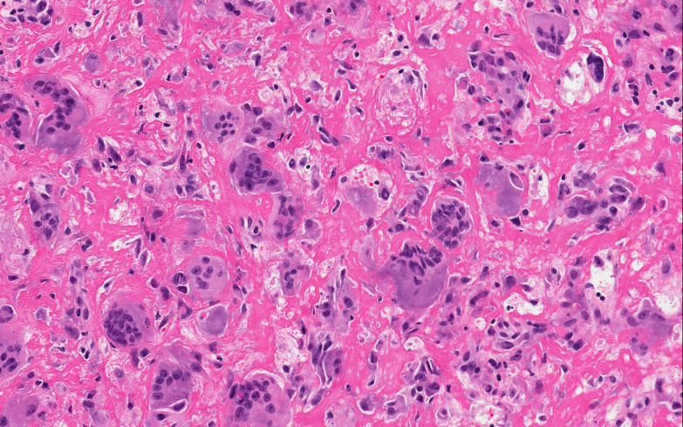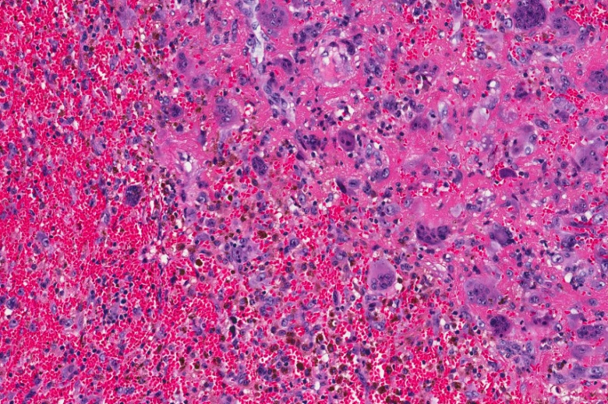

Discussion:
- Brown tumor is a bone lesion that arises in settings of excess osteoclast activity, such as hyperparathyroidism. It is not a true neoplasm, as the term "tumor" suggests; however, it may mimic a true neoplasm.
- These lesions are characterized by numerous giant cells, arranged in clusters or diffusely, in a background of mononuclear oval to spindle stromal cells. Vascularity is high and hemosiderin deposition may be abundant.¹
- The osteoclasts consume the trabecular bone that osteoblasts lay down and this front of reparative bone deposition followed by additional resorption can expand beyond the usual shape of the bone, involving the periosteum thus causing bone pain. The characteristic brown coloration results from hemosiderin deposition into the osteolytic cysts. Hemosiderin deposition is not a distinctive feature of brown tumors; it may also be seen in giant cell tumors of the bone.⁸
- Brown tumors typically occur in the medullary shafts of long bones, ribs, mandible, metacarpals and pelvis.⁴
- The hallmark of PTH excess is increased osteoclastic activity, with bone resorption. This is seen by increased expression of RANKL (Receptor Activator Nuclear Kappa-B Ligand) on the osteoblast stromal cells.⁸
- A diagnostic confusion arises mainly when the clinician encounters multiple lytic lesions involving different areas of the skeleton as was the case in our patient. About 90% of the patients with skeletal metastases present with multiple lesions. Clinically indistinguishable from malignant and/or metastatic lesions.^{2,9}
- Take home messages:
- Osteitis fibrosa cystica has been known to mimic primary and metastatic bone lesions on radiology and pathology
- Pathology of Giant Cell Tumor and Giant Cell Reparative Granuloma are indistinguishable from this lesion hence a thorough clinical history and lab work-up must be done to make sure hyperparathyroidism is ruled out especially when the patient solely presents with bone lesions.
- Usually it is known to rule out osteitis fibrosa cystica when the lesion is in the head, neck and throat region.

References:¹⁻⁹
- Askanazy, M. (1904). Über Ostitis deformans ohne osteoides Gewebe. Arb Geb Pathol Anat Institut zu Tübingen, 4, 398-422.
- Bassler, T., Wong, E. T., & Brynes, R. K. (1993). Osteitis fibrosa cystica simulating metastatic tumor: an almost-forgotten relationship. American journal of clinical pathology, 100(6), 697-700.
- Buchanan, W. W., Kraag, G. R., Palmer, D. G., & Cockshott, W. P. (1981). The first recorded case of osteitis fibrosa cystica. Canadian Medical Association Journal, 124(6), 812.
- Can, Ö., Boynueğri, B., Gökçe, A. M., Özdemir, E., Ferhatoğlu, F., Canbakan, M., ... & Apaydın, S. (2016). Brown Tumors: A Case Report and Review of the Literature. Case reports in nephrology and dialysis, 6(1), 46-52.
- Felton, J. S. (1969). Man Medicine, and Work in America: An Historical Series: IV. Thomas Cadwalader, MD Physician, Philadelphian and Philanthropist. Journal of Occupational and Environmental Medicine, 11(7), 374-380.
- Hoshi, M., Takami, M., Kajikawa, M., Teramura, K., Okamoto, T., Yanagida, I., & Matsumura, A. (2008). A case of multiple skeletal lesions of brown tumors, mimicking carcinoma metastases. Archives of orthopaedic and trauma surgery, 128(2), 149-154.
- Khalil, P. N., Heining, S. M., Huss, R., Ihrler, S., Siebeck, M., Hallfeldt, K., ... & Mutschler, W. (2007). Natural history and surgical treatment of brown tumor lesions at various sites in refractory primary hyperparathyroidism.European journal of medical research, 12(5), 222.
- Kumar, V., Abbas, A. K., Fausto, N., & Aster, J. C. (2014). Robbins and Cotran pathologic basis of disease. Elsevier Health Sciences.
- Meydan, N., Barutca, S., Guney, E., Boylu, S., Savk, O., Culhaci, N., & Ayhan, M. (2006). Brown tumors mimicking bone metastases. Journal of The National Medical Association, 98(6), 950.
- Ullah, E., Ahmad, M., Ali, S. A., & Redhu, N. (2012). Primary hyperparathyroidism having multiple Brown tumors mimicking malignancy.Indian journal of endocrinology and metabolism, 16(6), 1040.

Case 6
Presenter: Vamsi Parini MD, MPH
Attending: Stefan Pambuccian, MD

Clinical History: The patient is a 74-year-old female with 36 pack years of smoking history had left breast asymmetry during routine screening mammogram. Imaging revealed suspicious irregular mass with enhancement kinetics measuring 1.6 cm in left central outer breast. A biopsy of the breast mass followed by wire localized curative lumpectomy was performed. A representative section is submitted for your review.

Diagnosis: Invasive ductal carcinoma, Apocrine type

Differential Diagnosis:
- Primary and secondary tumors of the breast with abundant granular cytoplasm

Key morphologic and immunohistochemical features:
- Invasive tumor cells and DCIS luminal epithelial cells with abundant pink to blue granular cytoplasm
- Background of papillary cystic apocrine metaplasia
- Invasive carcinoma may show targetoid spread with varying tubule/ductal differentiation
- Large nuclei (>3 times RBC) with smooth nuclear membranes, fine chromatin and prominent nucleoli
- Rare mitoses (Low Ki67 proliferative index)
- Androgen receptor (AR) is diffusely positive
- Absence of ERα, PR and Her-2/neu (50%)
- Absence of basal cell markers: CK5/6, p63
- Intact BRCA

Discussion:

- Apocrine changes either proliferative or non proliferative, with simple or complex papillary change with no atypia carries no risk for invasive breast carcinoma.
- Atypical apocrine proliferations have relative risk of 5.5 for development of invasive breast cancer
- Androgen receptor (AR) is the most frequently expressed steroid hormone receptor among breast cancers. AR-positive status correlates with longer overall survival among ER+ breast cancers
- AR expression in the absence of ER and PR expression with accompanying morphological features is diagnostic of Apocrine carcinoma.
- Current WHO discourages the use of Apocrine Carcinoma. The new diagnostic category is “Carcinoma with apocrine changes”
- Apocrine carcinoma has unique gene expression (FOXA1;KRT18 ) and mutation profile (PIK3CA; PTEN;CDH1)
- Apocrine carcinoma falls under triple negative breast cancers (TNBC) but they behave similar to IDC (ER+) with respect to tumor size, grade, lymph node positivity and survival rates
- Apocrine carcinomas are least sensitive to neoadjuvant chemotherapy (PARP inhibitors) with lowest pathologic complete response (pCR). On the contrary they have highest overall survival compared to other TNBCs.
- Current targeted therapies for Apocrine carcinoma are in clinical trials phase ( AR antagonist- Bicalutamide)
- 50% of apocrine carcinoma are Her2/neu+ thus may benefit from Her2/neu therapy (Trastuzumab & Lapatinib) but resistance is common due PI3K/PTEN/Akt deregulation
- Avoid ineffective chemotherapy among old women with apocrine carcinoma who are least likely to tolerate

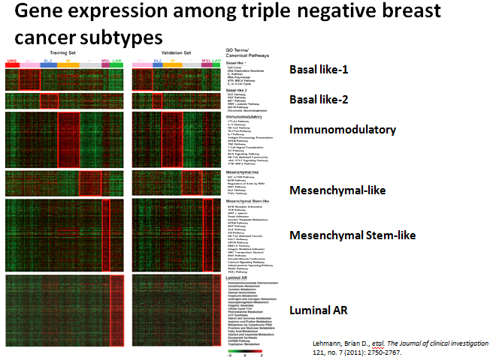
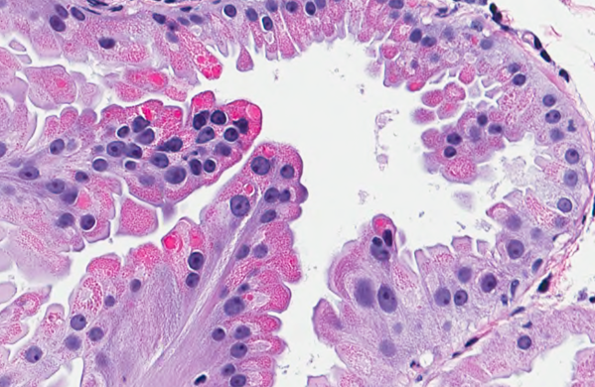

References

Lakhani et al. World Health Organization classification of tumours of the breast. 4th ed. Lyon: IARC Press 2012.

Page, David L., William D. Dupont, and Roy A. Jensen. "Papillary apocrine change of the breast: associations with atypical hyperplasia and risk of breast cancer." Cancer Epidemiology Biomarkers & Prevention 5, no. 1 (1996): 29-32.

Bose, Shikha. "Triple-negative Breast Carcinoma: Morphologic and Molecular Subtypes." Advances in anatomic pathology 22, no. 5 (2015): 306-313.

Vranic, Semir, Caterina Marchiò, Isabella Castellano, Cristina Botta, Maria Stella Scalzo, Ryan P. Bender, Cesar Payan-Gomez et al. "Immunohistochemical and molecular profiling of histologically defined apocrine carcinomas of the breast." Human pathology 46, no. 9 (2015): 1350-1359.

Masuda, Hiroko, Keith A. Baggerly, Ying Wang, Ya Zhang, Ana Maria Gonzalez-Angulo, Funda Meric-Bernstam, Vicente Valero et al. "Differential response to neoadjuvant chemotherapy among 7 triple-negative breast cancer molecular subtypes." Clinical Cancer Research 19, no. 19 (2013): 5533-5540.

Bianchini, Giampaolo, Justin M. Balko, Ingrid A. Mayer, Melinda E. Sanders, and Luca Gianni. "Triple-negative breast cancer: challenges and opportunities of a heterogeneous disease." Nature Reviews Clinical Oncology (2016).

Mills AM, C EG, S MW, C MB, Atkins KA. Pure Apocrine Carcinomas Represent a Clinicopathologically Distinct Androgen Receptor-Positive Subset of Triple-Negative Breast Cancers. Am J Surg Pathol. 2016;40:1109-16.

Safarpour, Damoun, and Fattaneh A. Tavassoli. "A targetable androgen receptor-positive breast cancer subtype hidden among the triple-negative cancers." Archives of Pathology and Laboratory Medicine 139, no. 5 (2014): 612-617.

Lehmann BD, Bauer JA, Chen X, Sanders ME, Chakravarthy AB, Shyr Y, et al. Identification of human triple-negative breast cancer subtypes and preclinical models for selection of targeted therapies. J Clin Invest. 2011;121:2750-67.

