IRAP April 21, 2014

Presented by:
Haiyan Chen MD, PhD, PGY II
Timothy VandenBoom MD, PGY II
Ian Hughes MD, PGY II
Reeba Omman MD, PGY III
Payal Sojitra MD, PGY II
Mohanad Shaar MD, PGY III

Case 1
Presenter: Haiyan Chen MD, PhD, PGY II
Attendings: Stefan Pambuccian MD and Razan Massarani-Wafai MD

Clinical History: A 68-year-old man presented with two month history of right nasal congestion. His past medical and family history were noncontributory. He was a banker and did not smoke. A CT scan showed a mass involving the right nasal cavity and maxillary sinus. Endoscopic resection of this mass was performed and a representative section is submitted for your review.

Final Diagnosis: NUT midline carcinoma

Differential Diagnosis:
Olfactory neuroblastoma
Lymphoepithelial carcinoma
Small cell neuroendocrine carcinoma
Sinonasal undifferentiated carcinoma (SNUC)
Ewing’s/PNET
Rhabdomyosarcoma
NUT midline carcinoma
Melanoma
Lymphoma

Key Features:
Histology:
Low power view shows intact respiratory mucosa. The underlying tumor cells form lobules separated by dense and desmoplastic stroma. No specific differentiation is identified: no squamous differentiation, glandular formation, or rosette formation is seen. Extensive central comedo-type necrosis and brisk mitotic activity, as well as prominent lymphovascular invasion and perineural invasion are appreciated. On high power view, the tumor cells are small to medium-size with indistinct cell membranes, small amounts of clear or eosinophilic cytoplasm, high nucleocytoplasmic ratios, chunky or vesicular chromatin, and indistinct or small nucleoli.

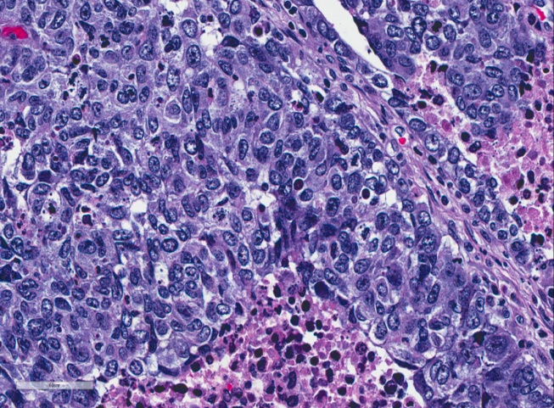

Positive IHC:
EMA: +, diffusely
Pankeratin (AE1/AE3): +, focally
Cam 5.2 (CK8/18): + focally
NUT: +, diffusely

Negative IHC:
p63
CK5/6
Desmin
CD99
NSE (neuron specific enolase)
Neuroendocrine markers (Synaptophysin, Chromogranin, CD56)

FISH:
BRD4-NUT fusion abnormality: t(15:19)(q14;p13.12)

Discussion:
- With positive EMA and keratin stains, lymphoma and melanoma were excluded from the list.
- With negative CD99 as well as positive EMA and keratin stains, Ewing sarcoma was unlikely.
- With negative desmin, rhabdomyosarcoma was unlikely.
- Given tumor location, negativity of NSE and all three neuroendocrine markers (chromogranin, synaptophysin and CD56), olfactory neuroblastoma was unlikely.
- With negative NSE and all three neuroendocrine markers (chromogranin, synaptophysin and CD56), small cell neuroendocrine carcinoma was unlikely.
- With lack of prominent lymphocytic infiltrate, the patient's demographics and negativity of CK5/6, lymphoepithelial carcinoma is down on the list.
- However, sinonasal undifferentiated carcinoma (SNUC) and NUT midline carcinoma (NUT) cannot be differentiated with only H&E stain and regular IHC When NUT midline carcinoma is suspected, the confirmatory tests including FISH and RT-PCR should be performed. The NUT antibody for IHC has been recently developed.
- For NUT midline carcinoma:

- A rare, aggressive poorly differentiated squamous cell carcinoma
- Cytogenetically defined disease by the translocation:
Most common: BRD4-NUT, t(15;19)(q14;p13.1)
Less common: BRD3-NUT [t(9;15)(q34.2;q14)] or others
- Histologically: aggressive poorly differentiated squamous cell carcinoma
- The function of BRD4-NUT fusion protein: blocking cellular differentiation to squamous cells and promoting uncontrolled growth of carcinoma cells
- Arise from the midline of body (intrathoracic, nose/paranasal sinuses)
- Occurs throughout life
- Diagnosis of NMC: IHC (Ab to NUT), FISH or RT-PCR
- Prevalence: unknown, frequently underdiagnosed or misdiagnosed
- Currently, no effective treatment

References:
- Vargas SO, French CA, Faul PN, Fletcher JA, Davis IJ, Dal Cin P, Perez-Atayde AR. 2001. Upper respiratory tract carcinoma with chromosomal translocation 15;19: evidence for a distinct disease entity of young patients with a rapidly fatal course. Cancer 92(5):1195-203.
- French CA. 2012. Pathogenesis of NUT midline carcinoma. Annu Rev Pathol 7:247-65.
- Bauer DE, Mitchell CM, Strait KM, Lathan CS, Stelow EB, Luer SC, Muhammed S, Evans AG, Sholl LM, Rosai J, Giraldi E, Oakley RP, Rodriguez-Galindo C, London WB, Sallan SE, Bradner JE, French CA. 2012. Clinicopathologic features and long-term outcomes of NUT midline carcinoma. Clin Cancer Res 18(20):5773-9.
- French CA. 2013. The importance of diagnosing NUT midline carcinoma. Head Neck Pathol 7(1):11-6.
- French CA. 2010. Demystified molecular pathology of NUT midline carcinomas. J Clin Pathol 63(6):492-6.
- French CA. 2010. NUT midline carcinoma. Cancer Genet Cytogenet 203(1):16-20.
- Yeshvanth SK, Ninan K, Bhandary SK, Lakshinarayana KP, Shetty JK, Makannavar JH. 2012. Rare case of extraskeletal Ewings sarcoma of the sinonasal tract. J Cancer Res Ther 8(1):142-4.
- Krishnamurthy A, Ravi P, Vijayalakshmi R, Majhi U. 2013. Small cell neuroendocrine carcinoma of the paranasal sinus. Natl J Maxillofac Surg 4(1):111-3.
- Schwartz BE, Hofer MD, Lemieux ME, Bauer DE, Cameron MJ, West NH, Agoston ES, Reynoird N, Khochbin S, Ince TA, Christie A, Janeway KA, Vargas SO, Perez-Atayde AR, Aster JC, Sallan SE, Kung AL, Bradner JE, French CA. 2011. Differentiation of NUT midline carcinoma by epigenomic reprogramming. Cancer Res 71(7):2686-96.
- Stelow EB. 2011. A review of NUT midline carcinoma. Head Neck Pathol 5(1):31-5.
- Gattuso P, Reddy VB, David O, Spitz DJ, Haber MH. 2015. Differential diagnosis in surgical pathology. Philadelphia, PA: Saunders/Elsevier. p. p.
- Hunt JL. 2011. Update on Sinonasal and Salivary Gland Lesions. ASCP Course.

Case 2
Presenter: Timothy VandenBoom MD, PGY II
Attending: Kelli A Hutchens MD

Clinical History:
A 28-year-old female with a history of well-controlled hypothyroidism presented with a four day history of fever, nausea, and vomiting. Physical examination revealed painless cervical and submandibular lymphadenopathy, hyperpigmented macules with central scarring involving bilateral helices, and an erythematous plaque with central hyperpigmentation involving the right nasal sidewall. An initial CBC revealed pancytopenia and the patient was subsequently admitted to our institution. A skin biopsy of the plaque located on the right nasal sidewall was performed for further evaluation of the patient.

Final Diagnosis: Kikuchi-Fujimoto Disease

Differential Diagnosis:
Infection: Mycobacterial, deep fungal
Hematologic: Subcutaneous panniculitis-like T-cell lymphoma
Lupus erythematosus: systemic, subacute, and discoid type

Key Features:
Histology:
The punch biopsy specimen from the right nasal sidewall plaque shows interface dermatitis with extensive basal vacuolar change. Within the dermis there is a superficial and deep inflammatory infiltrate, extending into the subcutaneous adipose tissue. The infiltrate is composed of lymphocytes and histiocytes with multiple foci of histiocytic necrosis. Neutrophils are not a prominent feature.
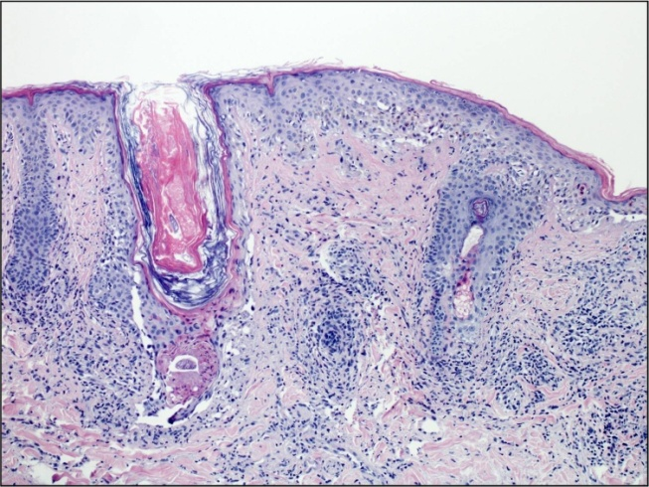
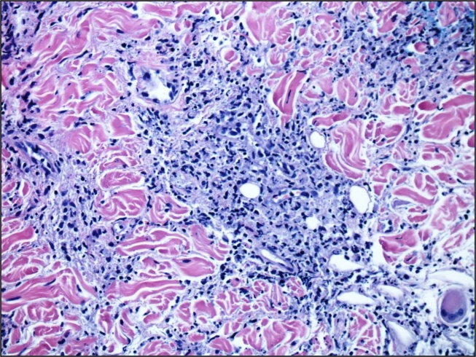

Special Stains:
PAS - Negative
GMS - Negative
AFB - Negative
Steiner - Negative

Other Studies:
Infectious disease workup - Negative
ANA, anti-dsDNA, anti-Sm, anti-Ro, anti-La - Negative
Bone marrow biopsy, flow cytometry, cytogenetics - Negative

Discussion:
- With the significant inflammation and degree of necrosis, we first considered an infectious process. However, neutrophils were not a prominent feature and we did not identify any fungal or bacterial organisms using special stains, allowing us to place infection low on our list of differential diagnoses.
- Taking into account the inflammatory infiltrate, in the context of cytopenias and lymphadenopathy, both primary cutaneous lymphoid neoplasms and systemic hematologic processes were considered. One entity that may show similar histologic features is subcutaneous panniculitis-like T-cell lymphoma. However, the characteristic features of lymphocyte atypia and fat rimming by lymphocytes were not present. Systemic hematologic conditions were excluded after the bone marrow biopsy was found to be normal.
- The histologic findings described above were also reminiscent of lupus erythematosus which is separated into three general categories:
a. Systemic: malar/morbilliform rash, serositis, renal/joint involvement, etc with positive serology (ANA, anti-dsDNA, anti-Sm)
b. Subacute: Scaly plaques and annular lesions involving trunk and upper
extremities, positive serology (anti-Ro, anti-La), often drug-induced
c. Discoid: erythematous, scaly plaques involving scalp, lips, ears, or nose; disease isolated to the skin, negative serology, no systemic Sx
Based on the clinical presentation in our patient, our main differential diagnosis was discoid lupus erythematosus (DLE). DLE can show a very similar histological picture to our case, even rarely showing foci of necrosis. However, DLE is typically isolated to the skin, whereas our patient presented with a variety of systemic symptoms that were not readily explainable by DLE. As these categories are very general and show some overlap, we considered the possibility of SLE. However, all serological studies were negative in our patient and findings such as renal or joint involvement were not present, making this unlikely.
4. Taking into account the histological features, the degree of necrosis, and the clinical context, the diagnosis of Kikuchi-Fujimoto Disease (KFD) was rendered.
a. KFD was originally described in 1972 in young women of Asian descent, but has been reported in all ethnicities
b. A variety of systemic symptoms have been reported, but the classic presentation is fever with cervical lymphadenopathy
c. Etiology is still uncertain; overall impression is that KFD is either an infectious process or a self-limited autoimmune condition
d. KFD is typically diagnosed on a lymph node biopsy; however, in the appropriate clinical setting it can be diagnosed on a skin biopsy. Skin biopsy shows features such as interface dermatitis with basal vacuolar change, superficial and deep lymphohistiocytic infiltrate, foci of necrosis with karyorrhectic debris, panniculitis, and absence of neutrophils, all of which were identified in our case
e. There is a potential association between KFD and SLE; various reports in the literature show some patients with KFD later develop SLE
f. KFD is self-limited and typically does not require treatment. However, patients should be monitored for recurrences and/or development of SLE
References:
1. Kim JH, Kim YB, In SI, Kim YC, Han JH. The cutaneous lesions of Kikuchi's disease: a comprehensive analysis of 16 cases based on the clinicopathologic, immunohistochemical, and immunofluorescence studies with an emphasis on the differential diagnosis. Hum Pathol. 2010;41: 1245-1254.
2. Kucukardali Y, Solmazgul E, Kunter E, Oncul O, Yildirim S, Kaplan M. Kikuchi-Fujimoto Disease: analysis of 244 cases. Clin Rheumatol. 2007;26: 50-54.
3. Bosch X, Guilabert A, Miquel R, Campo E. Enigmatic Kikuchi-Fujimoto disease: a comprehensive review. Am J Clin Pathol. 2004;122: 141-152.
4. Goldblatt F, Andrews J, Russell A, Isenberg D. Association of Kikuchi-Fujimoto's disease with SLE. Rheumatology (Oxford). 2008;47: 553-554.
5. Ohshima K, Shimazaki K, Kume T, Suzumiya J, Kanda M, Kikuchi M. Perforin and Fas pathways of cytotoxic T-cells in histiocytic necrotizing lymphadenitis. Histopathology. 1998;33: 471-478.

Case 3
Presenter: Ian Hughes MD, PGY II
Attending: Stefan Pambuccian MD

Clinical History:
A 68-year-old female with a history of hypothyroidism for many years presented with chronic cough and throat irritation. Her hypothyroidism was treated with daily Synthroid. The patient states that her last thyroid function studies performed a year previously were normal and that a thyroid biopsy performed 30 years previously showed benign findings. Repeat TSH and free T3 measurements were within normal range. CT scan revealed global thyroid enlargement, with a 1.9 cm dominant nodule in the left lobe. Fine needle aspiration of the nodule was attempted three times, but the cytology was reported as unsatisfactory, as the samples showed only blood. The patient underwent a left hemi-thyroidectomy for further characterization of the nodule.

Final Diagnosis: Sclerosing lymphocytic thyroiditis, IgG4-related, with extensive squamous metaplasia and solid cell nests

Differential Diagnosis:
Neoplastic:
Mucoepidermoid carcinoma,
Sclerosing mucoepidermoid carcinoma
Primary/metastatic SCC,
CASTLE
Medullary carcinoma,
Sclerosing papillary carcinoma
Hematologic: Lymphoma
Benign: Squamous metaplasia

Key Features:
Histology:
The left hemi-thyroid resection specimen demonstrates extensive fibrosis with prominent lymphoid aggregates. Squamous cells in scattered, well-circumscribed nests and lining cystic mucin-filled spaces are present. Focal intra-cytoplasmic mucin is also identified. The squamous cells show some mild irregularity but only minimal cytologic atypia.
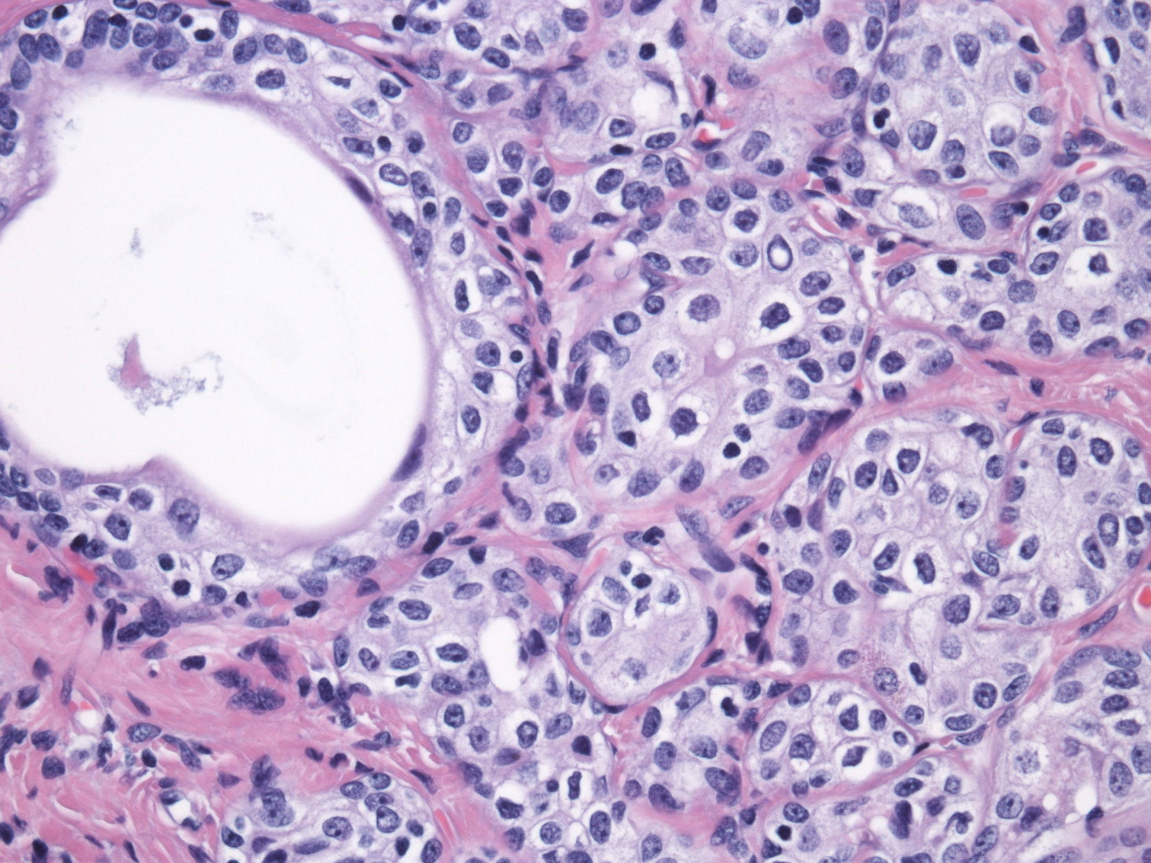
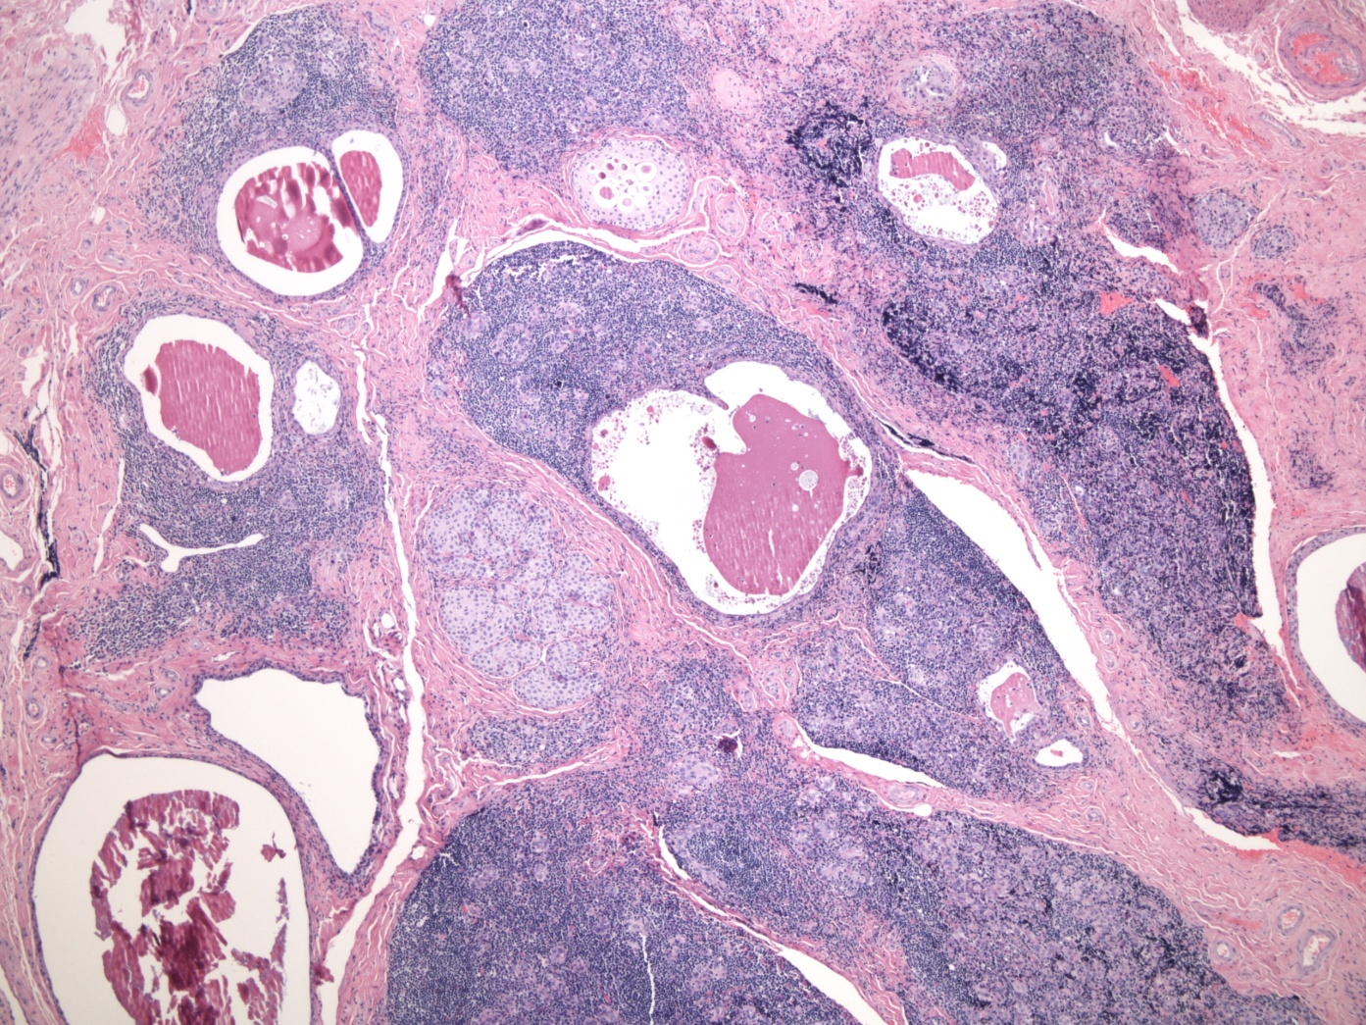

Special Stains:
Pankeratin – Positive
P63 – Positive
Mucicarmine and PASD – Positive (cystic spaces and intra-cytoplasmic mucin)
Thyroglobulin – Negative
TTF-1 – Negative
Calcitonin – Negative
CEA – Negative
Chromogranin – Negative
CD3 and CD20 – Mixed population of T- and B-cells

Other Studies:
TG Antibodies: 5320.4 IU/mL (normal: <4.1 IU/mL)
Anti-TPO Antibodies: 114.4 IU/mL (normal: <9 IU/mL)

Discussion:
- With such prominent lymphoid aggregates lymphoma should always be a consideration. We performed CD3 and CD20 stains which demonstrated a mixed population of T- B-cells. This places lymphoma very low on the differential diagnoses.
- A sclerosing variant of papillary thyroid carcinoma may show extensive fibrosis with scattered nests of cells. The cells in this case do not have a papillary morphology and negative thyroglobulin and TTF-1 stains make this diagnosis unlikely. Medullary carcinoma may present similarly, however negative IHC for calcitonin in conjunction with the previous negative thyroid stains (TG, TTF-1) help to rule out this diagnosis.
- Carcinoma Showing Thymus-like Differentiation (CASTLE) was ruled out primarily on morphologic features. Our case lacks the eosinophilic/amphophilic cytoplasm, prominent nuclei, and vesicular nuclei generally present in this neoplasm. Negative staining for CEA also helped to rule out this diagnosis.
- A primary or metastatic squamous cell carcinoma was considered, but the squamous cells in our case do not demonstrate the nuclear pleomorphism or invasive growth pattern characteristic of this neoplasm.
- Mucoepidermoid carcinoma (MEC) and a variant, sclerosing mucoepidermoid carcinoma with eosinophilia (SMECE), share many morphologic and immunohistochemical features with our case. Positive p63 and pankeratin are typically present with negative staining for thyroid markers (TG, TTF-1, calcitonin). The tumors demonstrate a mix of squamous and mucin-producing glandular cells in a sclerotic stroma and may arise in a background of lymphocytic thyroiditis. The cells themselves may only show mild-to-moderate pleomorphism. All of these features are seen in our case as well making the differentiation difficult. However, both MEC and SMECE show infiltrating features, whereas our case shows a well-demarcated epithelial proliferation.
- Based on the lack of an invasive growth pattern, a diagnosis of sclerosing lymphocytic thyroiditis with extensive squamous metaplasia and solid cell nests was favored.
a. Hashimoto’s thyroiditis was originally described by Hakuru Hashimoto in 1912 and is the most common inflammatory process of the thyroid gland.
b. Up to 10% of cases of Hashimoto’s thyroiditis are the fibrous variant which causes extensive fibrosis without involvement of surrounding structures.
c. Nodular squamous metaplasia arising in the setting of Hashimoto’s thyroiditis can mimic other more concerning entities such as mucoepidermoid carcinoma (MEC) and sclerosing mucoepidermoid carcinoma (SMEC). All three share similar morphologic and immunohistochemical features making differentiation difficult.
d. The origin of squamous cell nests in the thyroid gland is still being debated but one of the most widely agreed upon origins is differentiation from ultimobranchial bodies. Squamous cell nests may become more prominent as part of a reactive/reparative process. They hold the potential to differentiate into many of the carcinomas that may involve the thyroid such as MEC, follicular carcinoma, papillary carcinoma, and medullary carcinoma.
e. The fibrous variant of Hashimoto’s thyroiditis may have an IgG4-related component. In a specimen stained for IgG4, a high-powered field with >40 positive cells is widely considered positive. IgG4-related fibrous variant of Hashimoto’s thyroiditis may show more rapidly progressing and severe disease.

References
1. Iannaci G, Luise R, Sapere P, et al. Fibrous Variant of Hashimoto’s Thyroiditis as a Diagnostic Pitfall in Thyroid Pathology. Case Reports in Endocrinology. 2013; Article ID 308908: 5 pages.
2. Musso-Lassalle S, Butori C, Bailleux S, Santini J, Franc B, Hofman P. A diagnostic pitfall: nodular tumor-like squamous metaplasia with Hashimoto's thyroiditis mimicking a sclerosing mucoepidermoid carcinoma with eosinophilia. Pathol Res Pract. 2006;202: 379-383.
3. Ryska A, Ludvikova M, Rydlova M, Cap J, Zalud R. Massive squamous metaplasia of the thyroid gland-- report of three cases. Pathol Res Pract. 2006;202: 99-106.
4. Baloch ZW, Solomon AC, LiVolsi VA. Primary mucoepidermoid carcinoma and sclerosing mucoepidermoid carcinoma with eosinophilia of the thyroid gland: a report of nine cases. Mod Pathol. 2000;13: 802-807.
5. Das S, Kalyani R. Sclerosing mucoepidermoid carcinoma with eosinophilia of the thyroid. Indian J Pathol Microbiol. 2008;51: 34-36.
6. Kakudo K, Li Y, Taniguchi E, et al. IgG4-related disease of the thyroid glands. Endocr J. 2012;59: 273-281.
7. Watanabe T, Maruyama M, Ito T, et al. Clinical features of a new disease concept, IgG4-related thyroiditis. Scand J Rheumatol. 2013;42: 325-330.

Case 4

Presenter: Reeba A. Omman MD, PGY III
Attending: Milind M. Velankar MD

Clinical history: A 69 year-old male with a history of follicular lymphoma and prostate cancer presented with a syncopal episode and hypotension. On admission, the patient was noted to have fever, hepatosplenomegaly, new onset pancytopenia (WBC 0.7 K/µL, hemoglobin 8.3 g/dL, platelets 13 K/µL, with no circulating blasts on peripheral blood smear), elevated LDH of 1106 IU/L (normal: 98 - 192 IU/L), and elevated ferritin level of 11960 ng/mL (normal: 22 - 322 ng/mL). CT scan showed multiple subcentimeter hypodense lesions in the liver and spleen.

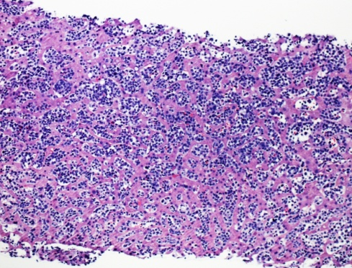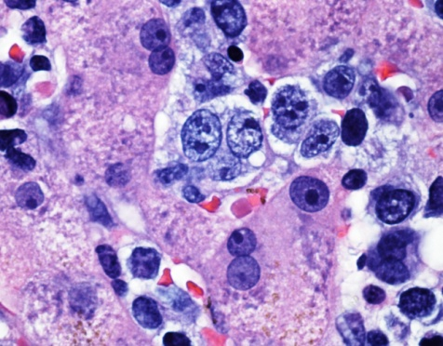

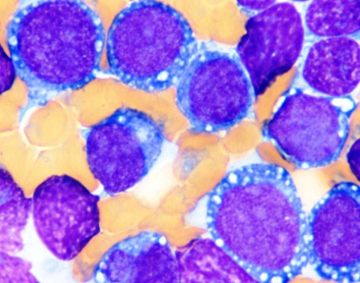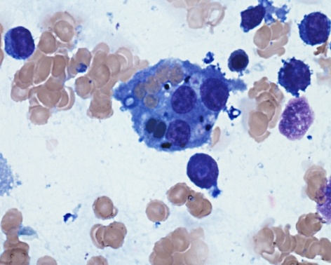

Final Diagnosis: Pure Erythroid Leukemia (AML - M6b) with concurrent Hemophagocytic lymphohistiocytosis

Differential Diagnosis:
- Follicular lymphoma with transformation to Diffuse Large B-cell lymphoma
- Metastatic carcinoma and other metastatic tumors(melanoma)
- Acute myeloid leukemia/myeloid sarcoma (therapy-related)

Key Features:
Histology:
- A liver biopsy was performed and showed sinusoidal infiltration by medium to large-sized cells with open chromatin and one to multiple nucleoli.

Immunohistochemistry:
Positive: LCA, hemoglobin A, E-cadherin, and moderately increased Ki-67 (80%).
Negative: AE1/AE3, CD20, CD3, CD5, CD34, and MPO.

- The bone marrow core biopsy was hypercellular for age (90% cellular) with architectural effacement by a leukemic infiltrate consisting of medium to large sized cells.

Immunohistochemistry:
Positive: E-cadherin, hemoglobin A, CD117, LCA
Negative: CD20, CD3, MPO, keratin, CD34

- The aspirate smears showed a markedly increased blast count (82%). The large blasts were characterized by fine nuclear chromatin, prominent nucleoli, and basophilic cytoplasm with vacuoles consistent with proerythroblasts. Multinucleated erythroid precursors with nuclear and cytoplasmic changes similar to proerythroblasts were also seen. The very few maturing erythroid precursors present showed dysplastic changes such as, abnormal nuclear contours, nuclear budding, and nuclear/cytoplasmic asynchrony. Megakaryocytes and myeloid cells were markedly decreased. Numerous hemophagocytic histiocytes (showing phagocytosis of nucleated marrow cells) were identified.

Flow cytometry:
Positive: very dim CD45, CD117, CD71 (transferrin receptor), and dim CD235a (Glycophorin A)

Negative: CD2, surface and cytoplasmic CD3, CD4, CD5, CD7, CD8, CD13, CD14, CD19, CD20, surface and cytoplasmic CD22, CD10, CD33, CD56, CD16, CD34, CD64, HLA-DR, CD61, myeloperoxidase, and other myelomonocytic, B-cell, and T-cell lymphoid markers

Discussion:
- Given the patient’s clinical history a follicular lymphoma with transformation to diffuse large B-cell lymphoma was first on our differential. However, the cells were CD19, CD20 and CD10 negative; hence not a follicular lymphoma with transformation to diffuse large B-cell lymphoma.
- Next we considered a metastatic carcinoma, especially melanoma because of the morphology of the cells however the cells were LCA positive therefore ruling out a metastatic carcinoma and melanoma.
- An acute myeloid leukemia/myeloid sarcoma that was therapy related due to his prior chemotherapy and radiation was also considered. However, as the architecture in the liver was not effaced a myeloid sarcoma was ruled out. And myeloid markers were also negative.
- Taking into account the histology, flow cytometry and immunohistochemical findings a diagnosis of Pure Erythroid Leukemia with concurrent Hemophagocytic Lymphohistiocytosis was made.
- Acute erythroid leukemia is of two types. The more common variant is acute erythroid leukemia (erythroid/myeloid), where more than 50% marrow cells are erythroid precursors and myeloblasts comprise 20% or more of non-erythroid cells in the marrow. The other, rarer subtype is Pure erythroid leukemia (PEL), showing proliferation of immature (undifferentiated/ proerythroblastic-appearing) cells of erythroid lineage (more than 80% of marrow cells) without a significant myeloblast component.¹ It is associated with very poor response and survival with currently available therapeutic modalities. Therapy-related PEL potentially can arise following chemo and radiation therapy for any condition.² HLH is a rare clinical condition and frequently secondary HLH can be associated with underlying conditions like infection (viral/bacterial/fungal) or malignancy that stimulate the immune system. ³ Secondary HLH potentially can be fatal unless the underlying condition is treated.

References:
- Arber DA, Brunning RD, Orazi A, et al. WHO Classification of Tumours of Haematopoietic and Lymphoid Tissue. ed. Lyon, France: IARC Press, 2008; Chapter 6, Acute Myeloid Leukaemia and Related Precursor Neoplasms.
- Roquiz W, Kini AR, Velankar MM. Pure Erythroid Leukemia diagnosed on Liver Biopsy with Concurrent Hemophagocytic Lymphohistiocytosis. Pathology 2014; issue assignment pending.
- Higa B, Velankar MM. Familial haemophagocytic lymphohistiocytosis in twin infants. Pathology 2013; 45(1): 83-5.

Case 5

Presenter: Payal Sojitra MD, PGY II
Attending: Ewa Borys MD

Clinical History:
A 71 year old man was evaluated for progressive left-sided hearing loss. The brain MRI performed as part of his work-up revealed multiple intra-axial and extra-axial, supratentorial and infratentorial minimally enhancing lesions, including lesions at the level of the foramen magnum, causing crowding of the cerebellar tonsils with deformity of cervicomedullary junction. Biopsy was obtained from the lesion at the foramen magnum.
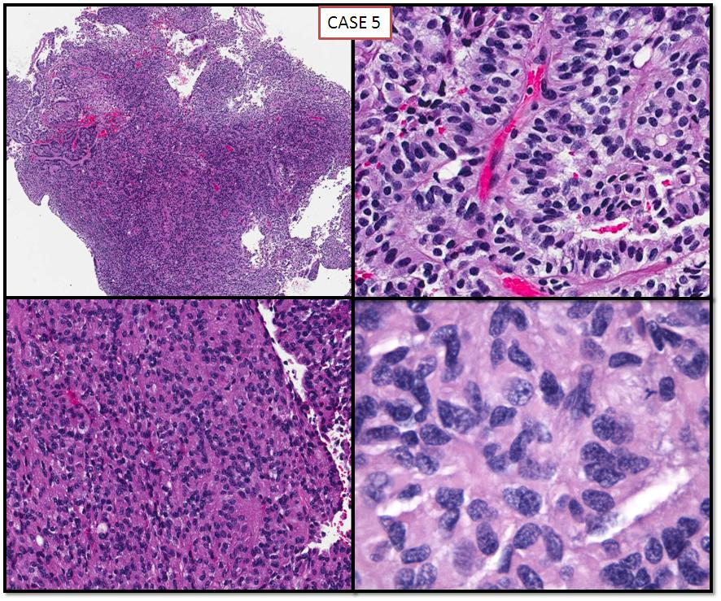

Final Diagnosis: Choroid Plexus Carcinoma (CPC)- WHO III

Differential Diagnosis:
Metastatic adenocarcinoma
Atypical choroid plexus papilloma (ACPP)
Choroid plexus carcinoma (CPC)
Papillary variant of ependymoma
Papillary meningioma
Key Features:
Radiology:
Multiple intra-axial and extra-axial supratentorial and infratentorial minimally enhancing lesions were seen. The lesions at the cerebellopontine angle cistern caused marked deformity of the brachium pontis with minimal effacement of the fourth ventricle. The lateral and third ventricles remained at the upper limits of their normal size, consistent with minimal noncommunicating hydrocephalus. Several small lesions at the level of the foramen magnum caused crowding of the cerebellar tonsils with deformity of the cervicomedullary junction.

Histology:
Biopsy showed a complex solid and focally papillary neoplasm lined by multiple layers of epithelioid cells with moderately increased nuclear-cytoplasmic ratio, hyperchromatic nuclei, moderate pleomorphism, clear to eosinophilic cytoplasm, and increased mitotic activity, reaching up to 5 mitoses /10 HPF. Necrosis was not identified.

Immunohistochemical stains:
- Positive
  - S100
  - Synaptophysin
  - Vimentin
  - GFAP (patchy)
  - Pankeratin (patchy)
  - Ki-67 (8-10%)
- Negative
  - BER-EP4
  - MOC-31
  - EMA

Discussion:
1. Choroid plexus is a complex epithelial-endothelial structure which consists of cuboidal, so-called “cobblestoned” epithelium, stroma and vasculature. The epithelium, of neuroectodermal origin can give rise to choroid plexus tumors, while the stroma may rarely give rise to intraventricular meningiomas¹

2. 100 years ago to date Harvey Cushing discovered that the CP produces cerebrospinal fluid (CSF)²

3. Choroid plexus has a unique distribution of ion transporters/channels which drives unidirectional flux of ions, forming the blood brain barrier

4. The choroid plexus is also the source of CSF-borne hormones and growth factors, like insulin-like growth factor II, vasopressin and transforming growth factor β1(TGF β1) and synthesizes transferrin and thyroid transporting protein transthyretin

5. Most cases of choroid plexus tumors are sporadic, but association with germline mutation of p53 tumor suppressor gene (Li-Fraumeni syndrome) has been described.

6. Clinical presentation of CPC as multifocal lesions in brain parenchyma and spine is very unusual, and possibility of metastatic papillary neoplasm should be considered and ruled out, particularly in an elderly individual.

7. Grading choroid plexus tumors is crucial and can guide appropriate treatment and prognosis³

References:
1. Safaee M, Oh MC, Bloch O, et al. Choroid plexus papillomas: advances in molecular biology and understanding of tumorigenesis. Neuro Oncol. 2013;15: 255-267.
2. Cushing H. Studies on the cerebro-spinal fluid. Journal of Medical Research. 1914;XXVI.
3. Louis DN, Ohgaki H, Wiestler OD, et al. The 2007 WHO classification of tumours of the central nervous system. Acta Neuropathol. 2007;114: 97-109.

Case 6
Presenter: Mohanad Shaar MD, PGY III
Attending: Stefan Pambuccian MD

Clinical History: A 63 year old man with history of coronary artery disease and hypertension presented for the evaluation of lightheadedness and passage of blood per rectum. Upper GI endoscopy showed a 32 mm well-defined, polypoid lesion in the gastric antrum. Partial gastrectomy was performed and a representative section is submitted for your review.

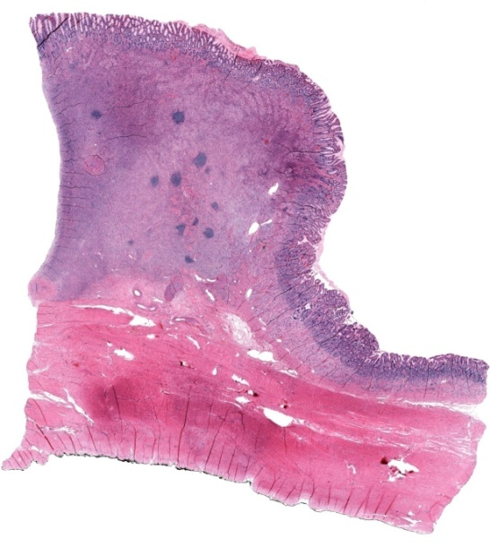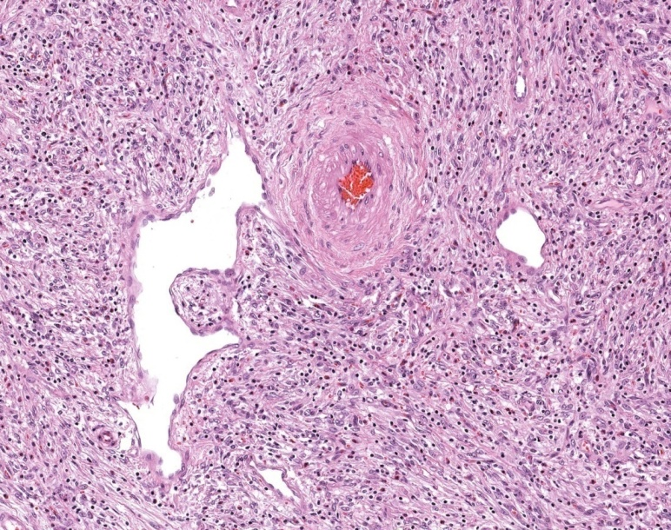

Final Diagnosis: Inflammatory Fibroid Polyp

Differential Diagnosis:
GIST
Schwannoma
Leiomyoma/Leiomyosarcoma
Glomus tumor
Calcifying fibrous tumor
Sclerosing mesenteritis
Mesenteric fibromatosis
Inflammatory myofibroblastic tumor
Primary melanoma of GI tract
Perineurioma

Key Features:
Histology:
Low power view shows a submucosal-based bland spindle cell proliferation that extends to superficial mucosa with entrapment of smooth muscles, gastric glands and focal ulceration; in addition the mass focal pushes the underlying muscularis propria. Vessels have antler shapes (hemangiopericytoma-like appearance) and at high power, medium-sized vessels with characteristic concentric cuffing by tumor cells are also seen. There is diffuse lymphocytic infiltration with abundant eosinophils in addition to some lymphoid aggregates. Focally, flower-like giant cells are also identified.

Positive IHC:
CD34: diffusely

Negative IHC:
Pankeratin
S100
SMA

Discussion:
1. Our lesion is mainly submucosal with infiltration of superficial mucosa, focally abutting the underlying muscularis propria, so we can exclude lesions affecting mainly mucosa, lamina propria, muscularis propria and serosa as a major compartment of involvement. Furthermore, non-reactivity with S-100 and reactivity with CD34 exclude melanoma and perineurioma, respectively.
Non-reactivity with SMA further excludes all other possibilities affecting deep layers of the wall as they are usually positive for SMA: Calcifying fibrous tumor, sclerosing mesenteritis, mesenteric fibromatosis (also positive for nuclear beta-catenin) and inflammatory myofibroblastic tumor.
2. The fact that our lesion is submucosal-based can limit the differential to lesions/tumors involving middle layers of the gastric wall:

- Glomus tumor usually involves muscularis propria: multiple nodules of uniformly round cells that are reactive with SMA.

- Schwannoma of the GI tract usually involves muscularis propria with surrounding lymphoid cuff and interlesional inflammation. However, nuclei and slender and wavy and the cells are positive for S-100.

- Smooth muscle tumors (leiomyoma and leiomyosarcoma) usually involve muscularis mucosa and can infiltrate superficial mucosa, but they are positive for SMA and negative for CD34.

- GIST is the most common mesenchymal tumor of the GI tract, usually involves muscularis mucosa as a main compartment. It may also share many immunohistochemical features with our case (like reactivity with CD34), and may be non-reactive with CD117, in addition to the fact that same PDGFRA mutations may be detected in both. Hence, it is almost only about morphologic features to distinguish some GIST cases from inflammatory fibroid polyp, and these include location, presence of atypia/pleomorphism, lack of eosinophils/diffuse inflammation, in addition to reactivity with CD117 (in KIT-positive GIST) and DOG1 immunostains.

References:
1. Kang HC, Menias CO, Gaballah AH, et al. Beyond the GIST: mesenchymal tumors of the stomach. Radiographics. 2013;33: 1673-1690.
2. Wardelmann E. Gastrointestinal stromal tumours: pathology and differential diagnosis. Diagnostic Histopathology. 2013;19: 211-219.
3. Lam-Himlin D. Gastrointestinal tract mesenchymal lesions. Surgical Pathology Clinics. 2011;4: 915-962.
4. Liu TC, Lin MT, Montgomery EA, Singhi AD. Inflammatory fibroid polyps of the gastrointestinal tract: spectrum of clinical, morphologic, and immunohistochemistry features. Am J Surg Pathol. 2013;37: 586-592.
5. Montgomery E, Voltaggio L. Mesenchymal polyps. Diagnostic Histopathology. 2014;20: 19-29.
6. Vanek J. Gastric submucosal granuloma with eosinophilic infiltration. Am J Pathol. 1949;25: 397-411.

