IRAP 9/28/15

Illinois Registry of Anatomic Pathology
September, 2015
Loyola University Medical Center

Case 1:
Presenter: Monica Aldulescu DO, PGY II
Attendings: Stefan E. Pambuccian MD

Clinical History: 13 y/o female with no PMH who presented to an outside hospital ED for abdominal pain and diarrhea. She had multiple episodes of diarrhea and the following morning awoke with sudden-onset, sharp, stabbing 10/10 pain in the left side of her abdomen. Pelvic US and CT scan revealed bilateral ovarian cysts and a mass posterior to the uterus. She was transferred to Loyola for further workup and treatment and underwent pelvic surgery. Pertinent intraoperative findings were benign-appearing bilateral multicystic ovaries and a 6.0cm peri-rectal mass, apparently not attached to the rectal wall, which did not break through the serosa. A representative section of the mass is submitted for your review.

Final Diagnosis: Perivascular Epithelial Cell Neoplasm (PEComa), measuring 5.4cm

Differential Diagnosis:
Metastatic:
Renal cell carcinoma
Adrenocortical carcinoma
Primary:
Germinoma
Clear cell mesenchymal tumors
Clear cell sarcoma/Melanoma of soft parts
Clear cell sarcoma-like tumor of the gastrointestinal tract
PEComa
Clear cell GIST
Alveolar Soft Part Sarcoma
Clear cell leiomyosarcoma

Key Features:
Histology:
Low power view shows a round, well-demarcated, encapsulated mass with solid and vascular areas. The tumor cells are predominantly with epithelioid, clear cell morphology, interspersed by connective tissue septae which are infiltrated by lymphocytes and contain delicate vessels. Higher power shows that there is some finely eosinophilic cytoplasm within some of the cells. The cells show mostly uniform/benign-appearing cytologic features with monomorphic nuclei, low N/C ratio, and no evidence of mitoses, necrosis, nuclear pleomorphism, or vascular invasion.

Positive IHC:
BCL-1 (Cyclin D1): +, diffusely
TFE3: +, diffusely
MITF: +, focally
HMB-45: +, diffusely

Negative IHC:
SMA
S100
Desmin
Caldesmon
MART-1
Muscle Specific Actin
Pankeratin
PAX-8

Discussion:
- Positivity for TFE3 excludes most of the tumors considered in the differential diagnosis, but is not specific for any tumor in particular.
- TFE3 gene fusions have been associated with number of neoplasms, including Xp11 translocation renal cell carcinoma (about 40% of RCCs in children and 1-4% of RCCs in adults), alveolar soft part sarcoma, a subset of PEComas, melanotic Xp11 translocation RCC, as well as a subset of epithelioid hemangioendotheliomas.
- With negative immunostains of PAX-8, Pankeratin, and MART-1, a metastatic renal cell carcinoma or adrenocortical carcinoma is highly unlikely.
- Positivity for TFE3 and HMB-45 points toward a PEComa, but may also be seen in melanotic Xp11 translocation RCC.
- PEComas are defined by WHO as "mesenchymal tumors composed of histologically and immunohistochemically distinctive perivascular epithelioid cells," that show a primarily epithelioid morphology and are immunoreactive for melanocytic markers.
- A gynecologic PECOMA-specific set of criteria for malignancy has been proposed by Schoolmester et. al, which classifies PEComas as benign, uncertain malignant potential, and malignant based on size ≥ 5cm, high-grade nuclear features, necrosis, vascular invasion, or mitotic rate ≥ 1/50 hpf.
- Although most PEComas harbor loss of TSC1/TSC2 mutations, recent research shows that a small subset carries TFE3 gene rearrangements.
- TFE3-variant PEComas have been shown to have a distinct morphology and immunostaining pattern compared to PEComas associated with TSC1/TSC2 mutations.
- While TSC1/TSC2-associated PEComas (or conventional PEComas) typically stain for myocytic and melanocytic markers, including Desmin, SMA, S100, HMB-45, TFE3-variant PEComas are negative for myo markers, yet still positive for melanocytic markers.
- TFE3-variant PEComas can also contain either a purely clear cell epithelioid morphology which has been shown to be negative (or at best focally positive) for MART-1, as well as a mixed clear cell epithelioid and spindle cell morphology which is strongly and diffusely positive for MART-1.
- Rao et. al proposes that TFE3 rearrangement-associated tumors share a distinct morphology (i.e. purely nested or sheet-like architecture, purely epithelioid cells with clear or finely eosinophilic cytoplasm, and uniform round or oval nuclei with small nucleoli). He also proposes that these tumors share similar immunoreactivity including moderate to strong positivity for nuclear marker TFE3, and no immunoreactivity for S100, SMA, desmin, and PAX-8.
- Take home messages:
-PEComas are composed of a distinct cell type known as perivascular epithelioid cells which are typically arranged around small-medium sized vessels.
-Conventional PEComas are immunoreactive smooth muscle and melanocytic markers (Desmin, SMA, H-caldesmon, HMB-45, MelanA, MITF).
-Increasing research has shown two distinct and mutually exclusive types of PEComas:
  - TFE3 rearrangements
  - TSC1/TSC2 loss of function mutations

References:¹⁻⁹
1. Agaram NP, Sung YS, Zhang L, et al. Dichotomy of Genetic Abnormalities in PEComas With Therapeutic Implications. Am J Surg Pathol. 2015;39: 813-825.
2. Argani P, Lal P, Hutchinson B, Lui MY, Reuter VE, Ladanyi M. Aberrant nuclear immunoreactivity for TFE3 in neoplasms with TFE3 gene fusions: a sensitive and specific immunohistochemical assay. Am J Surg Pathol. 2003;27: 750-761.
3. Folpe AL, Kwiatkowski DJ. Perivascular epithelioid cell neoplasms: pathology and pathogenesis. Hum Pathol. 2010;41: 1-15.
4. Hornick JL, Fletcher CD. PEComa: what do we know so far? Histopathology. 2006;48: 75-82.
5. Wang J, Thway K. Clear cell sarcoma-like tumor of the gastrointestinal tract: an evolving entity. Arch Pathol Lab Med. 2015;139: 407-412.
6. Rao Q, Shen Q, Xia QY, et al. PSF/SFPQ Is a Very Common Gene Fusion Partner in TFE3 Rearrangement-associated Perivascular Epithelioid Cell Tumors (PEComas) and Melanotic Xp11 Translocation Renal Cancers: Clinicopathologic, Immunohistochemical, and Molecular Characteristics Suggesting Classification as a Distinct Entity. Am J Surg Pathol. 2015;39: 1181-1196.
7. Schoolmeester JK, Dao LN, Sukov WR, et al. TFE3 translocation-associated perivascular epithelioid cell neoplasm (PEComa) of the gynecologic tract: morphology, immunophenotype, differential diagnosis. Am J Surg Pathol. 2015;39: 394-404.
8. Thway K, Fisher C. PEComa: morphology and genetics of a complex tumor family. Ann Diagn Pathol. 2015;19: 359-368.
9. Stockman DL, Miettinen M, Suster S, et al. Malignant gastrointestinal neuroectodermal tumor: clinicopathologic, immunohistochemical, ultrastructural, and molecular analysis of 16 cases with a reappraisal of clear cell sarcoma-like tumors of the gastrointestinal tract. Am J Surg Pathol. 2012;36: 857-868.

Case 2:
Presenter: Bogdan Isaila MD, PGY II
Attending: Stefan E. Pambuccian MD

Clinical History: A 37-year-old woman presented with chronic nasal congestion, obstruction, discharge, and episodes of bleeding for approximately one year. Her symptoms were worse on the left side, and were more accentuated over the last 3 months prior to her presentation. Imaging revealed a large, lobulated soft tissue density opacifying the left nasal cavity which appeared to be eroding or destroying a portion of the medial wall of the left maxillary sinus. The mass was resected and a representative section is submitted for your review.

Final Diagnosis: Human Papillomavirus-Related Carcinoma with Adenoid Cystic-Like Features

Differential Diagnosis:
Non Epithelial Neoplasms
- Mesenchymal neoplasms
Synovial sarcoma, hemangiopericytoma/SFT and other malignant mesenchymal tumors
- Neural and neuroendocrine neoplasms
High grade neuroendocrine carcinoma (small cell carcinoma)
High grade esthesioneuroblastoma
- Sinonasal melanoma
- Ewing’s sarcoma ⁄ PNET

Epithelial Neoplasms
High-grade salivary-gland-type carcinomas, including adenoid cystic carcinoma and myoepithelial carcinoma
Basaloid squamous cell carcinoma
Sinonasal undifferentiated carcinoma (SNUC)
Nasopharyngeal-type carcinoma
NUT midline carcinoma
HPV-related adenoid cystic-like carcinoma
SMARCB1(INI1)-deficient sinonasal basaloid carcinoma

Histology:
Both the biopsy and the excision specimen show similar histology dominated by a basaloid component and focal small nests or cysts conferring it a biphasic pattern. On low power most of the tumor appeared to be composed of ovoid to spindle basaloid cells with sheet-like growth pattern and a hemangiopericytoid vascular pattern and interspersed pale staining dots.
On high power the basaloid areas were composed of sheets of cells with scant, ill-defined cytoplasm, hyperchromatic nuclei, inconspicous nucleoli. The tumor focally showed vague rosette-like or acinar structures, cytoplasmic clearing and bizarre pleomorphic nuclei. Necrosis and numerous mitoses were seen. The second component which was present more focally consisted of small gland –like structures or solid nests formed of bland cells with moderately abundant cytoplasm, with clear or squamoid features and round uniform, enlarged, focally grooved nuclei. The significance of these structures was not clear initially, as they were considered to represent either entrapped glands or tumor elements.
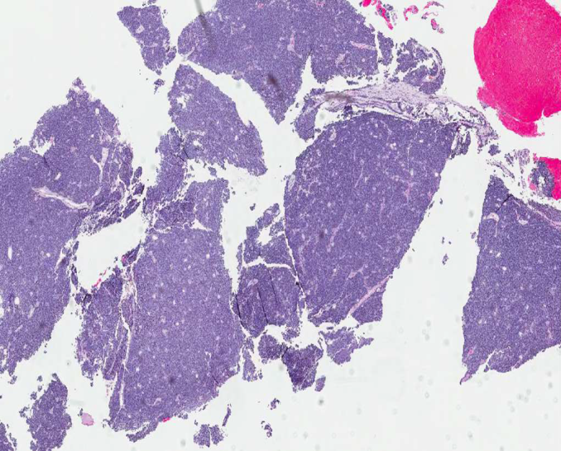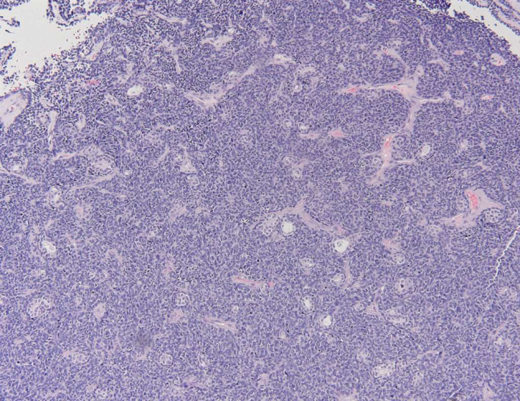
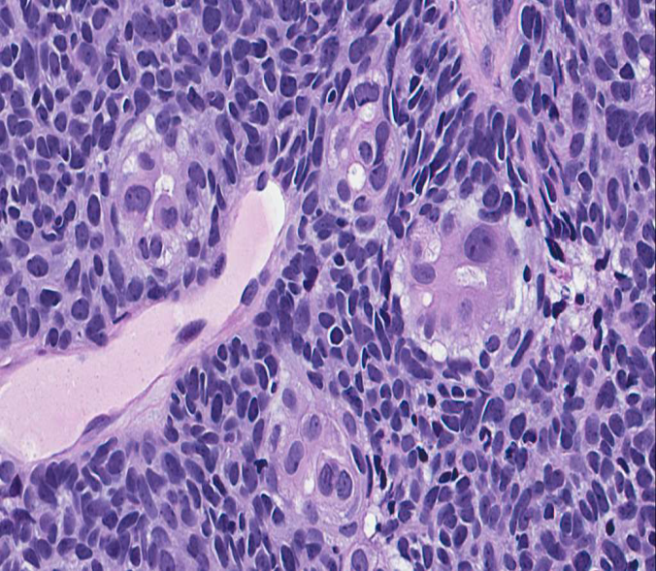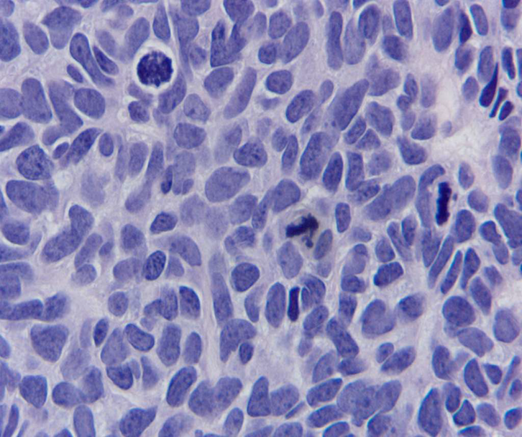

Positive IHC:

Basaloid Component
CK5/6 strong
P63 diffuse, strong
Ki67 diffuse, 80%
P16 diffuse, strong
Myosin, SMA, S100 focal
CD117 focal
CD56, Bcl2

Epithelial Component
CK (AE1/AE3), CK5/6, CK 8/18
P16 diffuse, strong
Luminal EMA, CD10, CEA
CD117 focal
P53 (weak)

Negative IHC, Both Components:
CD5, CD34, CD99, Desmin
TTF1, Chromogranin, Synaptophysin, NSE
EBER ISH

Discussion:
Our initial differential diagnosis was very extensive, including epithelial and non epithelial basaloid/small blue cell tumors of the sinonasal area. Positive stains for cytokeratins helped eliminate most of the non epithelial entities in our differential, except for synovial sarcoma, which was excluded by the absence of SYT-SSX fusion by PCR and the IHC staining pattern, which was highly unusual for synovial sarcoma.
Morphological features and positive myoepithelial markers exclude basaloid squamous cell carcinoma,
sinonasal undifferentiated carcinoma (SNUC) and nasopharyngeal-type carcinoma
The lack of BRD4-NUT rearrangement on FISH excluded NUT midline carcinoma, and the finding of preserved nuclear reactivity for INI1 IHC excluded SMARCB1(INI1)-deficient sinonasal basaloid carcinoma from our differential.
Human papillomavirus-related carcinoma with adenoid cystic-like features is a recently described tumor with only 8 cases previously described. Of these 8 cases six occurred in women and two in men, ranging in age from 40–73 years (mean 55).
The histologic featyres of this tumor were reminiscent of adenoid cystic carcinoma or high grade myoepithelilal carcinoma, which was the initial diagnosis in all cases. They showed a nested growth pattern, a prominent basaloid component showing myoepithelial differentiation and microcystic spaces. None of the cases was associated with the MYB gene rearrangement which characterizes adenoid cystic carcinomas and all cases were diffusely p16 positive and showed evidence of transcriptionally active HPV by ISH and PCR. The most common HPV type detected was HPV33.
In contrast, none of 91 adenoid cystic carecinomas were diffusely positive for p16 or showed HPV in situ hybridization positivity. In addition, also in contrast to adenoid cystic carcinoma these HPV related tumors frequently showed surface squamous dysplasia.

Compared to other basaloid neoplasms involving the sinonasal area which are associated with a very poor prognosis, human papillomavirus-related carcinoma with adenoid cystic-like features appears to have a better prognosis. In the only published series, four patients were alive and free of disease at 2 to 35 months after diagnosis, while two patients experienced local recurrences at 23 and 24 months post-treatment. No follow-up information was available for the remaining two patients.

Human papillomavirus-related carcinoma with adenoid cystic-like features is yet another HPV-related tumor located in the sinonasal area, which is after the oropharyngeal area another "hot spot" for HPV-related tumors, mostly squamous cell carcinomas with basaloid, papillary or nonkeratinizing histology, which appear to have a better prognosis than their non-HPV-related counterparts. This tumor is characerized by an unusual biphasic histologic pattern, and by an epithelial and myoepithelial differentiation demonstrated by IHC stains.

Take home messages:
Small blue cell/basaloid tumors of the sinonasal area are heterogeneous entities with:
different histogenesis (epithelial, mesenchymal, neural/neuroendocrine)
different etiology (EBV, HPV, various translocations)
different prognosis and management
Newly described basaloid epithelial tumors include
NUT midline carcinoma (poor prognosis)
SMARCB1(INI1)-deficient sinonasal basaloid carcinoma (poor prognosis)
HPV-related carcinoma with adenoid cystic-like features (better prognosis)
Clinical data, careful morphological study and the use of ancillary techniques are essential for an accurate diagnosis.

References
Bishop JA, Ogawa T, Stelow EB, et al. Human papillomavirus-related carcinoma with adenoid cystic-like features: a peculiar variant of head and neck cancer restricted to the sinonasal tract. Am J Surg Pathol. 2013;37:836-844.

Bishop JA, Antonescu CR, Westra WH. SMARCB1 (INI-1)-deficient carcinomas of the sinonasal tract. Am J Surg Pathol. 2014;38:1282-1289

Agaimy A, Koch M, Lell M, et al. SMARCB1(INI1)-deficient sinonasal basaloid carcinoma: a novel member of the expanding family of SMARCB1-deficient neoplasms. Am J Surg Pathol. 2014;38:1274-1281.

Franchi A, Palomba A & Cardesa A Current diagnostic strategies for undifferentiated tumours of the nasal cavities and paranasal sinuses. 2011 Histopathology, 2011;59, 1034–1045.

Al-Daraji W, Lasota J, Foss R, Miettinen M. Synovial sarcoma involving the head: Analysis of 36 cases with predilection to the parotid and temporal regions. Am J Surg Pathol. 2009;33:1494–1503

Lewis JS Jr, Westra WH, Thompson LD, Barnes L, Cardesa A, Hunt JL, Williams MD, Slootweg PJ, Triantafyllou A, Woolgar JA, Devaney KO, Rinaldo A, Ferlito A. The sinonasal tract: another potential "hot spot" for carcinomas with transcriptionally-active human papillomavirus. Head Neck Pathol. 2014;8(3):241-9.

Thompson LD, Penner C, Ho NJ, Foss RD, Miettinen M, Wieneke JA, Moskaluk CA, Stelow EB. Sinonasal tract and nasopharyngeal adenoid cystic carcinoma: a clinicopathologic and immunophenotypic study of 86 cases. Head Neck Pathol. 2014 Mar;8(1):88-109

Case 3:

Presenter: Burak Bahar, M.D., PGY III
Attendings: Milind M. Velankar, M.D.

Clinical History: Patient is a 23 year old white male with a 1-week history of uncomfortable left neck mass. He denied pain, dysphagia, odynophagia, shortness of breath, weight loss, fevers, chills or night sweats. CT neck with contast showed a well-circumscribed lobular mass measuring 6.4 cm in the greatest dimension. For further evaluation, the patient underwent fine needle aspiration of the left supraclavicular lymph node which was reported as negative for malignancy. Eventually, excisional biopsy of the neck node was performed and a representative section is submitted for your review.

Final Diagnosis: Classical Hodgkin lymphoma, nodular sclerosis, grade 2 (syncytial variant) with aberrant T-cell antigen expression.

Differential Diagnosis:
- Classical Hodgkin lymphoma nodular sclerosis (syncytial variant)
- T-cell/histiocyte-rich large B-cell lymphoma
- Anaplastic large cell lymphoma
- Peripheral T-cell lymphoma not otherwise specified

Key Features:
Histology:
Normal architecture effaced by nodular atypical polymorphic lymphoid proliferation. Reactive follicles are pushed to the rim of the lymph node. In the nodules, there are irregular pale areas composed of clusters of large atypical cells with amphophilic cytoplasm, irregular nuclei, vesicular chromatin and prominent nucleoli. There are some eosinophils and neutrophils intermixed with atypical cells. Numerous small lymphocytes surround the clusters of atypical cells. Focally, fibrous bands can be seen.

HE x2 | HE x40

Immunohistochemistry:

Positive Stains | Negative Stains
CD30 | CD15
CD4 | CD20
MUM-1 | CD45
 | PAX-5
 | CD3 (some cells with incomplete expression)
 | CD5 (some cells with incomplete expression)
 | ALK-1
 | OCT-2

Discussion:
- T-cell antigen (TCA) expression can be seen in 5% to 8% of cases of classical Hodgkin lymphoma (cHL). Only a small subset (~10% to 35%) of HRS cells express TCAs in TCA expression positive cases. cHL nodular sclerosis grade 2 (syncytial variant) is most common subtype showing TCA expression. cHL cases expressing TCAs present at younger age compared to TCA negative cHL cases.
- CD4 and CD2 are most frequently expressed (80.4% and 77.4%, respectively) TCAs and TCA expression is never uniform and widespread. One to multiple TCAs may be expressed and any combination is possible. Incomplete staining pattern can be seen.
- In spite of the best efforts up to 30% of HL cases relapse. For better stratification of risk of adverse outcome/early relapse a number of factors including age, sex, Ann Arbor stage, and International Prognostic Score have been tested. However, a subset of HL patients with high risk of relapse cannot be identified upfront indicating need for better biomarkers. TCA expression was found to be independently associated with a worse outcome. TCA expression by HRS cells could be one of such biomarkers that help to identify patients with increased risk of relapse

Take-Home Points:
- Rare cases of classical Hodgkin lymphoma show expression of T-cell antigens on the neoplastic Hodgkin/Reed-Sternberg cells and these cases are associated with a worse outcome
- Flow cytometry has low sensitivity and low specificity in contributing to the diagnosis of classical Hodgkin lymphoma

References:
- Venkataraman G, et al. Aberrant T-cell antigen expression in classical Hodgkin lymphoma is associated with decreased event-free survival and overall survival. Blood. 2013;121(10):1795–804
- Falini B, et al. Expression of lymphoid-associated antigens on Hodgkin’s and Reed-Sternberg cells of Hodgkin’s disease. An immunocytochemical study on lymph node cytospins using monoclonal antibodies. Histopathology. 1987;11(12):1229–1242
- Kadin ME, et al. Expression of T-cell antigens on Reed-Sternberg cells in a subset of patients with nodular sclerosing and mixed cellularity Hodgkin’s disease. Am J Pathol. 1988;130(2):345–353
- Müschen M, et al. Rare occurrence of classical Hodgkin’s disease as a T cell lymphoma. J Exp Med. 2000;191(2):387–394
- Seitz V, et al. Detection of clonal T-cell receptor gamma-chain gene rearrangements in Reed-Sternberg cells of classic Hodgkin disease. Blood. 2000;95(10):3020–3024
- Tzankov A, et al. Rare expression of T-cell markers in classical Hodgkin’s lymphoma. Mod Pathol. 2005;18(12):1542–1549
- Asano N, et al. Prognostic significance of T-cell or cytotoxic molecules phenotype in classical Hodgkin’s lymphoma: a clinicopathologic study. J Clin Oncol. 2006;24(28):4626–4633
- Hasenclever D, Diehl V. A prognostic score for advanced Hodgkin’s disease. International Prognostic Factors Project on Advanced Hodgkin’s disease. N Engl J Med. 1998;339(21):1506–1514

Case 4

Presenter: Reza Eshraghi MD, PGY II
Attendings: Ananthanarayanan Vijayalakshmi MD, Stefan E Pambuccian MD

Clinical History: A 54-year-old woman who presented with a lesion on the anterior dorsal aspect of the tongue. The lesion was present for a duration of four years. Biopsy done on the lesion 4 years ago showed squamous hyperplasia with hyperkeratosis since then the lesion has gotten slightly larger and is slightly painful. Past medical history is remarkable for hypertension and polycythemia Vera. Initial lab findings are unremarkable. The patient underwent partial glossectomy. Gross findings revealed 2.2 cm soft, pedunculated and non-tender mass which does not appear vascular or hemorrhagic cut surface demonstrated tan-yellow, submucosal nodule with gelatinous appearance. A representative section is submitted for your review.

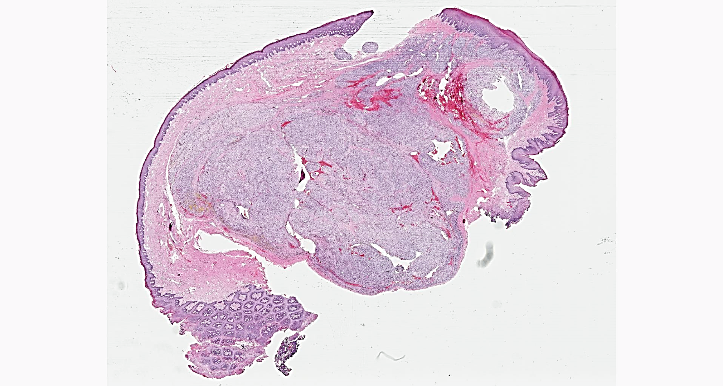
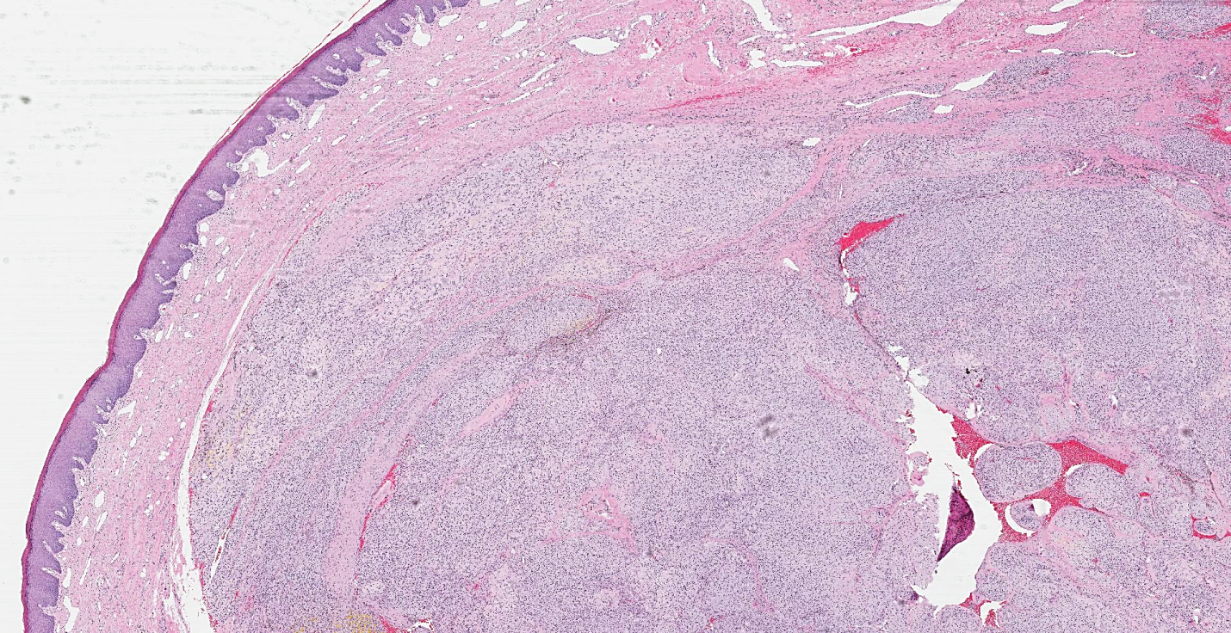
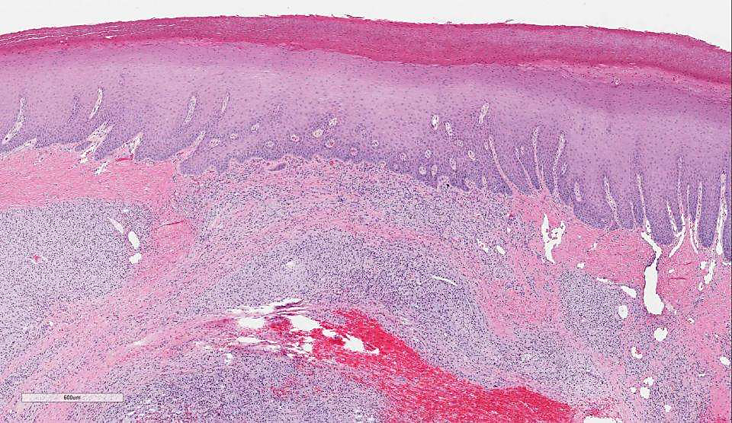

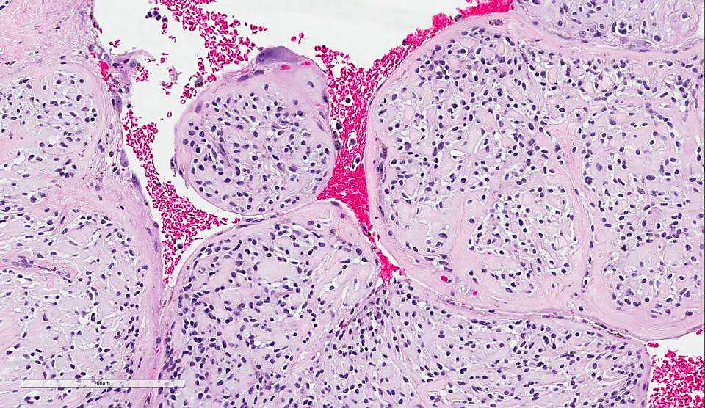

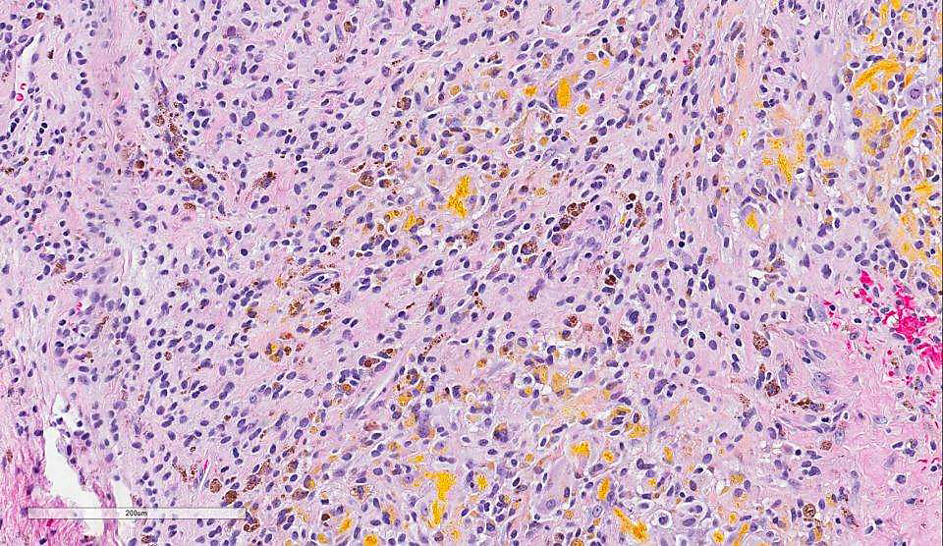

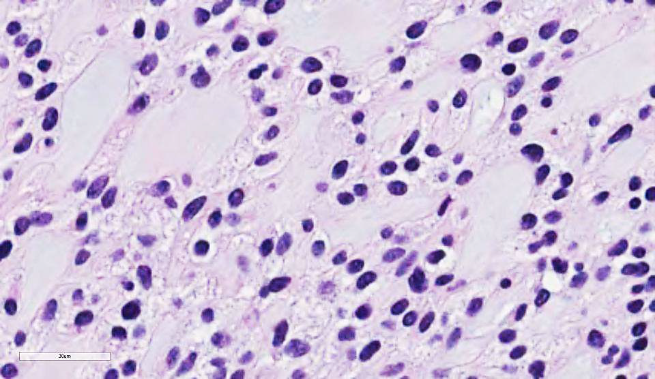

Final Diagnosis: Ectomesenchymal Chondromyxoid Tumor

Differential Diagnosis:
Pleomorphic Adenoma
Neurofibroma with myxoid changes
Extraskeletal Myxoid Chondrosarcoma
Ectomesenchymal Chondromyxoid Tumor
Myoepithelioma of salivary glands
Mucocele with myxoglobulosis
Soft tissue myxoma
Glial choristoma (heterotopic glial tissue)
Chondroid choristoma

Key Features:
Histology:
Submucosal, well-demarcated, non-encapsulated, lobulated tumor, mostly separated from the overlying hyper and parakeratotic squamous mucosa by fibrovascular tissue but focally extending to the squamous epithelium (. There is focal surface ulceration. Previous biopsy site changes are present. Tumor cells are bland, uniform, with indistinct cytoplasm and cell borders, with small, round to ovoid nuclei without visible nucleoli. There is some degree of nuclear pleomorphism in the form of random nuclear atypia. Variable cellularity in different lobules is also identified. Tumor cells are embedded in a vaguely myxochondroid to hyalinized matrix; with no overt cartilaginous matrix formation. ; Mitotic activity is absent. Necrosis is absent. RBC extravasation, hemosiderin deposition are present
Immunohistochemistry:

Positive Stains: Negative Stains:
GFAP AE1/AE3
SMA CK5/6
BCL-2 CK8/18
Focally CD57 p63
Weakly and focally S-100 EMA
Alcian blue D2-40
HMB-45
DESMIN
CEA

Discussion:
Anterior 2/3 of the tongue is formed by lateral lingual swelling and tuberculum impar from the first pharyngeal arch which is free of minor salivary glands on the dorsal aspect, so it is a very rare location for tumors arising from salivary glands. The term ectomesenchymal chondromyxoid tumor (EMCT) was first coined in 1995 for unusual chondromyxoid tumors of the tongue that failed to meet the established clinicopathologic criteria of previously described soft tissue chondromyxoid lesions of the oral cavity that encompassed a heterogeneous group of uncommon but well-documented entities. Myoepithelioma, neurofibroma with myxoid changes, chondroid choristoma, pleomorphic adenoma, extraskeletal myxoid chondrosarcoma, ossifying fibromyxoid tumor and chondroid choristoma are among the differential diagnosis.
ECMT exhibit a lobular proliferation of ovoid and fusiform cells which often have multilobated nuclei and occasional foci of atypia, embedded in a chondromyxoid background. The cells are diffusely and intensely immunoreactive for glial fibrillary acidic protein (GFAP) and are variably immunoreactive for cytokeratins. Staining is variable for smooth muscle actin (SMA) and S-100 protein but is negative for desmin and epithelial membrane antigen (EMA). A study done in 2013 ³, suggested that the tumor arises from pluripotent ectomesenchymal cells. The ectomesenchymal cells are proposed as originating from neural crest cells and with neuronal/neuroglial like properties, this study further demonstrated that cells cultured from these tumors revealed immunofluorescence activity for proteins participating in neuronal cell structure formation including GFAP, MAP2 and Nanog, Majority of the entities considered in the differential diagnoses can be easily excluded based on morphology or immunohistochemical studies. Differentiating ECMT from myoepithelioma can be quite a challenge due to the considerable morphologic and immunophenotypic overlap. In our case, the tumor was completely negative for keratins and p63, enabling us to exclude myoepithelioma with ease. ECMT can often be excluded from salivary gland type myoepithelioma based on its location on the anterior dorsal tongue. However, if ECMT is synonymous or distinct from soft tissue myoepithelioma remains a contentious issue.
Based on history of the patient, location of the tumor, microscopic and macroscopic findings and IHC the ectomesenchymal chondromyxoid tumor is the final diagnosis in our patient.
The patient is doing well post operatively with no evidence of recurrence.

Take-Home Points:
- ECMT is a very rare tumor, classically located on anterior dorsal tongue
- Superficial biopsy may not be helpful to make diagnosis, excisional biopsy is recommended
-The most likely tissue of origin is the uncommitted ectomesenchymal cells of neural crest
- Myoepithelioma is its closest differential
- S-100 and GFAP positivity supports neurogenic differentiation
- Benign tumor, with low recurrence rate

References
1: Aldojain A, Jaradat J, Summersgill K, Bilodeau EA. Ectomesenchymal Chondromyxoid Tumor: A Series of Seven Cases and Review of the Literature. Head Neck Pathol. 2014 Nov 18.
2013 WHO Classification of Tumors of Soft Tissue and Bone (4th Edition)
Diagnostic Pathology , Head and Neck THOMPSON . WENIG (Nelson.Muller)
2: Cardin MJ, Fiset PO, Zeitouni AG, Caglar D. Ectomesenchymal chondromyxoid tumour of the posterior tongue. Head Neck Pathol. 2014;8(3):329-33.
3: Yoshioka Y, Ogawa I, Tsunematsu T, Sakaue T, Yamasaki S, Fukui Y, Hayashido Y,Toratani S, Okamoto T. Ectomesenchymal chondromyxoid tumor of the tongue:insights on histogenesis. Oral Surg Oral Med Oral Pathol Oral Radiol. 2013, Feb;115(2):233-40.
4: Tsai SY, Chang KC, Tsai HW, D D S YT. Ectomesenchymal chondromyxoid tumor of tongue. Indian J Pathol Microbiol. 2012 Oct-Dec;55(4):519-20.
5: Closmann JJ, Eliot CA, Foss RD. Ectomesenchymal chondromyxoid tumor: report of a case with description of histologic and immunohistochemical findings. J Oral Maxillofac Surg. 2013 Mar;71(3):545-9.
6: Smith BC, Ellis GL, Meis-Kindblom JM, Williams SB. Ectomesenchymalchondromyxoid tumor of the anterior tongue. Nineteen cases of a new clinicopathologic entity. Am J Surg Pathol. 1995 May; 19(5):519-30.
Case 5:
Presenter: John Biemer MD
Attending: Güliz A. Barkan, MD

Clinical History:
70-year-old man with past medical history of lymphoplasmacytic lymphoma/Waldenstroms macroglobulinemia, testicular mass status post orchiectomy, benign prostatic hypertrophy with lower urinary tract symptoms, fecal incontinence and basal cell carcinoma presents for surveillance CT. He is found to have a 3.1 x 3.1 cm left common iliac lymph node. An FNA is
performed to this lymph node.

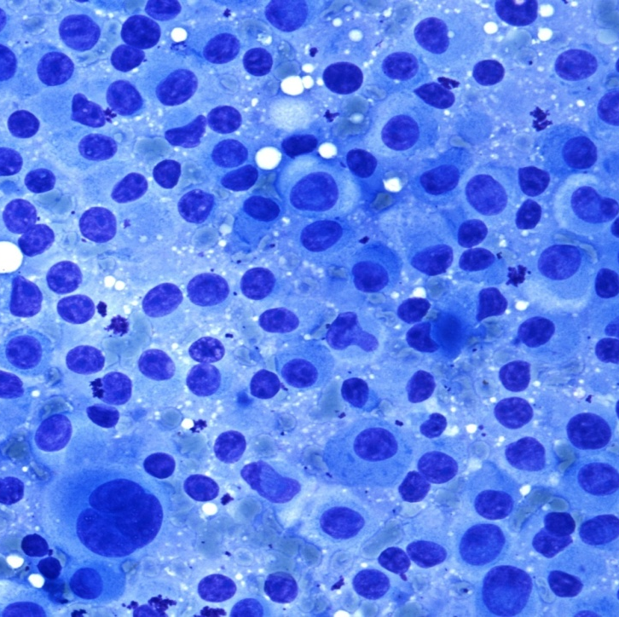
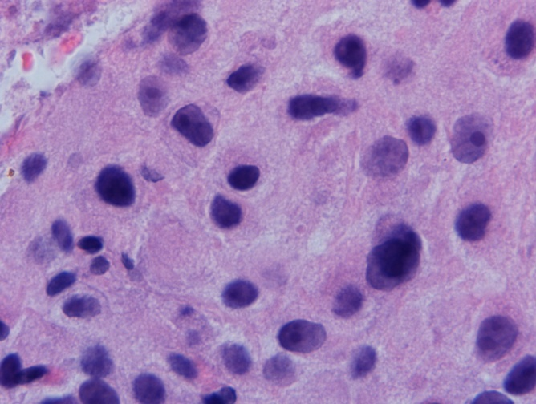
Final Diagnosis: Metastatic Leydig Cell Tumor
Differential Diagnosis:
- Lymphoma
- Melanoma
- Neuroendocrine Tumor
- Adrenal Gland (normal)
- Metastatic Testicular Tumor:
  - Germ cell tumors: seminoma, embryonal, yolk sac, choriocarcinoma, teratoma, mixed germ cell tumors
  - Sex cord stromal tumor: Sertoli cell tumor

Key Features:
Cytology:
Fine needle aspiration demonstrates a cellular cytology with large discohesive cells with indistinct cell borders. There are round, eccentric nuclei with evenly distributed chromatin and prominent nucleoli. Some nuclei demonstrate grooves. The cytoplasm is abundant and finely granular.

Histology:
The patient’s orchiectomy was diagnosed as malignant Leydig cell tumor with marked nuclear atypia, foci of brisk mitotic activity and focal necrosis. Leydig cell tumors most commonly demonstrate nests or sheets separated by delicate fibrovascular septa. They also can have small clusters or trabecula separated by a variable amount of fibrous or myxoid stroma. Abundant cytoplasmic lipofuscin pigment, appearing as golden yellow to brown cytoplasmic granules is a distinctive feature, though nonspecific.

Four cell types have been described: 1) large polygonal cells with abundant, finely granular, eosinophilic cytoplasm, indistinct cell borders and regular, round to oval nuclei, 2) same as 1 but distinct cell borders and smaller nuclei, 3) small cells with scant, densely eosinophilic cytoplasm and grooved nuclei and 4) spindle-shaped (sarcomatoid) cells. Some tumors will demonstrate a combination of multiple cell types.

Immunohistochemical stains:
- Positive
  - Inhibin is characteristic for sex cord-stromal tumors and is best to differentiate them from germ cell tumors
  - Calretinin
  - Melan-A, good for steroid-secreting tumors including Leydig cell tumors (if melanoma is excluded)
  - Vimentin
- Negative
  - Cytokeratins

Discussion:
1. Leydig cells, the interstitial cell located between seminiferous tubules, were first described by German anatomist Franz Leydig in 1870. They produce testosterone when stimulated by luteinizing hormone and are involved in development of secondary male characteristics and maintenance of spermatogenesis.
2. Leydig cell tumors comprise 1 to 3 percent of all testicular neoplasms. There are no known risk factors and they are not known to be associated with cryptorchidism as germ cell tumors are. They can occur at any age, but are most often seen in boys 5-10 years old and men aged 30-60.
3. Malignant Leydig cell tumors are differentiated from benign tumors by a larger size (greater than 5 cm), infiltrative margins, necrosis and hemorrhage. They may replace the testes or extend beyond the testicular parenchyma.
4. Serum testosterone is usually elevated in patients with Leydig cell tumors and serum estradiol is increased in patients with feminization. Unlike in germ cell tumors, serum tumor markers testing for α-FP, β-HCG and PLAP should be within normal ranges.
5. Reinke crystals are pale-staining refractile, cylindrical, rectangular or rhomboid structures or inclusions that are pathognomonic of Leydig cells. However, studies have shown that they are difficult to find on H&E because they tend to dissolve in aqueous-based solutions such as formalin. They may be more apt to be identified on cytology because of non-aqueous fixation methods.
6. Leydig cell tumors are rarely seen on cytology because FNAs of testicular neoplasms are contraindicated, as are biopsies, due to concern for seeding of the tumor. However, metastatic Leydig cell tumors should be in the differential diagnosis for patients who are post-orchiectomy.
References:
Osama M. Al-Agha and Constantine A. Axiotis (2007) An In-Depth Look at Leydig Cell Tumor of the Testis. Archives of Pathology & Laboratory Medicine: February 2007, Vol. 131, No. 2, pp. 311-317.
Ober, W. B. and C. Sciagura . Leydig, Sertoli and Reinke: three anatomists who were on the ball. Pathol Annu 1981. 16:1–13.
Holm, M. , E. Rajpert-De Meyts , A-M. Andersson , and N. E. Skakkebk . Leydig cell micronodules are a common finding in testicular biopsies from men with impaired spermatogenesis and are associated with decreased testosterone/LH ratio. J Pathol 2003. 199:378–386
Kim, I. , R. H. Young , and R. E. Scully . Leydig cell tumors of the testis. A clinicopathological analysis of 40 cases and review of the literature. Am J Surg Pathol 1985. 9:177–192.
Iczkowski, K. A. , D. C. Bostwick , and P. C. Roche . et al. Inhibin A is a sensitive and specific marker to testicular sex cord-stromal tumors. Mod Pathol 1998. 11:774.
Bertram, K. A. , B. Bratlof , G. F. Hodges , and H. Davidson . Treatment of malignant Leydig cell tumor. Cancer 1991. 68:2324–2329.
Dilworth JP, Farrow GM, Oesterling JE, Non-germ cell tumors of testis, Urology, 1991;37(5):399.
Mesa H, Gilles S, Smith S, Dachel S, Larson W, Manivel JC. The mystery of the vanishing Reinke crystals. Hum Pathol. 2015;46:600-606.
Handa, U., Sood, T. and Punia, R. S. (2010), Testicular leydig cell tumor diagnosed on fine needle aspiration. Diagn. Cytopathol., 38: 682–684. doi: 10.1002/dc.21306
Jain, M., Aiyer, H.M., Bajaj, P. and Dhar, S. (2001), Intracytoplasmic and intranuclear Reinke's crystals in a testicular Leydig-cell tumor diagnosed by fine-needle aspiration cytology: A case report with review of the literature. Diagn. Cytopathol., 25: 162–164. doi: 10.1002/dc.2029
Kronz, J. D., Nicol, T. L., Rosenthal, D. L. and Ali, S. Z. (1998), Metastatic testicular sertoli-cell tumor: Cytopathologic findings on fine-needle aspiration. Diagn. Cytopathol., 19: 127–130. doi: 10.1002/(SICI)1097-0339(199808)19:2<127::AID-DC13>3.0.CO;2-H
H. Evin Gulbahce, Arthur T. Lindeland, William Engel, and Tamera J. Lillemoe (1999) Metastatic Leydig Cell Tumor With Sarcomatoid Differentiation. Archives of Pathology & Laboratory Medicine: November 1999, Vol. 123, No. 11, pp. 1104-1107

CASE 6:
Presenter: Nicolas Lopez-Hisijos, DO PGY2
Attendings: Dr. Stefan Pambuccian, M.D.

Clinical History: A 33 year old woman was evaluated for increasing abdominal pain of two weeks duration. The pain was not associated with other symptoms such as nausea, weight loss, and fever. The physical exam was unremarkable. An abdominal ultrasound revealed a cystic mass in the pancreatic tail. A follow-up CT scan confirmed the presence of a 5cm loculated cystic lesion in the tail of the pancreas abutting the splenic vessels. A EUS biopsy showed the following morphology:
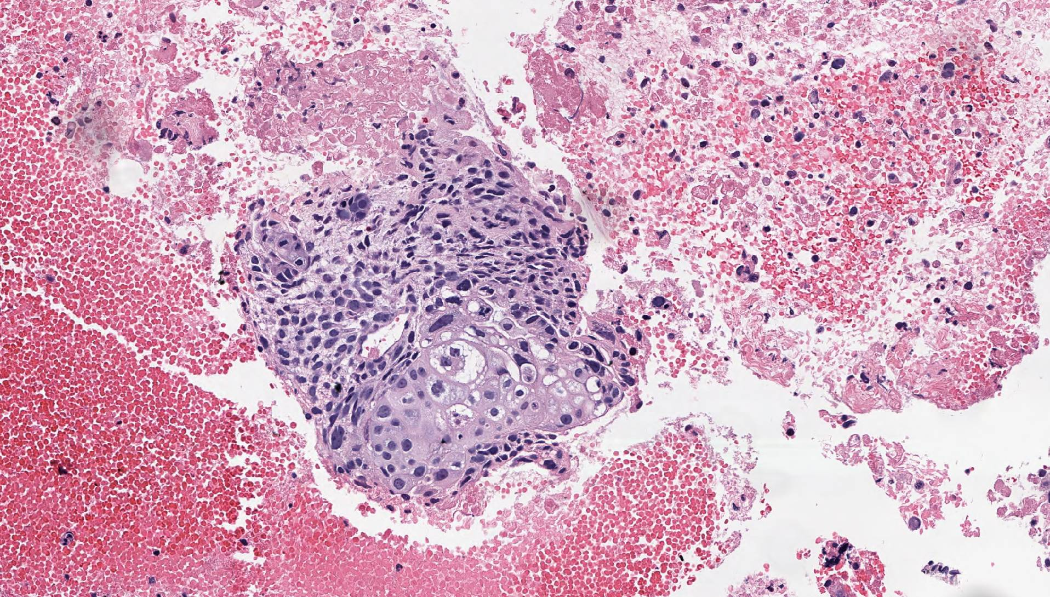
Fig 1: Cluster of pleomorphic cells with glandular and squamous features.

Given the biopsy results a distal pancreatectomy and splenectomy was performed:
Fig 2: Distal pancreatectomy specimen showing an era of biphasic growth pattern (A) and an area of ductal adenocarcinoma (B).
B
A

Histology: The histologic findings in the biopsy point to a high grade epithelial tumor (Fig.1). The pancreatectomy specimen revealed spindled and glandular components in the tumor (Fig. 2A). However, this biphasic pattern was only seen in areas of the tumor outside the pancreas (in the spleen and splenic vessels). Within the pancreas, the tumor cells were glandular, with an infiltrative growth pattern in desmoplastic stroma.
Immunohistochemical Profile: The two distinct populations of tumor cells seen in the pancreatectomy specimen exhibited different marker profiles. Most notably, the glandular component was positive for multiple cytokeratin stains (AE1/AE3, Cam5.2, CK7) and negative for vimentin, while the spindle cells showed the opposite profile:

IHC stain | Spindle Cells | Glandular Cells
Cytokeratin | - | +
Vimentin | + | -

Differential Diagnosis:
1) Adenosquamous Carcinoma
2) Pancreatoblastoma
3) Mucinous Cystic Neoplasm with Sarcomatous Stroma
4) Solid Pseudopapillary Tumor with Sarcomatous Area
5) Undifferentiated Carcinoma

Discussion: This is the case of a young woman with a pancreatic tail mass. Given this clinical presentation, a solid pseudopapillary tumor was initially high on the differential. However, the biopsy showed a discrepant morphology to the most likely clinical diagnosis. The pancreatectomy revealed that the areas of tumor outside the pancreas showed a spindle cell population growing in sheets and a glandular population with variable atypia and focal clear cell changes. The areas of tumor within the pancreas showed a glandular population most consistent with ductal adenocarcinoma. It was also noted that the spindle and glandular elements in the tumor had different immunohistochemical profiles. Given this presentation and following the terminology described in the WHO our final diagnosis was carcinosarcoma (undifferentiated/anaplastic carcinoma). Carcinosarcoma is a recognized histologic variant of undifferentiated carcinoma of the pancreas. It is characterized by the presence of two distinct populations of malignant cells, one displaying mesenchymal differentiation and the other showing epithelial differentiation. This diagnosis is extremely rare, representing only 0.3% of all pancreatic malignancies. Of this 0.3% only a small subset of cases are seen in young patients. However, when young patients (under 40) are diagnosed with adenocarcinoma of the pancreas, they display aggressive subtypes more often than patients of advanced age.

Take Home Points:
Not all pancreatic tail tumors in young women are SPPTs
EMT is a well characterized process that is likely occurring in this case
Carcinosarcoma is a histologic subtype of undifferentiated carcinoma of the pancreas
Pancreatic malignancies in young patients are extremely rare, but adenocarcinomas are common within this category
Variants of ductal adenocarcinoma are more common in young patients

References:
- Silva RG, Dahmoush L, Gerke H. Pancreatic metastasis of an ovarian malignant mixed Mullerian tumor identified by EUS-guided fine needle aspiration and Trucut needle biopsy. JOP. 2006 Jan 11;7(1):66-9. PubMed PMID: 16407622
- Lamouille S, Xu J, Derynck R. Molecular mechanisms of epithelial-mesenchymal transition. Nat Rev Mol Cell Biol. 2014 Mar;15(3):178-96. doi: 10.1038/nrm3758. Review. PubMed PMID: 24556840; PubMed Central PMCID: PMC4240281.
- Van den Berg W, Tascilar M, Offerhaus GJ, Albores-Saavedra J, Wenig BM, Hruban RH, Gabrielson E. Pancreatic mucinous cystic neoplasms with sarcomatous stroma: molecular evidence for monoclonal origin with subsequent divergence of the epithelial and sarcomatous components. Mod Pathol. 2000 Jan;13(1):86-91. PubMed PMID: 10658914.
- Paal E, Thompson LD, Frommelt RA, Przygodzki RM, Heffess CS. A clinicopathologic and immunohistochemical study of 35 anaplastic carcinomas of the pancreas with a review of the literature. Ann Diagn Pathol. 2001 Jun;5(3):129-40. Review. PubMed PMID: 11436166.
- Omiyale AO. Clinicopathological review of pancreatoblastoma in adults. Gland Surg. 2015 Aug;4(4):322-8. doi: 10.3978/j.issn.2227-684X.2015.04.05. Review. PubMed PMID: 26312218; PubMed Central PMCID: PMC4523633.
- Gilabert M, Turrini O, Niccoli P, Moureau-Zabotto L, Boher JM, Poizat F, Giovannini M, Delpero JR, Raoul JL. Solid pancreatic tumors in patients younger than 40 years old--experience of a French comprehensive cancer center. Pancreas. 2015 Mar;44(2):345-6. doi: 10.1097/MPA.0000000000000221. PubMed PMID: 25675423
- Kalluri, R., & Weinberg, R. A. (2009). The basics of epithelial-mesenchymal transition. The Journal of Clinical Investigation, 119(6), 1420–1428. http://doi.org/10.1172/JCI39104
- Bosman, Carneiro, Hruban, Theise (2010). WHO Classification of Tumours of the Digestive System. IARC, Lyon (2010)
- Rosai (2011). Rosai and Ackerman’s Surgical Pathology. Edinburgh ; New York : Mosby, 2011.
- Cantrell LA, Blank SV, Duska LR. Uterine carcinosarcoma: A review of the literature. Gynecol Oncol. 2015 Jun;137(3):581-8. doi: 10.1016/j.ygyno.2015.03.041. Epub 2015 Mar 21. Review. PubMed PMID: 25805398.
- Lüttges J, Stigge C, Pacena M, Klöppel G. Rare ductal adenocarcinoma of the pancreas in patients younger than age 40 years. Cancer. 2004 Jan 1;100(1):173-82. Review. PubMed PMID: 14692038.
- Tang LH, Aydin H, Brennan MF, Klimstra DS. Clinically aggressive solid pseudopapillary tumors of the pancreas: a report of two cases with components of undifferentiated carcinoma and a comparative clinicopathologic analysis of 34 conventional cases. Am J Surg Pathol. 2005 Apr;29(4):512-9. PubMed PMID: 15767807.

